**SUNY OSWEGO – MARQUEE PROPERTY #3**

**Intersection of Rudolph Road (CR 89) and Iroquois Trail**

**Proposed Parcel:** Southwest Corner lot at the Intersection of CR 89 and Iroquois Trail

**Area:** College Campus/Educational

**Current Use:** Student Recreation/Overflow Parking

**Construction Status:** Ready

**Lot Size:** 3.3 acres (+/-)

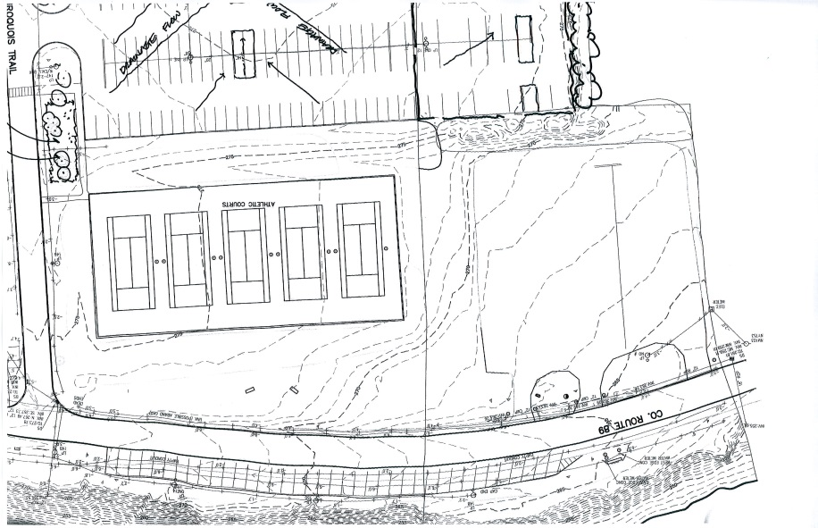

**Physical description:** A relatively flat parcel with direct views onto Lake Ontario. It is bounded on the north and east by public streets. It is bounded on the south by a resident student parking lot. It is bounded on the west by a private residential property. It has direct access to both public streets and is served by public transportation. The parcel has electric, water and sewer immediately available. It can be linked to the College’s central heating plant for high temp hot water if needed.

