**SUNY OSWEGO – MARQUEE PROPERTY #2**

**Romney Commuter Parking Lot**

**Proposed Parcel:** Southeast Corner lot at the Intersection of NYS Route 104 and Barnes Drive

**Area:** Commercial Corridor

**Current Use:** Commuter Parking

**Construction Status:** Ready

**Lot Size:** 5.8 acres (+/-)

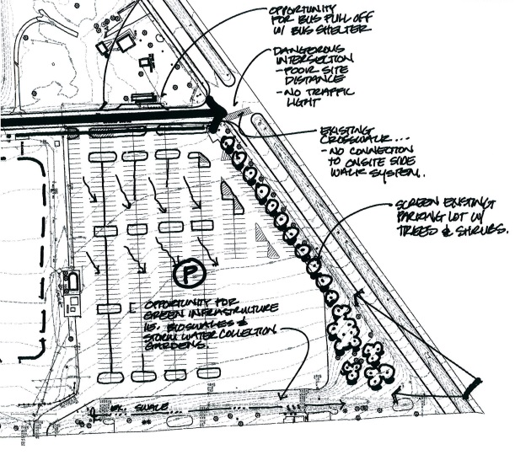

**Physical description:** A relatively flat parcel with direct frontage onto NYS 104 to the north. It is bounded on the west by Barnes Drive. It is bounded on the south by intercollegiate athletic playing fields. It is bounded on the east by a private residential neighborhood. It has direct access to both public streets and public transportation. The parcel has electric, water and sewer immediately available. The parcel is construction ready.

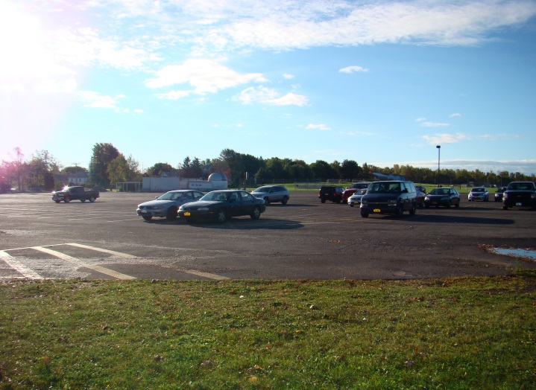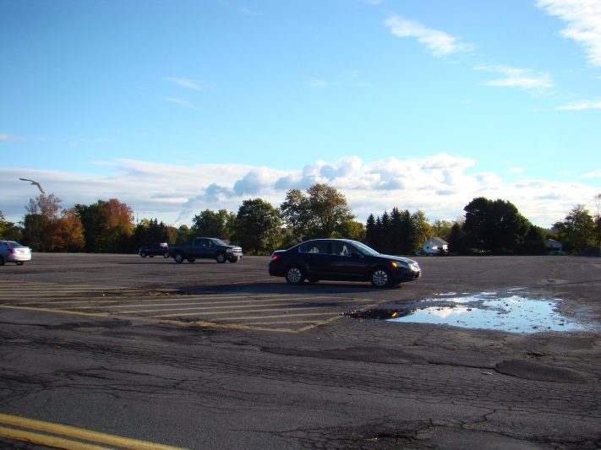**View from Barnes Drive**  **View from NYS 104**