Team Final Report on Teacher and Student Learning at Oswego Middle School
with Christine Walsh
EDU 525 - Cultivating Learning Communities through Mindful Language and Literacy

Teacher Participant Name: Carole Lloyd
Please update us on any changes you made to your team action plan:

The changes I made involved expanding my project of self-regulation of stress levels and mindful thinking to include using focus activities with my students when I felt it would benefit their ability to focus and reduce stress levels. I chose to practice mindful activities, breathing exercises, and story-telling into my class activities. If I could reduce their stress levels to help them better focus on my curriculum, I would only benefit from that personally and professionally.

Analysis of Data on Teacher Learning:
I examined my reflections and found the following:

Results that I have observed and noticed through my journaling reflections, yoga sessions, mindful listening, mindfulness in nature, are listed as follows:
I have engaged in mindful observation, journaling, yoga, walking, and listening over the last five months. My observations are that these mindfulness based stress reduction activities have given me an awareness of significant gain in self-regulation, self-compassion, and mindfulness related skills. I have become more aware through my observations of the necessity to be non-judgmental and non-reactive when I find myself in stressful situations.
Examples/evidence of my personal observations are that I feel that I have made significant improvements in the areas of sleep quality, relaxation time, and being able to appreciate my personal talents. At my most recent doctor’s visit, the findings of my lab work are that my levels are good (I have hypothyroid) as well as my high blood pressure diagnosis is being regulated. My findings provide promising evidence of the effectiveness of the mindfulness activities that I have chosen to participate in and are useful strategies for promoting my personal and professional well-being.
Analysis of Data on Student Learning:

I examined 1) my student reflections on their daily math warm-ups, 2) student pre and post-reactions to mindfulness breathing exercises, and 3) mindful reading and writing (appreciation letters my students have written).
I have found the following:

- Student Reflections:
Students who could write about their math errors with clearly written explanations experienced higher math scores and lower stress in the math class. Students who had a pattern of writing “I don’t know” or “I got it wrong” allowed me to work with them and explain the appropriate way to reflect on their errors. They were getting overwhelmed with the “enormity” of their errors rather than picking one mistake that made the entire problem wrong and journaling about that first thing. I have observed through their daily and weekly reflections that when they were given permission to reflect on one area of error, they became better reflectors and their math scores improved.

Examples/evidence of this finding are before and after reflections from a student that was failing my math class and did not know how to write about her mistakes, many times not writing any reflection at all. She has blossomed into a very good writer and her math score has improved by 20 points. I think that her ability to pinpoint and write about what she did wrong and learning how to correct her errors has helped her. I think this improvement is due to mindful reflection of her math work.

Pre-passing math reflection

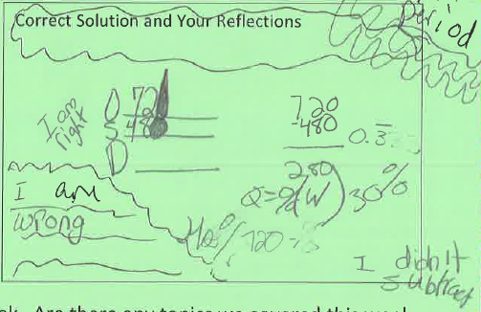

Post-passing math reflection. Student is recognizing her mistakes, her understanding of math is becoming better, she is more confident, and her work is neater.

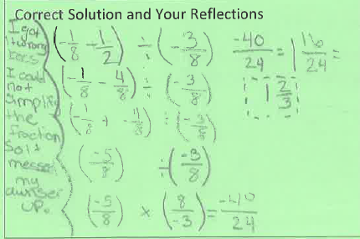

- Mindful Breathing Exercises:
I have lead my class in mindful breathing exercises on a monthly basis. However, I did not do it enough to observe any significant change. I did it on a needs basis, when students’ focus was lacking and I felt that a focusing activity would be beneficial. Most of the students enjoyed the activity. I feel that the class focus improved after students participated in the activity. They all liked it and have asked to do it again when the need for focus is great.

- Mindful reading/writing:
I recently showed my students a movie in math class (after the state tests were completed). It was about a math teacher and the mutual appreciation that grew between the teacher and students. I had my students think about a teacher that has inspired them as we watched the movie. At the conclusion of the movie, my kids wrote letters of appreciation to their former teachers. I sent the letters to the teachers. I told them that they would make a teachers day with their letters and they liked that. Mindful writing is a good way to remember the good teachers that they have had and a good outlet to express those memories. Students can slow down, remember the teacher that they liked, and express their appreciation to that teacher. I liked the activity and they did as well. I am including some letters that they wrote.

Examples/evidence of the benefits of mindful writing are portions of some of the students’ letters that follow:

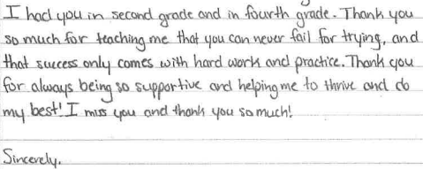

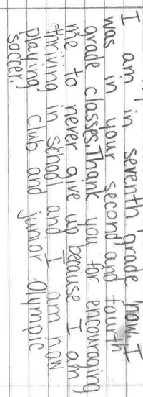

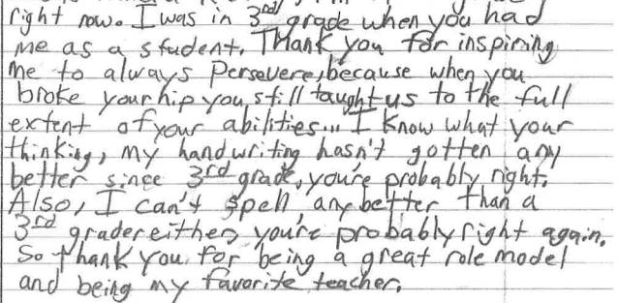

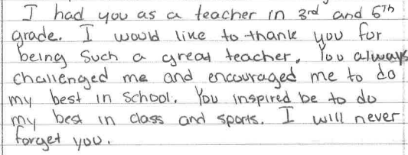

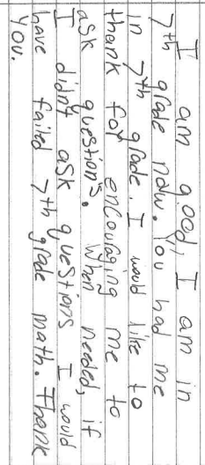

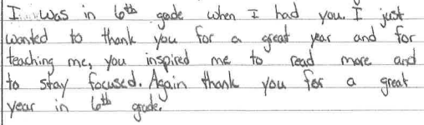

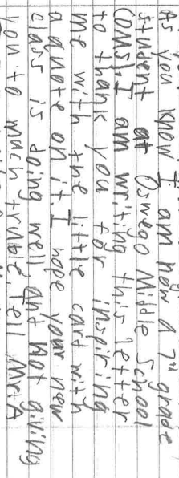

Conclusion:
There are potential benefits of practicing mindfulness activities with adolescents. The benefits far outweigh doing nothing and will improve students’ physical health, psychological well-being, social skills, academic performance, and far outweigh not using any mindful activities at all. I found that mindfulness activities support prosocial behavior and academic success in adolescents (ages 12-13). Student response to the letter writing activity was overwhelmingly positive.

What is available to us educators is the full spectrum of who we are and what we have to give. We need to slow down and become more mindful of our lives, the little details that pass by us every day without notice. What is required is nothing short of appreciating the fleeting, joyful moments of our days. Start paying attention and wake up to things as they are happening around us. All else will follow.

Teacher Participant Names: Mary Alice Brennan and Alison Anderson
Please update us on any changes you made to your team action plan:
Upon reflection, we felt that administering a mindset assessment to teachers offered only extraneous data that did not further the goal of changing student mindset. We, therefore, eliminated step 3 from our action steps. By doing this, we altered all of our steps (16) to eliminate “teacher mindset” from the action steps.

Analysis of Data on Teacher Learning: We examined our reflections and found the following:
Students are significantly impacted by teacher comments on students’ performance. Teacher comments can stifle student growth or create a learning rich environment. When student mistakes were verbally acknowledged as “growth opportunities” instead of negative performances on the part of the student, students who had previously refused to answer questions willingly began taking chances and volunteered to answer questions. For students who suffer from diagnosed anxiety and depression, this is a significant accomplishment. What we have found is that teacher acknowledgement of their own mistakes, having to repeatedly try before accomplishing a task, or struggling with certain concepts, significantly impacted student willingness to use ‘grit,’ focus, and determination to accomplish set goals. Student motivation to put in sustained effort came about, despite encountering some failure, because of a focus on and acknowledgment of mindsets. As teachers, we clearly impact student performance.

Analysis of Data on Student Learning:
As a result of the integration of growthmindset focused lessons, students’ mindsets were positively impacted as evidenced by the post mindset assessment survey. Initially, in January, 13% of surveyed students displayed a growth mindset. However, post assessment data in May indicated that 86% of students had a growth mindset!
Students demonstrated a clear understanding of what a growth mindset is, and clearly articulated messages of their personal growth mindset philosophies in student created posters. Student N.H. identified with a quote from baseball legend Mike Trout: “ You just have to want it more than everyone else .”
On March 24, 2016, students watched a TED talk about mindfulness and reflected on its application to their own lives. They discussed how grades are a reflection of the effort put into an area of study, and not necessarily an accurate representation of their intelligence. Personal examples were shared of times when they encountered difficulty in learning a subject, and they were reminded that the five paragraph essay with a thesis statement that they are learning how to write is really the very first time that they've ever done this type of writing. Even though this writing can be difficult to master initially, it's something that through repeated effort and practice, that they will master. The discussion concluded with a writing reflection piece. Many of the responses were powerful, but one in particular stands out. Student J.B. wrote, “ My mindset is mostly growth mindset but my fixed mindset is on math. I usually have a hard time on figuring out equations on my own but I’m gonna try my best getting better. By studying more and paying more attention, I’M GONNA GET THAT VOICE OUT OF MY HEAD!!!! ”
A readaloud and written response activity also highlighted student growth mindset reflections. The Dot is a picture book written and illustrated by Peter H. Reynolds about a girl named Vashti who thinks she can't draw. One message from the book is that getting started on a goal, and sticking with it, can be challenging, but is ultimately the way to success. After MaryAlice read the story to Alison’s ELA class, discussion about the theme was held and then students were given the opportunity to respond in writing. Student R.P. agreed with the author’s purpose in the story, which was “ to always have confidence in yourself even if you think you can’t, just try .”

A culminating activity demonstrated that intelligence isn’t fixed. Students created edible diagrams to illustrate how their brains transfer information through neural connections. We discussed how learning, and trying new things, helps the brain make new connections (when dendrites and neurons are stimulated to grow and
connect) to transfer information better and faster. They applied this information to their own learning and reflected on how, through effort and persistence, they can become successful learners.
A text was chosen for the class, Touching Spirit Bea r, that portrayed the main character overcoming challenges brought on by a fixed mindset which ultimately ended with personal growth and healthing brought on by a growth mindset. This text allowed students to reflect on the actions of the main character and whether they showed a growth or fixed mindset. Through these discussions, students were able to bring in their own life experiences and how they have been impacted by their mindsets.
As a result of these and other activities, it is clear that students developed a more growthoriented mindset. Pre and post assessment data, as well as student writing, were key indicators of this positive change. Student J.B.’s mindset poster encapsulated this thought with the motto: “If ‘Plan A’ didn’t work, the alphabet has 25 more letters! Stay cool . ”
Teacher(s): Jeffrey Brown
Please update us on any changes you made to your team action plan:

I spent much more time attempting to identify the scope of the problem when it comes to “deep reading.” Instead of exposing it and correcting it, I found that I needed to understand it first, and then find a way to get students to understand and buy in to it. The solution, I’m finding, is far more like a workout routine than a surgery. By that, I mean that you can’t just solve it in one day like a doctor, I think my role will have to be one of personal trainer – one who identifies specific steps that can be taken to encourage deep reading, one who identifies specific reading passages that will help to illuminate the issue for my students, and then one who regularly implements this training to produce gradual improvement. By the end of this year, I have a good deal of data on “the problem,” and know what direction I’ll be heading for the solution, but the issue proved to be far too large to accomplish in a 40 hour course.

I stuck with the 10% Happier meditations, and in fact completed the entire course twice, and then listened to some a third time. I continue to get emails from them as an “original member,” inviting me to buy additional courses on meditation and mindful eating.

Analysis of Data on Teacher Learning: We examined our reflections and found the following:

Deep reading needs to be regularly incorporated into my instruction. I found that when I left the topic for a week or so, and then revisited it, all progress had been lost.

I need to carefully select reading samples for my class weekly. In September, I want text that can be more easily “visualized.” This will actually work out well for me, as I begin with the abolition of slavery, and should have no trouble finding such readings. Emerging deep readers should meet with some success early on so that they know what deep reading feels like when done properly. Then, I can progress into more typical social studies text.

Specific questions and activities need to be developed in order for students to truly see themselves and their reading for what it is. My research showed that many students do not honestly see the problem. It will be up to me to craft lessons that will aid in this.

Analysis of Data on Student Learning: We examined deep reading and found the following:

- Student grades often reflect their level of mindfulness rather than their ability.
- Evidence: Students can recall up to 110% more information while deep reading, than with their “traditional” approach.
- Evidence: Students can increase scores on assignments by up to 11% just by being more mindful in their approach to the assignment.
- Evidence: On a typical social studies reading of 500 words, students’ minds will wander about 17 times, or once every 2 sentences. This could help to explain the challenge of reading comprehension.
- Several students are either unaware of the degree to which their mind wanders while they read, or are in denial about it.
- Evidence: Some of the students who struggle the most with reading comprehension self-reported very few instances of a wandering mind. When done with the reading, however, they demonstrated limited recall. Clearly deep reading was not happening, now the question is do they know this and they wanted to cover it up, or are they unaware of this next level of reading that they can experience where they are able to visualize while they read?

All data is analyzed in attached journal.

Teacher Participant Names: Dan Rose
Please update us on any changes you made to your team action plan:
I have stayed pretty close to my original plan, which was to utilize student-written reflections to inform and guide my classroom reading and writing instruction. Originally, I thought that I would focus on 8th grade reading habits and motivation, but I found quite quickly that my main area of interest once again became writing instruction. I think this was due to the ubiquitous nature of teaching reading – how the entire process is so difficult to monitor and track and keep record of, and how it is so difficult to tell exactly where reading happens and how it happens and when it is happening in the brain. I find the teaching of writing so much more track-able and palpable and, and so much more visible and immediate – when writing growth is occurring it is easy to point out, right there on the page. I can’t do that so easily with reading growth.
I did have an unexpected revelation while conducting my research and following through on this semester’s action plan. I noticed (by way of the reflections) that one of the reasons students said that they were motivated to write was that they had a bigger audience than just the teacher (an audience including all of their fellow classmates on the team – some 100 other readers). We used Google docs this year to share our finished pieces of writing, and we took 2 days to read and comment on writing from our own class -- and writing from other classes. A pretty large audience of attentive readers. Knowing that you writing has the potential to be seen by many different eyes, gives the whole process more accountability and more credibility. Over the course of the school year, students made the comment that when they knew their writing might be read by the entire south team of students, they were motivated to put out a good product.
I knew this about writing, but had not been taking it to heart. I mean, I had been taking it to heart with my students’ writing, but now my own writing. Each year, I write and write and write – on my own, and in my writing workshop here at school – and I have never really tried to extend my audience-- get anything published. With my students’ reflections in mind, I set about trying to find places (websites, on-line magazines, Blogs) that would publish my own writing this semester.
Though a little selfish maybe, I made it part of my action plan (so I guess I did change my action plan a little!). In the end, it is why we write, I think. We have important things to say and we want as many people to hear us as possible. I think I finally realized this upon reading my student writing reflections. I was also secretly hoping for some rejection notices so I could show my students! So, after a couple of days of research, I sent out 5 different pieces of writing to 3 different online magazines in hopes of reaching a wider audience and thus following my own inclination about writing – that developing a larger bank of readers provides motivation to write.
Analysis of Data on Teacher Learning: We examined our reflections and found the following:
One of the most useful pieces of data that I use throughout the year to assess my students learning I call reflection sheets. Reflection sheets consist of 5 or 6 well thought-out questions contained on the front and back of one sheet of paper. I put 6 or 7 blank lines under each question and at the end of each unit of study I hand one out to all and let them have at it. They turn them in a day later and I read through them. All of them. Carefully. The information contained in the answers to my questions helps me shape my teaching for the remainder of the school year (and all subsequent school years).
Over the years, my questions have gotten more precise and more refined. I always ask the same first question after we have handed in a major writing piece: How was this piece of writing similar to other pieces of writing you have done in other grades? How is it different? The second question I ask is always the same: What are you learning about yourself as a writer this year? The third question is always the same: How has your writing improved this year (if at all)? When I ask students questions like these (after taking a few moments to explain the importance of answering the questions fully and honestly) they feel empowered, and they should. They get a say in what goes on in the classroom – how they are being taught – what works or doesn’t work for them. They are always honest – sometimes brutally so, and their answers sometimes surprise me, but always, always, their answers force me to stop and think about what and how I am teaching.
These last couple of years I have noticed some trends in student answers. About writing students say that they no longer have to think up their own writing ideas, that all of their writing ideas are either given to them by a teacher or provided through a question or prompt on a paper or smartboard. The other trend in middle level writing that students make reference to is that they no longer spend much time on one piece of writing – that they are mostly asked to write short, text based pieces with no title or by line, and that most of the writing piece is a gathering of evidence from a non-fiction text. The writing piece is short, takes very little thought and time (done in under 1 period), and is replaced by another, similar piece quite quickly.
This is important data for all teachers. If these trends are accurate, if most secondary writing consists of short, evidence rich texts, built from prompts or teacher questions, our students may be very good at this one way of writing – but may have a lot of trouble sustaining a writing piece (beyond a half a page) or coming up with original idea for a writing piece. Creativity may be a skill that is hard to tap for our students. Students may find it difficult or even pointless to revise a piece of writing (or even edit a piece of writing) and forming an opinion about something (or even a book, story, poem, newscast, science experiment) and may be scratching their heads if you ask them say more about a certain topic.
But, students will probably be very proficient at answering a question in writing with evidence from a short text provided by a teacher. They will be very good at going back into a piece of reading and defending a claim. They will know how to use in text citations.
So what’s next for teaching middle level writing (and reading)? Do we continue to funnel students into this very specific on demand, evidence based argumentative writing style or do we expose them to other forms of writing like fiction, poetry web design?
One question worth asking any writing teacher is: “What kinds of writing are most beneficial in the development of the 20th century, college bound student? Which genres of writing build the kind of literacy skills a student will need after high school and ultimately, after college?
I argue that one of these types of writing is reflective writing -- that is, writing that forces the student to consider and think about the learning process and progression, gives them a chance to identify areas of confusion and success, to advocate for certain methods of teaching, to call out for help if needed, to critique the classroom learning environment (and instructor), and to offer up suggestions for future learning.
Analysis of Data on Student Learning: We examined student reflections and found the following:
I (we) have uncovered many writing “truths” this year based on the data I have collected from the 400+ writing reflections I have received from my literacy students. The information I have received from my students over the years has been an invaluable teaching tool, and one that has helped me deliver more efficient, more precise, more genuinely engaging and meaningful writing instruction each year of my teaching career. I am trying, ultimately, to provide comments and information here based solely on this year and this data, however, my answers will most likely be infused with years of data collection and student responses that have helped informed my current mindset. From student writing reflections this year, my beliefs about writing and learning to write have been both reinforced and bolstered. In the space below, I have tried to articulate 3 “truths” that have surfaced from all of the data I have collected this year.
1.Writing in varied genres with deep thought, original ideas, and careful, deliberate revision is no longer the norm. Process writing starting with topic choice seems to have taken a back seat to on-demand and other quick, direct, evidence-based writing tied to a prompt associated with an article, story, or poem chosen in advance by the teacher. By asking students how a piece is similar or different to anything they have written in the past, I get a window into what kinds of writing students remember doing (and are used to doing), and if they are at all used to the kind of deliberate, process writing we do in class. Responses over the last 5 years have been eerily similar and all comment on the fact that the writing they do in writing workshop is very different than the writing they have done in other years because in workshop they go much deeper and spend more time to make the words the best they can be and don’t just write one draft and stop. Many of the comments to this question talk about the length of time spent “writing” and how they are not used to spending so much time on one writing piece. Students say that when they have the time to write and think and look over and revise and talk and read and utilize mentor texts, then they feel more confident with the final product. They can see improvement - they feel more confident with their writing. Like Scotty said - “I have become less nervous about writing.”
2. Ideas are everything! Students often comment that the idea generating lessons we do in class are some of the most helpful lessons during the course of a writing unit. Students comment that once they have an idea developed for which they are passionate, the writing becomes more enjoyable and even fun! Because so many students have made this comment about ideas over the years, I have come to spend a lot more time on the idea generation portion of the unit. When the writers speak, I listen, and if they tell me it is easier to write when they have a great idea -- then I want to make sure that they have a great idea before I move on to the next step.
3. Students recognize that their writing can be a powerful tool for reflection, moving an audience, advocating for change, and helping sort through complex ideas and feelings when given a chance to develop a writing piece over time. We cannot lose sight of this fundamental idea -- that writing can change minds, that writing can open lines of communication (where once there were none), that writing can call people to action, that writing can make a person want to live a better life. Students’ reflective comments toward the end of the school year indicate these ideas that writing is (or has become) a powerful tool for them, somewhere they can turn if they are worried, or angry, or feeling unaccepted, somewhere they can go to express joy or sorrow or confusion or hope. Careful, thoughtful, deliberate writing with careful, thoughtful, deliberate revision can, ultimately change a student’s world -- and the world around them.
By studying the student reflections, especially the final reflections of the year, I have been able to track the changing mindsets of student writers after a year of writing workshop. By the end of the school year, students say that they feel more confident with their writing, that they can better express themselves through the medium of writing, and that they understand that they can produce influential writing -- writing that can change minds or call a reader to action. Below, I have listed actual 8th grade quotations (evidence) from student reflections this year (2016) that help show just how effective writing workshop can become.
“I have discovered that I think a lot, and have a lot of feelings.” - Grayson
“My writing has many layers of deeper meaning through it (that) I never thought my brain could do.” - Nicole
“My writing now goes in-depth.” - Colin
“This kind of writing helped me grow as a writer by guiding me to access more sensitive and risky subject matter.” - Kayla
“I can now write more deeply about a topic.” - Sophia
“This is the first essay in which I was able to choose my own topic. In earlier years, I’ve always been told what to write.” - Dan
“My confidence in writing has improved vastly, my ability to form a meaningful piece of writing has gone far and beyond what I ever expected, and my ability to write deliberately has improved.” - Scotty
“I have learned that I like to make an impact on the reader. I like to leave the reader with a feeling of “Whoa!” - Abby
“I learned to use words wisely. I have become more conscious of the words that I use.” - Victoria
‘I have realized that for a story or a poem or a writing to sound good, you have to take a risk while writing.” - Hunter
“Before this year, I would not write about stuff that was deep and close to me. I always wrote really corny stories / poems. But during this year, I opened up my feelings and wrote deeper.” - Katie
“I learned that I should take more risks with my writing.” - Hailey
“I’ve never gone this deep into a topic before.” - Katie
“I don’t get as nervous about writing as I have in the past.” -Kirstin
“I have become less afraid to try new things.” - Dan
“I’m taking more thought into the words I write and what I’m choosing to write about.” - Sophia
“Now, I write with more of a purpose, by using carefully crafted sentences to make the writing piece sound more mature.” - Victoria
“This year has made me a more confident writer, because I am sure that what I’m writing is what I actually think.” - Dan
“I now want my writing to have an almost activist effect, causing the reader to want to take action in what they’re reading about - whether it be a certain cause or just inspiration.” -Abby
“I am taking more time because I want the final piece to be something that I am proud of.” - Alyssa
“I am taking my time more on my writing to make the reader feel something.” - Taylor
“My writing went from bland with no detail or deeper meaning into meaningful writing that comes from a special place in my heart.” - Kayla
This is the kind of reflective thinking that I read through each quarter-- the kind of reflective thinking that guides my instruction and helps me become a better writing teacher.

Teacher Participant Names: Danielle Clemens & Lilly DeCaire
Please update us on any changes you made to your team action plan:
Danielle’s original plan- My plan for this project is to monitor and reflect on the instances of both deep reading and off-task behaviors while reading a variety of academic literature and pleasure reading in hopes of becoming a more focused, attentive, and mindful reader.
Danielle’s changes- Once I started completing more written reflections, it became apparent that it would be difficult to document the instances of on and off task behaviors while reading both professional/pleasure texts. I was not always able to dedicate the same amount of time when reading in order for the quantitative data to make sense. Some days I was able to devote 45 -50 minutes to reading while other days I could only spend 25-30 minutes with it. By the end of March, I started to realize that the data was taking on a more qualitative nature. In my journal reflections, I talk about the types of things I was seeing/feeling/doing that contributed to off and on-task behaviors while reading. I (along with Lilly) also found that mindful music began to take on a large role in my research. Other than that, I really did stick to my original plan.
Lilly’s original plan-My plan for the project was to monitor and reflect upon the instances of both off task behavior and deep reading while reading a variety of academic literature as well as pleasure reading. My plan involved incorporating mindfulness and mindful practices and demonstrate how they contributed to my becoming a more focused reader.
Much like Danielle, it was difficult for me to document instances of on and off task behaviors while reading. It was ironic as I found that it became more of a distraction for me!! My journaling also turned from more of a note taking method to one filled with questions and expressions of feeling. I found that I WAS deeply reading as I was relating to the texts in my journal. Incorporating mindful breathing along with music (specific mindful practices) within my reading schedule was very beneficial. I didn’t find myself deviating too far from the original plan.
Analysis of Data on Teacher Learning: We examined our reflections and found the following:
Danielle’s findings:
How many off-task behaviors/distractions did I experience while reading? As previously stated, I was unable to collect quantitative data with respect to my instances of on and off-task behaviors while reading. There were times that I would read for 25-30 minutes and have 5-6 off-task behaviors and other days I would read for 45-50 minutes and also have 6 off-task behaviors. This is when I started to grow concerned that the data would be inconsistent. So, in place of this, I started to make note of the things that I was seeing/feeling/doing when experiencing instances of deep-reading and off-task behaviors.
Did it differ between the types of materials that I was reading? I quickly noticed (at the beginning of the year) that it didn’t matter about the type of text that I was reading, rather, the type of day I was having and how “quiet” or “busy” my brain was when trying to read.
Did the length of the article/book have an impact on my focus? In reading my journal reflections, I do not believe the length of the article or chapter of a book made a difference in my focus.
What were some of the strategies that helped me to maintain/regain focus?
I began this project thinking that I would need to have a completely quiet location, free of distractions, in order to be able to have an attentive and focused deep-reading session. I also thought that, at times, it was beneficial for me to read aloud in order to stay on task. So, when I returned from my maternity leave, I dove in and started to “try” some deep-reading with the articles for class. I would pick a quiet location or wait until my kids had fallen asleep to try to read and reflect. And if while reading, I went off-task, I would recognize that, and would bring my focus back to the text (as was the case with the mindful breathing practices that we learned last year). As the spring continued (especially after reading the article “How Mindful Focused Reading Can Double Your Efficiency” on 3/30), I realized that it was more beneficial to start with some mindful activities in order to “quiet” my brain in anticipation for reading. Some days I would begin with a deep-breathing exercise in order to prepare. At the end of March (and after discussions with Lilly), I started to play mindful music (instrumental only)when reading. This really seemed to help my focus and quiet my brain. It was also at this point that I started incorporating more music into the classroom hoping that it would help my students as it had me. In retrospect, I think having a completely quiet location made it easier for background noises (like the dog barking at home, the heater turning on, baby crying, etc.) to distract me. The music helped to drown out those distractors and ultimately increase my attention and focus to the text.

When did I know that deep-reading was truly taking place? While reviewing my journal entries, I realized that the instances of deep-reading certainly
increased over the course of the research period (whether reading professional texts or pleasure texts). I found that deep-reading was taking place in the following ways: for professional texts, I was making the connections between the strategies/tactics in the text and how to incorporate them into my own classroom (Journal Reflection on article “Emotional Learning & Common Core”-4/15-students must trust their ability to solve a problem,”confianza”). I also reflected on things that took place while being a student in an Honors English class with Mr. Shaw in 10th grade (journal entry 4/12). When I was reading pleasure texts, I found that deep-reading was taking place when I was able to visualize what the characters looked like and where the setting of the story took place (The Longest Ride by N. Sparks). These instances of deep-reading started to become the norm once I began implementing the mindfulness strategies both before and during reading sessions.
Ultimately, did I see an increase in focused, attentive, and mindful reading over the course of the research? Absolutely!!! I started to enjoy reading and realized that I was not having issues with needing to re-read pages at a time in a text. I truly think that the article on 3/30 helped me to see the importance of starting a reading session, whether professional article, journal, or pleasure book, with mindfulness exercises that calm the brain and bring my focus to the text.
Did I stick to my original plan? More or less, yes! My goal was to learn to become a more focused, attentive, and mindful reader and I believe that I achieved that goal. I was surprised to see how music began to play a big role in this project (and has implications for my students).
Research for the future? Mindful writing/penmanship??? Often times, while writing my reflections, I noticed that I would make careless errors or write sloppy. I always took pride in having nice writing in high school and recognized that this has not been the case in the past few years. Just recently, my husband commented that I do not have nice handwriting. So, this got me thinking about mindful writing or mindful “penmanship”, if you will. One of my online research days was devoted to finding articles about mindful writing. I quickly realized that all this comes down to is mindfulness in general-taking time to be in the moment, to slow down, to take a breath--to not rush. Mindful reading, mindful writing, mindful literacy!
Lilly’s findings:
How many off-task behaviors/distractions did I experience while reading? It was challenging for me to gather data on my off task behaviors and distractions. I found at times that I was off task because I was trying to remind myself to chart my off task behaviors!
My distractions varied upon my environment, time of day and by what I was reading. I did eventually give up on the EDI text as I did not enjoy reading it, but did find the content to be useful in the classroom.
One factor that I did find, which helped me better stay focused and on task, was doing my mindful breathing BEFORE I began to read. It also made me feel better.
Did it differ between the types of materials that I was reading? I thought at first it would, however, as I began reading a “choice” book, I noticed that when my mind was preoccupied I had great difficulty staying focused and on task.
Did the length of the article/book have an impact on my focus? The length of any text has never been an issue for me and still was not.
What were some of the strategies that helped me to maintain/regain focus?
The biggest factor for me was doing my mindful breathing. It really made a big impact for the better. After analyzing my notes, as long as I did my breathing the time of the day had no impact. I would take 3 quick breaths and exhale slowly. It really helped me get back to center and I felt much more energized. I also took notes and highlighted text while I was reading. This is something that I have always done as student and I was able to find that the instances off task were far less frequent (for both academic and pleasure reading texts. Danielle and I both found the article , “How Mindful Focused Reading Can Double Your Efficiency, very helpful and encouraged us to quiet our brains before reading. I have found myself utilizing this strategy for more than just reading too!
Ultimately, did I see an increase in focused, attentive, and mindful reading over the course of the research? Yes, I did. I did have some challenges and there was about a month during the research where I STRUGGLED to read. I was in the middle of Explicit Direct Instruction and was not enjoying it. In addition, my personal life was incredibly busy and my child was sick. I was not breathing or listening to music. That’s where I took a step back and began doing things a bit differently. I noted instances of breathing before reading and I made sure to do it each time as I felt a sense of rejuvenation and my mind was less “busy”. Listening to music too, instrumentals, began to play an important calming role before and during reading. Without realizing it, I have been doing this for my students for a while. I have been playing music for my students during activities for the past few years and only until recently have I realized the benefits of it. My students have grown accustomed and are much appreciative of the music I play for them and have expressed to me its calming effects on them.
Did I stick to my original plan? To a degree, yes. I would have liked to accomplish even MORE reading than I did. One can never read enough. I enjoyed closely looking at myself as a learner and as a reader and believe I have found strategies to help me better remain on task and be better able to “read deeply”.
Analysis of Data on Student Learning: We examined _______________ and found the following:
Lilly and I were both surprised to see how music started to take on a larger role in our research on how to increase focused, attentive,and mindful reading. Once we saw how it increased our attention and focus, we decided to start using it more and more during our classes. We surveyed our students regarding the use of music while completing tasks (studying, homework, classwork, etc) in school.
We administered a 4 question survey to each of our classes which included the following questions:
- Do you like to listen to music while studying?
- Do your teachers play music for you during class? Which classes? How does music affect you?
- What is/ are you favorite genre(s) of music?
- Do you currently feel stressed?

Results:
Danielle

Question | Period A | Period B | Period C | Period D
# Listen Music | 94% | 79% | 78% | 83%
#2 Teacher Play | 19% | 29% | 56% | 58%
#4 Stressed | 64% | 64% | 33% | 17%

Periods A and B are Spanish 1 (advanced placement) language classes that take place before lunch. Periods C and D are Spanish 8 classes that take place after the lunch period. Notice the difference in stress levels-the advanced placement students (who had to qualify for this class) had more instances of feeling stressed than the Spanish 8 students. When asked why they were stressed, they responded with a variety of comments such as the following: “everything”, “everyday”, “finals”, “too much HW”, “the last two weeks have been brutal” (due to state testing). The Spanish 8 students were not as stressed as the advanced placement students. Their reasons ranged from “drama in school” to “tests”/”finals”. Only one student from the whole survey commented with “I’m pretty relaxed and happy”-this makes me sad to think that only one student could describe him/herself in this manner. Perhaps some mindful strategies, like breathing and playing music, implemented in the classroom would change that outcome? I believe so.
The data from the surveys on including music while studying was overwhelmingly positive. 84% of students responded that playing music while studying is their preference. When asked why they preferred listening to music, the two comments that kept coming up in the data were “relaxed” and “helps me to focus”. Many of these student said that listening to music in class helps them to ignore the distractions from their peers and other outside noise. Only a handful of students surveyed stated that listening to music while studying is distracting. In the past, I have allowed students to state their request for a specific genre; other times I chose mindful/instrumental music for them to listen to. I believe (in reflecting on my own experiences) that the instrumental music would best be played during assessments to allow the opportunity for deep-reading to take place without distractions from the lyrics. On the other hand, when students are put to task on an independent or unstructured activity (like studying or a small group assignment), listening to music with lyrics would not be as distracting. When asked if teachers at OMS play music during classes, 50%-60% of students in each class responded with “sometimes”. From the comments they had made, it was obvious that a majority of students believe it is beneficial to them and would like to see implementation of any music in classes more often.

Results:
Lilly

Question | Period A | Period B | Period C | Period D
#1 Listen Music | 79% | 75% | 80% | 100%
#2 Teacher Play | 64% | 58% | 90% | 91%
#4 Stressed | 64% | 67% | 20% | 55%

The data acquired was interesting. Out of the 4 classes surveyed, Periods A and B are both during the first part of the day and both were advanced classes. Periods C and D are both in the afternoon and are my non advanced courses. It was interesting to see that in both periods A and B,over ⅔ of the students feel stressed. The comments they listed were quite interesting…”I always feel stressed”, “I feel stressed on days that only end in “y” “ (that was my personal favorite).
Period D is the last class of the day, and 55% are stressed. I administered this survey on a Friday which leads me to believe that perhaps many of the students were not looking forward to going home for the entire weekend. Some of the students stated that “home” is the reason they feel stressed too.
Overall, I ascertained a lot of information from this brief survey. Over 75% of my students in 4 classes utilize music to facilitate studying. There were a few who did state in their responses that they did not like it and found it distracting, however, that was less than 25%. I learned that I do have colleagues who do play music and whether or not they realize it, the students do prefer it. There have been several occasions when working independently, students have asked for me to play music as they miss a working environment with the soothing music. It also has been a great opportunity to introduce different genres as well as music which is culturally relevant to our content area.

Teacher Participant Names: Sally Kingsbury
Please update us on any changes you made to your team action plan:
My action plan stated that I would analyze the 20 Week Exam and compare it to the 5, 10, and 15 Week Exams. I decided to only compare the 20 Week Exam to the 10 and 15 Week Exams. The content and difficulty level on the 5 Week Exam is too low compared to the others.

Analysis of Data on Teacher Learning: We examined our reflections and found the following: (Support each claim with examples/evidence)

Claim #1: Median and Upper Quartile test scores were higher on the 20 Week Exam where students had to show all work before being given the multiple choice options.

10 Week
15 Week
20 Week

0 10 20 30 40 50 60 70 80 90 100

 | 20 Week | 15 Week | 10 Week
Mean | 61.7352 | 61.9117 | 58
Standard Deviation | 19.98 | 13.77 | 21.08
Minimum | 14 | 45 | 8
Lower Quartile | 46 | 45 | 48
Median | 67.5 | 64 | 55
Upper Quartile | 80 | 73 | 78
Maximum | 89 | 90 | 93
Range | 75 | 45 | 85

Claim #2: Differences in individual student test scores were not statistically significant. I ran a matched pairs T-Test by looking at the 20 Week vs the 15 Week and then the 20 Week vs the 10 Week. The average difference in scores is shown below as well as the statistical analysis for each.

Matched Pairs Hypothesis Test for differences in 20 Week versus 15 Week:
H_{o}: d = 0
T-Interval
$$α= .95$$
(-4.903, 4.5498)

H_{A}: d $≠$ 0
t = -.07596
p = .9399
$\overline{x}$ = -.17647
S_{x} = 13.545
Matched Pairs Hypothesis Test for Differences in 20 Week versus 10 Week:
H_{o}: d = 0
T-Interval
$$α= .95$$
(-1.764, 9.2349)

H_{A}: d $≠$ 0
t = 1.3818
p = .1763
$\overline{x}$ = 3.735
S_{x} = 15.762
Unfortunately, the hypothesis test and T-Intervals I calculated do not show a statistically significant difference in the scores. My p-values are high which means I fail to reject my hypothesis that the difference in scores = 0. The Matched Pairs T- Test between the 20 Week and the 10 Week shows a positive average difference of 3.735 but it is not enough of a difference to be statistically significant.

In the future, I would like to research more about types of questions and break the analysis down into sub groups of students to see if there is a difference among gender, socioeconomic status, or ability.

Analysis of Data on Student Learning: I examined the student responses to the reflection questions answered after they finished the test and found the following:

Claim #1: Students were mindful when going back to see if their answers were included in the multiple choice. The majority of students went through the exam more carefully the second time to see if their answers were included in the multiple choice options. Examples: “it gives me a chance to fix my mistakes”; “it helped me figure out the mistakes I made yesterday”

Claim #2: The majority of students used the opportunity to re-work questions that did not match the multiple choice options. 33 out of 35 students responded that they liked having the multiple choice options so they could go back to re-work questions as needed. Example: “I had to re-work 9 problems but now I feel more better about them”; “I had to re-work about 3 or 4 problems to find an answer that was in the multiple choice”.

Teacher Participant Names: Wendy Allen and Sandra Brown

Please update us on any changes you made to your team action plan:

- The original Project Smart Action Plan included the books Our Town, Inside Out and Back Again, Friedrich, and The Outsiders. Although we have completed Our Town and Inside Out and Back Again, we have not yet finished Friedrich and haven’t started The Outsiders. (Wendy and Sandee)
- We were able to complete some journal reflections, one mindful inventory, and gratitude journals entries twice weekly. Students were able to complete one self-reflective essay based student choice of theme from Our Town, but the planned self-reflective essay based on the novel Friedrich has not yet been assigned, as well as The Outsider journal reflections. (Wendy and Sandee)

Analysis of Data on Teacher Learning: We examined our reflections and found the following:

- As we moved through the novels Our Town, Inside Out and Back Again, and Friedrich, we felt that students were more engaged in the novel and more attached to the characters. Classroom discussions revolved around:
  - “Why do you think the character did that?”
  - “What do you think the character was feeling?”
  - “What could the character have done differently?”
  - “What you would have done in the situation and why?”
- This type of questioning encouraged students to create connections with the characters. Creating these connections to the characters built energy in the classroom. Students were able to develop compassion and empathy for the characters. We enjoyed seeing the students want to read further and develop their own opinions.
- Students were able to step out of themselves and view the stories of the novels’ characters from a different point of view, developing a sense of agency. Even the students with special needs were able to be involved in the discussions. The way we phrased our questions reflected points brought up in the article, “An Evolutionary, Democratic Learning Community.” We encouraged students to imagine themselves in the shoes of the characters and to see, appreciate, and value the differing perspectives, opinions, and actions of others. We learn from others. We can learn from the perspectives and experiences of others (both peers, adults, and the characters from our novels).
- A mindful approach to reading and using gratitude journals was an excellent combination. Students who first complained about writing in their gratitude journals spent the entire time allotted the writing in their journals filling the pages. Enthusiasm to write in their journals inside and out of the classroom grew.
Analysis of Data on Student Learning: We examined _______________ and found the following:

Gratitude journals were helping students calm their minds and get ready for class. We examined Gratitude Journal Reflections and found the following:
- “Writing in my gratitude journal makes me feel lighter on me, letting everything go.”
- “Writing in my gratitude journal makes me realize that there are more things to be grateful for.”
- “Writing in my gratitude journal makes me see all the positive stuff that happens in my life.”
- “Writing in my gratitude journal makes me feel better about myself. It makes me open up how I think.”
- “Writing in my gratitude journal makes me feel good inside, calm and soothing.”
- “Writing in my gratitude journal makes me feel thankful for everything I have and everything that makes me happy.”
- “Writing in my gratitude journal makes me feel I don’t know, I don’t hate it, but I don’t not hate it. It makes me think hard about what I’m grateful for.”
- “Writing in my gratitude journal makes me feel happy, because it allows me to see that I do have positive things going on in my life and that there not all negative.”
- “Writing in my gratitude journal makes me feel happy because if there is stress that I am dealing with I can talk about it to myself.”

Gratitude journals were helping students look beyond themselves. We examined Gratitude Journal Entries and found the following:
- Our “street wise” student started journalling with entries like “I grateful we get to go home at the end of the day of school because I don’t like none of you.” A later entry the student stated “I grateful I’m not dead, but now I pretty mad I’m at school and I don’t really wanna be in this class. I grateful I go tto see the Deadpool movie. I glad I got to spend time with my family.” He started accepting the purpose of the gratitude journals when he wrote “My mom just had the new baby. I got to spend time with my family on Easter. The weather was nice.” He gradually moved from negative entries to positive entries.

- Our “student with special needs” had difficulty understanding the concept of journal in the beginning of the process, but picked up speed and was able to look beyond basic ideas. His first entry was “I’m grateful for my family, food, and clothes.” Later entries were more developed. “I am grateful for having people who care about me, having people who understand me and help me out. I am grateful for people who can calm me down and make me laugh.”

- Our “reluctant student” dated the first entry date and crossed that date off putting the second entry date. The date was crossed off several times before anything was entered into her journal. She eventually resolved to write one day with the entry “I am thankful for.” Her momentum eventually built to filling a page each occasion time was given for gratitude journals.

Students were also asked to put themselves in the roles of the characters, writing gratitude journal entries for the characters. For Inside Out and Back Again, we asked them to respond to: What would Ha be grateful for? What should Ha be grateful for? The character, Ha, is a young and somewhat self-centered and selfish character. It was interesting to see them step inside Ha’s character and share what they knew she would be grateful for and add another perspective, as an outsider looking into to Ha’s life, and share what the character should be grateful for. Looking back, it would have been interesting to have the students apply that same strategy to their own lives: what they are grateful for vs. what other people would say you should be grateful for.

Students were able to become more self-aware by reflecting on themes found in novels. We examined self-reflective essays and found the following:
Students were asked to identify some themes found within the novel Our Town. They were then asked to apply those themes to their own lives.
- It was wonderful to see what personal insight they walked away from the novel with. One “special needs” student wrote:
  - “After reading the book Our Town, I realized that I shouldn’t waste my life away. You need to love life while you live it not waste it on dumb stuff. The way I view this is that you do not know when you will die. It could be in years or in minutes, so you should love the little things in life and just be happy. One other reason why I feel this is because if you waste your life away, you could never get the moments back with your love ones. I'm going to live my life and not waste it.”

- Another “typical” student identified “Living Life to the Fullest” as a theme. Not only did he include goal setting as one thing he hoped to do in order for his life to reach his full potential, but he developed a plan to make this happen. He also provided specific on how the novel change some of his actions at home. He shared:
  - “This theme helped me become thoughtful of more things around me and to help my family more by cleaning the house and taking the dog for more walks and doing all that instead of being on the video games all day.”

- Some students identified themes found within the novel, other students wrote letters to their future selves reminding themselves of the mindful life lessons explored within the novel and how they hoped to apply it to their future lives. This is a small section of what one girl wrote:

  - “Dear Future Self,

It is important to appreciate the value of your life while you have a life to value,
because you could lose your life at any moment. Ask yourself “Am I happy with where I am in life?” And if the answer to that question is no, change what you need to change to make you happy because your have one terribly short human life, and you should make the most out of it.
Take opportunities in your life! do not pull a typical M----- move and say “I’ll do it later” because there might not be a later. So go right now and buy those tickets to London, or Japan, and have fun! because you do not have time for procrastinating.”

Students were able to find compassion and empathy for others. We examined class discussions about characters in the novels we are reading and found the following: Before reading Friedrich, we completed a pre-reading activity that asked their current opinions and feelings about the following topics:
- Do you find yourself believing what some people say about others, even though it may not be true? Explain.
- Would you follow your conscience and do “The right thing” or are you a person that gets caught up in the moment and following the crowd? Explain.
- Would you ever hide and befriend someone you knew was truly a good person, even if it put your family in danger? Explain.
- Do you consider yourself to be free from prejudice against other people or do you discriminate and judge people by their appearance, religion, social standing, etc.?
- State whether you agree or disagree and explain why.
  - We should follow leaders without fully knowing what they stand for.
  - Making the right moral decision is always an easy thing to do.
- Choose your answer and explain:
If you see something bad happen to someone else, the best thing to do is:
- Walk away; it’s none of your business.
- Get involved and try to help the “victim.”
- Join the crowd.

While we read, we discuss these things as they unfold in the story. Students are asked to reflect on what they previously wrote and gage whether their answers have changed.
At the end of the novel we do this again, and we debate the issues and the difficult decisions the characters face and how they would handle the same situations. Students are expected to be mindful and respectful of others opinions, as there is no right or wrong answer.

Teacher Participant Names: Catherine Celeste
Please update us on any changes you made to your team action plan:

I planned on doing metacognition activities 3 times a week during my genetics unit for my 7th period class. However, I was only able to do activities 2 times a week as I had two different student teachers and it just didn’t work out logistically otherwise. I also planned on having kids do mindful activities the first week but the activities I picked were so foreign to the kids that they were ineffective initially. I realized I needed more time to get them to buy into the concept that being mindful will help them be more successful in my classroom. I did spend time before each mindful activity reviewing the purpose. I also spent time bringing attention to the students whenever we had a good class period that started with a mindful activity. Because I needed more time working on buy-in, I ended up doing mindful activities with the students from January until mid-April, much longer than I planned on.

Additionally, I planned on assessing grades in Life Science as a measure of effectiveness, during the Genetics Unit. This is not how I measured success for a number of reasons. My first student teacher did his teaching unit on some of Genetics so having 2 different teacher’s would have skewed the results. I also realized that much of a student’s grade comes from homework and I wasn’t testing their mindfulness at home but in the classroom. I realized that I needed to gauge student achievement by their success in completing class work on days they practiced mindful activities against days they didn’t practice them.

Analysis of Data on Teacher Learning: We examined our reflections and found the following: (

I kept a journal of each mindful activity I did. Some activities came from materials from our course but most came from internet resources. Some of the examples of mindful activities included using singing bowls, chimes, candles, pebbles, breathing exercises, and listening. I printed out each activity I did and kept a reflective journal of how each activity went. I ended up with 14 different activities, and ended up repeating the best ones. In reviewing my journal, I came up with 4 conclusions that I shared with my classmates.

- Mindful activities do improve if there is teacher mindfulness and buy-in. On days when I was just going through the motions doing a mindful activity with the students, and then getting back into stressful teaching mode, pushing the kids to complete the task at hand with little tolerance for deviation, the mindful activity was ineffective. After rereading my journal, I found that only when I practiced mindfulness the whole period, did the students succeed. I had to practice what I preached. Teacher buy-in is significant. As evidence to this effect, I wrote in my journal on March 3rd, “It took a good 3 – 4 minutes to get kids to settle down enough for me to do the mindful activity. They I felt rushed as my new student teacher had a lesson planned that was already going to be time consuming. ….Kids were bonkers in class. I’m wondering if my tone of voice mattered as I’m guessing I sounded annoyed with them.” On January 28th I wrote, “Today, I told the students I was going to burn a candle for 1 minute and the only thing I wanted them to think about during that time was what they learned during the lab we worked on yesterday in class…..I do believe they were in the right mindset because they were the only class to finish the lab today. Perhaps my focus and calm helped.”

- Students will buy-in and be more mindful in class if they understand the value of the mindful activity. On January 15th I wrote, “I played the Tibetan Singing Bowl today…..This study is far from scientific as there were more than 1 variable (mindful activity plus I am specifically telling them what I hope to accomplish – called the halo effect). Either way, it had a positive effect so I’m sticking with it.” Please see 2 attachments (1 is the heartfeltness activity and the other is from my 3/17 journal entry). My students did a mindful activity and they really got a lot out of it. We all need to remember self-love when trying to be mindful.
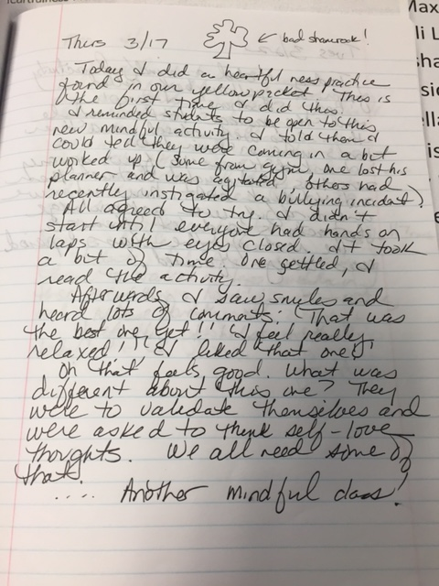
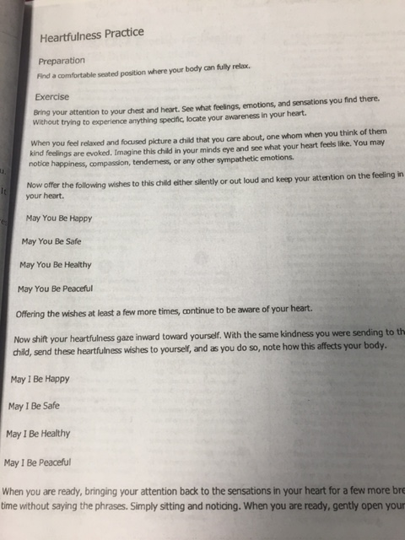
- Students will value mindful activities and practice mindful techniques throughout the period if they are reminded of the effect the mindful activity from the beginning of the class has on their productivity. Out of the 23 different mindful activities I did this semester, students completed the task at hand and were noticeably more mindful and focused on 16 of those. I always made sure to tell them when they were very focused. They seemed genuinely pleased when I would tell them how much better they did than the other 2 classes.

- An added and unexpected benefit of mindful practices was the relationship building that occurred. This was a class that I really connected to at the beginning of the year but as the first semester went on and the grades in that class went down, our relationship soured. I couldn’t get through to them. This is why I picked this class to do the mindful lessons with. I was surprised how much I began to really enjoy the class again. Being able to praise them for their mindfulness was good for them to hear and good for our relationship.

- For further research, I concluded that taking 2 – 3 minutes at the beginning of a class does indeed make the students more mindful but my suggestion is to do it every day, not just 2 – 3 times a week. The time it takes to do is gained back tenfold in students accomplishing tasks expected of them. Next year, I plan on doing this in all of my classes much more regularly.

Analysis of Data on Student Learning: We examined _______________ and found the following:

I had the students do the Freiburg Mindfulness inventory at the start of my experiment to see how mindful they were. Their results showed them to be between 54 and 84% mindful. I explained that I was only 74% mindful and that our goal throughout this process is to continue to improve our attention to mindfulness. Since I did not measure student achievement via grades before and after the experiment (as stated above, because there were too many variables with 2 different student teachers), I simply used my journal to gauge student mindfulness. If they completed the daily task, I found them to be mindful, especially when classes before them were unable to do so. As stated above, they were more mindful 16/23 times. This tells me my students were mindful 70% of the time for the remainder of the period when they did mindful activities. This is really good!

