GLS 100/POL 300
Havana: a global city
Spring 2012, Quarter 3
(with travel over spring break)

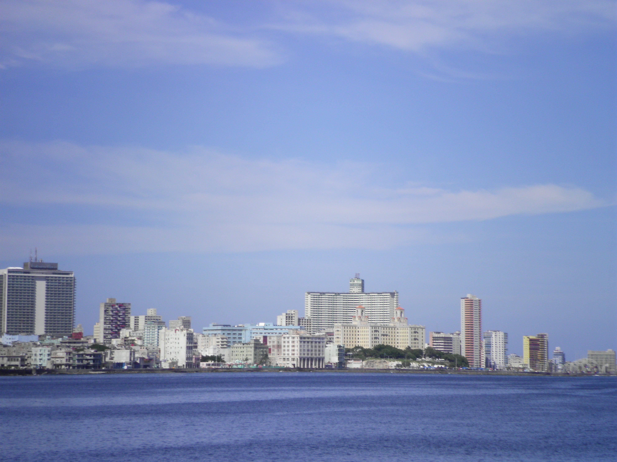

Professor Lisa Glidden
lisa.glidden@oswego.edu
439 Mahar
Office hours: TTh 11 – 12, and by appointment
Course meets MW 1:50 – 2:45 in Mahar 111

Havana, the capital of Cuba, is the largest city in the Caribbean, and reflects its centuries’ – old heritage. Today in Havana one can have a history lesson in architecture, from baroque Spanish, to U.S. neo-Gothic and modern architecture, and Soviet functionalist architecture. The streets are full of Hyundais, Toyotas, Ladas, and still a few ’57 Chevys and Pontiacs.
Control of Havana and Cuba has been fought over for centuries. Initially a Spanish colony that faced attacks from and eventually briefly ruled by the British, Cuba’s fight for meaningful independence spanned almost one hundred years (1868 – 1959).

This course provides an examination and analysis of Havana and its role in global politics. We begin with a brief review of Cuba’s fight for independence, transference from Spain to the United States, and the Cuban Revolution. We will look at how other countries have influenced Havana, and also Havana’s influence on other countries. The main focus of the course will be on Havana since the fall of Soviet Union, with an emphasis on policy and social innovations—the hip-hop movement, civil society, organic farms in the city, and the increasing privatization of the economy.
Students have the option of registering for either GLS 100 or POL 300, but should be aware that POL 300 requires a research paper.
Required Readings:
Sweig, Julia E. (2009) Cuba: What Everyone Needs to Know Oxford University Press
“How to Travel in a Socialist Country” – on Angel reserves

Recommended book:
Miller, Tom (2008) Trading with the Enemy: A Yankee Travels Through Castro’s Cuba Basic Books

Grading GLS 100 POL 300

Map quizzes 30% 30%
Current events quiz 20% 20%
Travel journal 50% 20%
Research paper 30%

Course Outline
Mon, 1/23 | Introduction to the course  Havana map distributed with notations
Wed, 1/25 | Sovereignty  Cuba before 1959  - Read pages 1 – 35
Mon, 1/30 | The Cuban Revolution  - 36 – 56
Wed, 2/1 | Map Quiz #1  The Cuban Revolution  - 56 – 73
Mon, 2/6 | U.S. – Cuba Relations  - 74 – 103
Wed, 2/8 | Cuba and the U.S. During the Cold War  - 104 – 125
Mon, 2/13 | The fall of the Soviet Union and the Special Period  - 126 – 160
Wed, 2/15 | No class  - read about US Cuba policy in the 1990s 161 – 190
Mon, 2/20 | No class  - read about Cuba’s foreign policy since the fall of the SU  - 191 – 205
Wed, 2/22 | Political transition from Fidel to Raul Castro  - 207 – 226
Mon, 2/27 | Current events quiz  US Policy shifts post-Fidel  - 227 – 244
Wed, 2/29 | ALBA & Cuba’s recent foreign policy  - 244 – 256
Mon, 3/5 | Travel etiquette and rules for while we’re in Cuba  - “How to travel in a socialist country”
Wed, 3/7 | Map Quiz #2  Conclusions and travel reminders
 | ***Tentative travel itinerary***
Sat, 3/10/11 | Possible departure date JFK – HAV
Sun, 3/11/12 | Walking tour of Old Havana  The role of sugar Rum Museum  Hotel Caribbean o Residencia Academica …
Mon, 3/12 | Jose Marti Memorial  University of Havana  Red bus tour of Havana  Conference at the Institute for the environment  Hospedaje Hotel Caribbean
Tues, 3/13 | Museum of the Revolution  Morro for el Canonazo  Talk with Luis Rene Hernandez of UH about US- Cuban relations  Hospedaje Hotel Caribbean
Wed, 3/14 | Cuba’s changing economy  Partagas tobacco factory  Optional: meeting with diplomats at US Interests Section to learn about the Foreign Service
Thurs, 3/15 | Early pickup for excursion  Che memorial  Excursion to Buenavista Biosphere Reserve(?)  Hospedaje Villa San Jose del Lago (?)
Fri, 3/16 | Buenavista Biosphere Reserve (?)  Hospedaje Villa San Jose del Lago (?)
Saturday, 3/17 | Return to JFK

