Penfield Library

Providing a URL to a Journal Article
for e-Reserves

How to copy & paste
the correct URL from the following databases:
Ebsco
ProQuest
JSTOR

For questions about other databases, or questions about sending URL’s, please contact the Library Reserves Department:
reserves@oswego.edu
312-4268

Ebsco databases

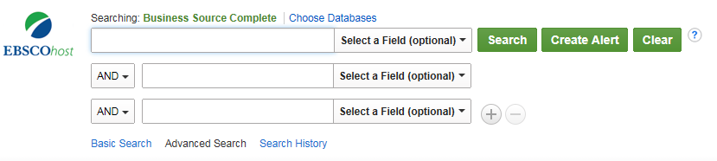

- Search for article.
  - On the search results screen, click the title of the article

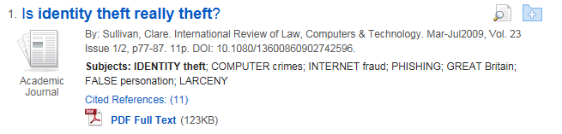

- On the Tools bar on the right side of the screen, click Permalink

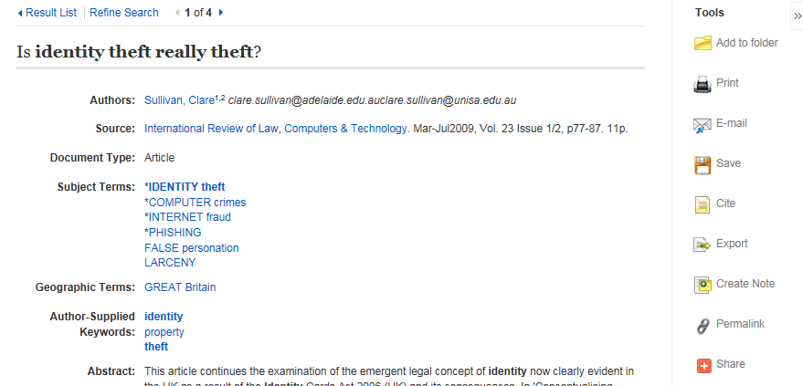

Ebsco databases – Page 2
The URL will appear near the top of the screen:

- Highlight the URL in the Permalink box
- Right-click on the high-lighted link
  - And select Copy

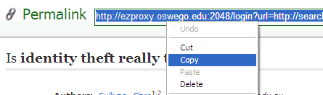

- On the Penfield Library Reserves Request Form, or in an email, paste the URL

http://ezproxy.oswego.edu:2048/login?url=http://search.ebscohost.com/login.aspx?direct=true&db=bth&AN=37362628&site=ehost-live&scope=site

ProQuest Databases

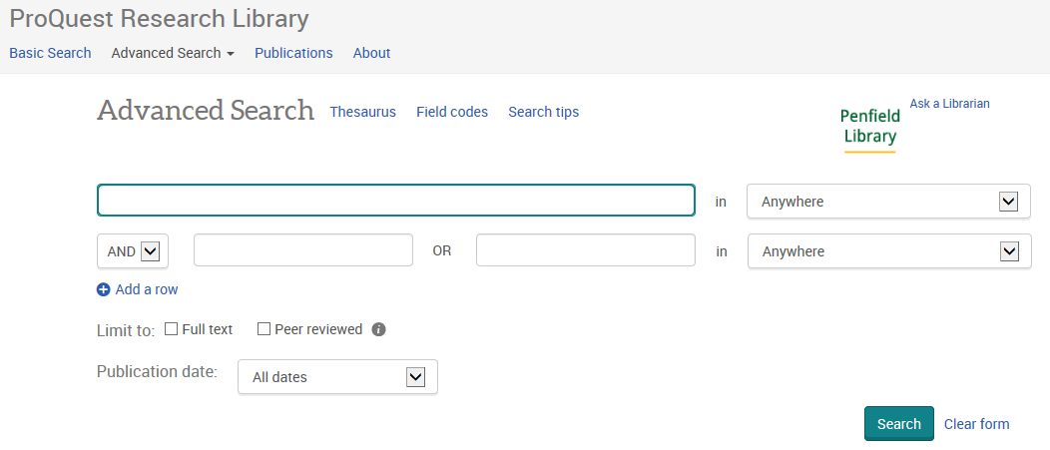

- Search for article

  - On the search results screen, click the title of the article

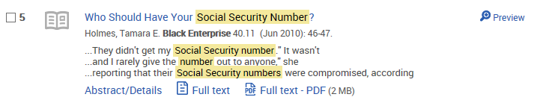

- Click on the tab for Abstract/Details

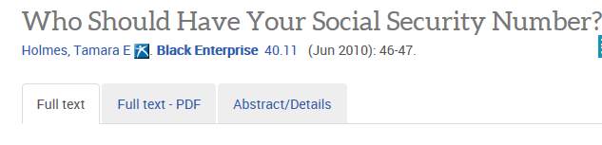

ProQuest databases – Page 2

- Scroll to the bottom of the screen and look for the “Document URL”

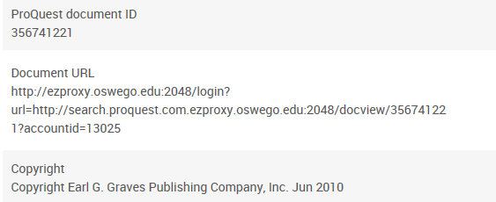

- Highlight the URL
- Right-click on the high-lighted link
  - And select Copy

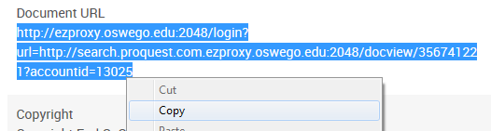

- On the Penfield Library Reserves Request Form, or in an email, paste the URL

http://ezproxy.oswego.edu:2048/login?url=http://search.proquest.com.ezproxy.oswego.edu:2048/docview/356741221?accountid=13025

JSTOR

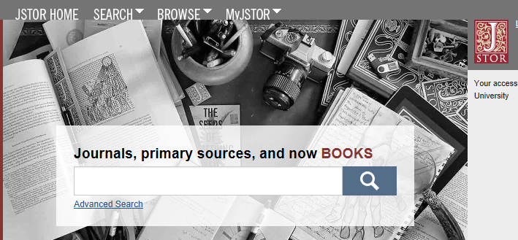

- Search for article.
  - On the search results screen, click Download PDF

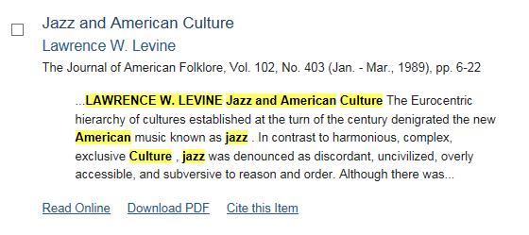

- On the PDF article:
  - On the first page will be a line for Stable URL
  - Highlight the Stable URL
  - Right-click the highlighting
  - Select Copy
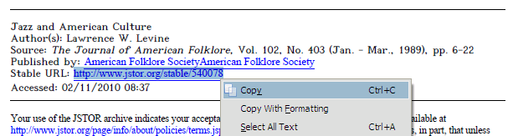

- On the Penfield Library Reserves Request Form, or in an email, paste the URL.

http://www.jstor.org/stable/540078

