*Information in FrontLine Employee is for general informational purposes only and is not intended to replace the counsel or advice of a qualified health or legal professional. For further help, questions, or referral to community resources for specific problems or personal concerns, contact a qualified professional. Add “http://” to source links to follow. Link titles are always case sensitive. The views and opinions expressed herein are solely attributable to DFA publishing).  None of the views or opinions expressed in this publication reflect the views or opinions of the NYS EAP or the NYS Office of Employee Relations.*



***Wellness, Productivity, and You!***

**October 2022**

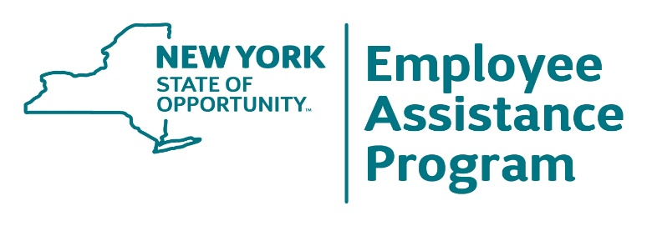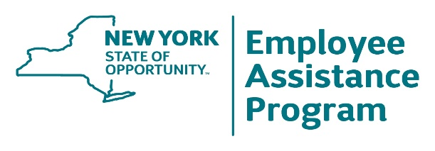

**1-800-822-0244  
www.oer.ny.gov/eap**

**October 2022**

Do You Need a   
Social Media   
 Break?

Online Coaching   
for Employees with Autism





**Are you an employee** on the

autism spectrum who, despite high

motivation and abilities, faces

common challenges regarding job

performance, assertiveness, and

interpersonal communication? Are

daily workplace routines difficult?

Talk to your EAP or a professional

counselor to discover coaching

solutions. ASD coaching is a

growing specialization. An ASD coach specialist may help you develop the ability to successfully navigate workplace challenges that are unique to you. The goal is to help you feel more confident and less stressed and provide you with an ability to focus better on maximizing productivity.

**Could you stand** to be away

from all your social media apps

for a week? You may reap

positive mental health benefits

that include less anxiety and

depression and increased mental well-being. That’s what 154 research participants experienced after abstaining from social media of any kind for seven days. Participants were randomly chosen, but each previously used social media an average of eight hours a day. How much time do you spend on social media? Another study identified 46 harms from social media use, most being some psychological harm or impact. The point of taking a week’s break isn’t quitting altogether but gaining awareness of the impact and the benefits that can come from moderation.



Avoid Relapse of  
 Your Health   
 Condition



Source: https://www.bath.ac.uk/ [social media break]   
”]

Should I Get Help   
 for a Crisis?



**Relapse triggers** are

ever-present for many chronic

illnesses that require attention

to personal health. If you

struggle with relapse triggers

for a health condition, you may

underestimate the power of

complacency. Complacency

is losing the healthy fear of your condition. Slowly you may drift toward doing things, going places, or participating in activities that make relapse likely and not participating in health practices that make it less likely. Willpower eventually becomes one’s sole prevention strategy. All it takes to relapse at this point is a crisis or an emotion-filled event that triggers a rationalized decision to give up treatment or one’s recovery program.

**Virtually everyone** will

experience a personal crisis at

some point in their life. How

long that crisis lasts, how

adverse its effects are, and

what benefits or undesirable

outcomes are ultimately

derived from it will vary

depending on one’s approach to intervention. Most of us are taught to be self-reliant. It’s a worthy value, but self-reliance does not mean delaying taking advantage of—or avoiding—helpful resources, whether it is a fire extinguisher or professional mental health counseling. The real skill is your ability to define a crisis early; don’t allow resistance to external resource solutions let the crisis you face become more difficult to resolve due to delayed intervention.

.



October 2022 FrontLine Employee

**Some people are** so

empathetic that they

may absorb

co-workers’ stress and

anxiety and, therefore,

feel drained of energy

needed to take care

of themselves and

loved ones at the end

of the day. Do you

absorb other people’s

stress and anxiety in

this way? If so, reach

out for help. Empathy is a powerful and positive human trait but exploring how to set boundaries, protect yourself, and if needed, acquire skills to help release the tension you picked up during the day will help you be more productive without losing the ability to have deep and meaningful relationships with others on the job.

**Many workplace teams**

experience stress, but it

is often made worse by

not nurturing a team

culture that can maintain

high morale and

resilience. Take these

steps to reinforce team

positivity: 1) Decide to

not just perform tasks.

Instead, agree on a

common vision and set up goals. Then post them.

2) Lose the cynicism and believe in the organization, or discover how to rekindle this loyalty so you have a foundational purpose with your employer and a real reason to engage that naturally pulls you forward;

3) Don’t avoid the manager; determine how to elicit praise for your successes. Praise from the boss is pure currency to boost morale. 4) Regularly set aside a few minutes to have honest discussions about issues—even if a moment of silence passes as members consider what’s relevant. Don’t allow only a concern or issue to be what prompts such meetings. You may miss the opportunity to resolve a problem early-on.

The Hazard of Using   
Alcohol to Manage Pain

Boost Your   
Team’s Positivity!

Build Resilience   
 by Raising   
Self-Esteem

Stop Stress, Right Now:   
Absorbing Other People’s Stress?

Source: www.niaaa.nih.gov [search “using alcohol relieve pain” ]   
and onlinelibrary.wiley.com/doi/10.1111/acer.14883





**Positive self-esteem** is a resource

tool when adversity hits. You’re able

to make more effective decisions,

feel confident, and sense hope when

the going gets tough. If you question the level of your self-esteem, try these action steps to boost it: 1) Identify the positive human qualities you possess by using this massive list: [http://ideonomy.mit.edu/essays/traits.html ] This exercise will make you more aware of the real you. You may be surprised at how many positive qualities you actually possess. 2) Catch negative self-talk quickly and ask, “What is causing me to think this way right now?” This exercise will erode negative, knee-jerk reactions to the everyday mishaps we all experience. 3) When mistakes happen, don’t target yourself for self-criticism. Instead, focus on the decision and changes you need to consider next time. 4) Everyone reacts with discouragement or emotions to mishaps and unfortunate events. The life skill to develop is learning to overcome a negative emotional response quickly and restoring your courage to try again. 5) Gravitate toward those who seem to validate your self-worth, particularly good listeners. 6) If you struggle with self-esteem, it can be easier to be critical of others, just as you are with yourself. The act of accepting others along with their shortcomings has a double-healing effect of improving relationships with others while you actually improve the one with yourself.

**Do you use alcohol** to manage pain?

Some research shows more than 25%

of people have tried it, but there is risk

to the practice. Using alcohol to reduce

pain can increase the risk of acquiring

a substance use disorder (alcoholism),

primarily by stressing susceptibility to

the disease, particularly if you have a

family history of substance use

problems. Although gaining temporary

relief from pain using alcohol

(alcohol analgesia) might work, research shows that a safe level of consumption isn’t enough to manage pain. This means you are consuming daily amounts beyond what the U.S. Centers for Disease Control and Prevention recognizes as safe (one drink for women and two for men.) Talk to your doctor or employee assistance program for assessment and direction in managing pain. Consider an assessment for a substance use disorder.

.