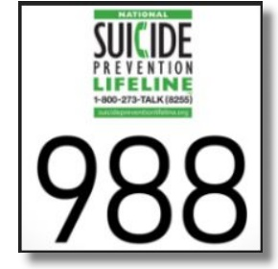

*Information in FrontLine Employee is for general informational purposes only and is not intended to replace the counsel or advice of a qualified health or legal professional. For further help, questions, or referral to community resources for specific problems or personal concerns, contact a qualified professional. Add “http://” to source links to follow. Link titles are always case sensitive. The views and opinions expressed herein are solely attributable to DFA publishing).  None of the views or opinions expressed in this publication reflect the views or opinions of the NYS EAP or the NYS Office of Employee Relations.*



***Wellness, Productivity, and You!***

**August 2022**

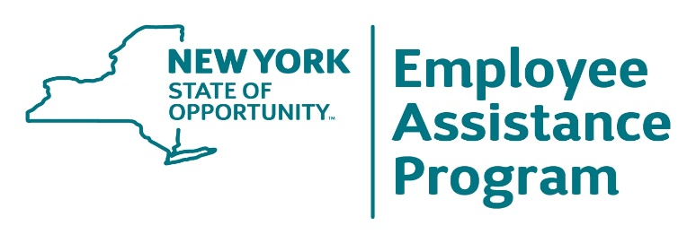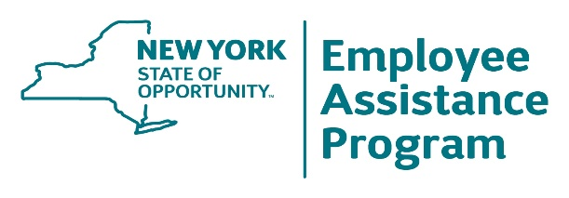

**1-800-822-0244  
www.oer.ny.gov/eap**

**August 2022**

**Many dietary fats** are healthy.

They give you energy and

support cell growth, but they are

calorie dense, and more so than

carbohydrates are. Olive oil is a

healthy fat, but do you know a

tablespoon of it has around

120 calories? Use it in many

dishes, but sparingly—splashing it on with abandon every day can add 3,500–4,000 calories to your diet each month! When you consider that a person who weighs 155 lbs. uses fewer than 100 calories to walk a mile, you can see how consuming even healthy fats can make you put on the pounds!

**Helping to ensure** plenty of

happy, memorable moments

with your family is something

no one would consciously shy

away from; however, most

people do just that, by default.

Busyness gets in the way. Time

passes and it is finite, so don’t let happiness be something that happens only by accident. 1) Decide what you and your partner or spouse want to do for the family. Try making weekly, monthly, and yearly goals. 2) Get everyone involved in the discussions and decisions. 3) Conduct these discussions at regular intervals as part of a larger family meeting. 4) Get things scheduled. 5) Consider scrapbooking everything so memories stick around. For more ideas search Family-goals online.

Family Goals:   
 Making Good   
 Stuff Happen

**Journaling (expressive** writing)

has been studied scientifically. It’s

considered a powerful tool to support change, overcome challenges, accelerate goal achievement, and support the therapy and medical treatments used for many challenges. These include anxiety, depression, grief, and stress. It’s not a gimmick. UCLA scientists in a brain-imaging study discovered that putting feelings into words produces therapeutic changes in the brain. The real news is that everyone can benefit from journaling, and the theme you might want to consider is “happiness.” Journaling daily about happy moments in your life may lead to more of them, an upbeat mood, and perhaps a longer life, because happy people have been shown to live longer.

What You Forgot About Dietary Fat

Could Keeping   
a Happiness   
Journal Lengthen   
 Your Life?

Dial 988 for   
 Suicide   
Prevention

Learn more: “Dietary Fats: Balancing Health & Flavor”; International Food Information Council

Source: www.newsroom.ucla.edu/releases/Putting-Feelings-Into-Words-Produces-8047

**On July 16, 2022,** “988,” the new

suicide and mental health crisis

hotline, became active in the United

States. (The newly named “Talk Suicide Canada” suicide prevention phone number is 1-833-456-4566.) 988 callers are connected to “a compassionate, supportive, and trained counselor” ready to give assistance to callers experiencing thoughts of suicide, a mental health crisis, and/or a substance use–related crisis. 988 is also for those concerned about someone they care about who may be in crisis. A network of over 200 locally operated and funded crisis centers across the country make it all possible.

Learn more at www.samhsa.gov/find-help/988/key-messages.

.



**Men have higher** rates of

alcohol-related

hospitalizations and deaths

than women do, but

unfortunately**,** these

statistics overshadow

alcohol’s *disease effects*

on women: Illnesses

associated with alcohol use claim more lives of women than of men. Women who drink alcohol face a higher risk of alcohol-related problems than men do because women, on average, weigh less and have less water in their bodies than men, so their blood alcohol concentration will be higher after the same number of drinks. Because most women do not metabolize alcohol as quickly as men do, they also are more susceptible to long-term health problems. The risk of alcohol-related liver disease, brain shrinkage, heart damage, and breast and other cancers are all greater for women, even if they consume less alcohol over a lifetime than men.

**So, you are** feeling

well and are without

any apparent health

problems? Great, but

are you postponing

preventive health

care, screenings, and

examinations

because you don’t

seem to have any

cause for concern?

Don’t do it, especially

as you grow older. Delays in identifying and treating some medical conditions can make doing so harder or even futile later. Many detectable health conditions, like high blood pressure, diabetes, vision problems, and cancer, can be cured when they are spotted early, and you won’t notice any symptoms in early stages. Postponing preventive health care might be more likely if you live alone, without someone who may urge and prod you to see a doctor because of conditions like sleep apnea. Use this month (August is National Wellness Month) as your reason for making preventive health care a routine part of your life, so you can enjoy your life longer.

Renewing Relationships  
 at Work

What Women Should Know About   
 Alcohol

Don’t Skip Your   
Health Checkups

August 2022 Frontline Employee

Chronic Pain   
and the Family



**Chronic pain has** many

secondary effects. You know this

already if you live with a chronic

pain sufferer or endure chronic

pain yourself. Pain can influence

moods because of the resulting

associated irritability it creates.

Communication dysfunction can contribute to everyone becoming angry and snappy. Family members of the pain-impacted individual—the ones who care the most and feel helpless—become victims. But it doesn’t end there. Family members also develop unhealthy coping strategies like avoidance and isolation. Household conflicts may be frequent, and even normal conversations become triggers for conflict. The pain sufferer’s personality may be wrongly labeled as selfish, narcissistic, or anxiety disordered rather than simply pain affected. Change and relief begin with education about chronic pain dynamics, particularly the “mind body” connection and how pain creates mental stress and how mental stress makes pain worse. If your family or relationship is affected by chronic pain, it is not just about pain medication. It is also about education for learning how to communicate effectively with real conversations, avoiding triggers, separating the pain from the person you love, and dropping the blame game. Seek to overcome personal resistance to professional counseling with experts who specialize in the psychological issues associated with pain. Discover the life-changing positivity of self-help support groups for family members and the pain sufferer. And learn how to take care of your personal physical and mental health so you are more resilient in a relationship with the person experiencing chronic pain. Start with a visit to your EAP, but also review the educational resources at www.uspainfoundation.org,



**Does your team** oremployee group

need to get reacquainted after its

return to on-site work? Being deliberate

and organized about this goal can

greatly improve communication, reduce

any stress associated with leaving a

remote job, and rekindle trust so you

are in sync with your peers. Try

weekly meetings to discuss ongoing

concerns about interpersonal communication and teamwork; talk about your individual roles/duties, successes, and need for support and resources as well as any issues relating to the work environment, customer stress, and growing concerns. Make honesty a tradition of this group, and follow up at the next meeting. Start the meeting and end it on time. Make it unvaryingly regular. You will quickly refresh your commitment to each other and fire up the productivity of your group.

Learn more at www.niaaa.nih.gov/publications/brochures-and-fact-sheets/women-and-alcohol and www.niaaa.nih.gov/news-events/news-releases/alcohol-related-deaths-increasing-united-states.

.