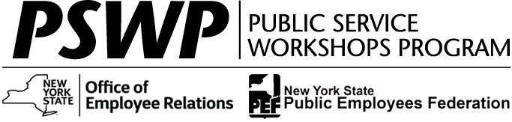
PSWP Workshops are for PEF-Represented and Management/
Confidential Employees

To reference full workshop details and to register go to the Statewide Learning Management System (SLMS) at https://nyslearn.ny.gov.
For additional information
regarding currently available offerings, check
PSWP Course Offerings
at www.pswp.info
Equal Opportunity & Reasonable Accommodation
Printed:
February 6, 2024

Seats in the following virtual workshops are now available

February 6, 2024

Virtual
Training Title: | Data Analysis - Virtual
Dates & Times: | Monday, 3/4/2024 &Tuesday, 3/5/2024, 1:00 PM – 4:00 PM  Wednesday, 3/6/2024 & Thursday, 3/7/2024, 1:00 PM – 4:00 PM
Provider: | MicroKnowledge
Location: | Virtual - Zoom
SLMS Search Number: | 6149 or Click here to register (sign in required)
Registration Deadline: | Monday, 2/26/2024

This four-session (each 3 hours in length) workshop will help participants develop skills for visualizing and analyzing data. Topics include descriptive statistics, histograms, cross tabulations and pivot tables, correlation and regression, and confidence intervals. Use of graphs to explore patterns and relationships in the data is emphasized. Data sets are provided for practice in building statistical analysis skills. Microsoft Excel will be used as a tool for learning about data analysis and the workshop will be delivered virtually using Zoom. Each participant will be required to participate in all exercises using their computer. Prerequisite: Familiarity with Excel, including knowing how to enter simple formulas and use built-in functions, and completion of the New York State GOER Working with Data (Online) course component prior to attending the workshop.
Capital District
Training Title: | Data Analysis: Advanced
Dates & Times: | Tuesday, 3/19/2024 & Wednesday, 3/20/2024, 9:00 AM – 4:00 PM
Provider: | MicroKnowledge
Location: | Albany
SLMS Search Number: | 6156 or Click here to register (sign in required)
Registration Deadline: | Tuesday, 3/12/2024

This two-day workshop continues to develop the skills to analyze data. Topics include multiple regression, regression modeling, analysis of variation, multiple comparison procedures, and nonparametric methods. Data sets are provided for practice in building statistical analysis skills. The workshop uses Microsoft Excel for learning about data analysis. Each participant will be required to participate in all exercises using a computer. Prerequisite: Familiarity with Excel, including knowing how to enter simple formulas and use built-in functions. Attending the basic data analysis workshop as well as an introductory statistics course is recommended.

If you are enrolled and then unable to attend, please contact PSWP customer service at PSWPRegistration@albany.edu immediately or no later than three business days prior to the delivery date to allow a person on the waitlist a chance to attend.

The Public Service Workshops Program is funded through the negotiated Agreement between the State of New York and the Public Employees Federation, AFL-CIO, and through additional Management/Confidential funds. The Program is administered by the Professional Development Program of the Nelson A. Rockefeller College of Public Affairs at the University at Albany, under contract with the Office of Employee Relations. February 2024

