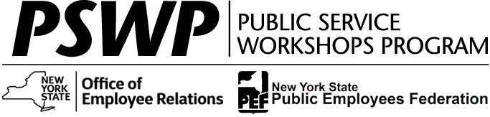
PSWP Workshops are for PEF-Represented and Management/
Confidential Employees

To reference full workshop details and to register go to the Statewide Learning Management System (SLMS) at https://nyslearn.ny.gov.
For additional information
regarding currently available offerings, check
PSWP Course Offerings
at www.pswp.info
Equal Opportunity & Reasonable Accommodation
Printed:
February 14, 2024

Seats in the following workshop
are now available

February 14, 2024

Capital District
Training Title: | Fundamentals of Business Analysis for the IT Professional
Dates & Times: | Wednesday & Thursday, 3/6/2024 & 3/7/2024, 9 AM to 4 PM
Provider: | Org-Ology
Location: | Albany
SLMS Search Number: | PSWP_6152 or Click here to register (sign in required)
Registration Deadline: | Wednesday, 2/28/2024

This two-day workshop on business analysis covers the process, questions, and techniques to efficiently extract expertise from the Business Users. Topics include the role of business analysis and structured ways to define success. Follow change requests/projects through entire SDLC. Define scope for new projects and write business cases, provide cost/benefit and risk analysis, elicit and document business requirements, help business to identify needs vs. wants and prioritize requirements, document business policies, document AS-IS and TO-BE business process flows, assist with creating test plans and test cases, coordinate user acceptance testing and provide results, assist with creation of training documentation and materials.

The Public Service Workshops Program is funded through the negotiated Agreement between the State of New York and the Public Employees Federation, AFL-CIO, and through additional Management/Confidential funds. The Program is administered by the Professional Development Program of the Nelson A. Rockefeller College of Public Affairs at the University at Albany, under contract with the Office of Employee Relations. February 2024

