Grab & Go Workouts
Presented by the Fitness Centers
Created by: Natalie Horton
Name of Workout: | Baby Got BACK
Primary Target Area: | Back and Biceps
Approximate Time: | 45 min – 1 hour
Skill Level: | Intermediate
Warm-up: 10 minutes of cardio of your choice (walk, run, bike) followed by upper body band stretches.
Exercise Routine
Exercise | Sets | Reps/Time | Rest Interval | Notes
Tri Set:  Seated Hammer Curls  Seated DB Curls  Alternating Cross Body Curls | 3 | 10-12 | 1 minute | Perform each exercise take a 20-30 second break and then perform the next exercise
Superset:  Lat Pulldown  Underhand Grip Pulldown | 4 | 10-12 | 1 minute | Keep chest tall, elbows pointed straight down, squeeze lats thinking about pulling them from armpit
21’s | 3 | 21 | 1 minute | Perform bicep curls, 7 from the low position or the middle, 7 from middle to the chest, then 7 full bicep curls
Underhand BB Row | 4 | 10-12 | 1 minute | Bend knees slightly while bringing torso forward slightly, bending at the waist. Keep back straight (parallel to floor)
Face Pulls | 4 | 10-12 | 1 minute | Pull weight directly towards face, pulling hands apart as the weight is coming towards you. Keep arms parallel to the ground
Single Arm DB Bicep Curls | 4 | 10-12 | 1 minute | Keep your elbows pinned to your sides, don’t let them drift forwards. Keep back straight and minimize momentum.
Rear Delt Fly | 3 | 10-12 | 1 minute | Bend at the waist, keeping you back straight. Keeping elbows slightly bent, lift weights until both arms are parallel to the floor
Cool Down: Walk for 5 min on treadmill, then perform upper body and back static stretches.
Adjust weights and reps on how you are feeling; if it is too easy or too hard! More importantly have fun with it!
Additional Notes:

Questions or Comments? Please e-mail fitness@oswego.edu
Sample Diagrams

Resistance Band Stretches
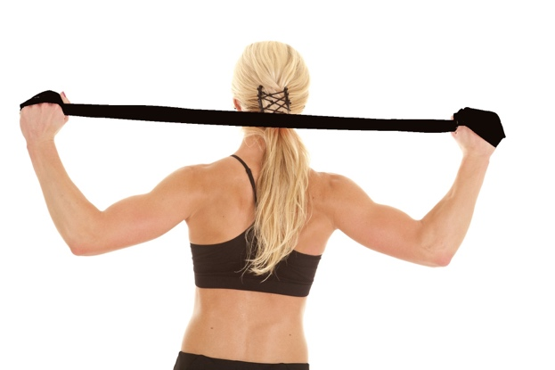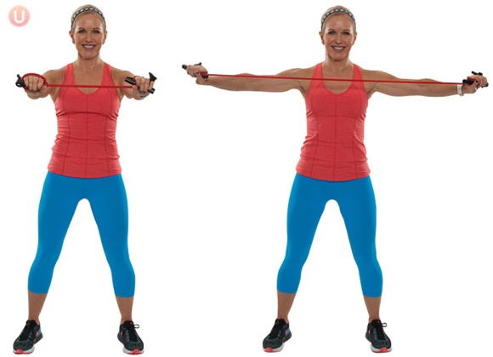

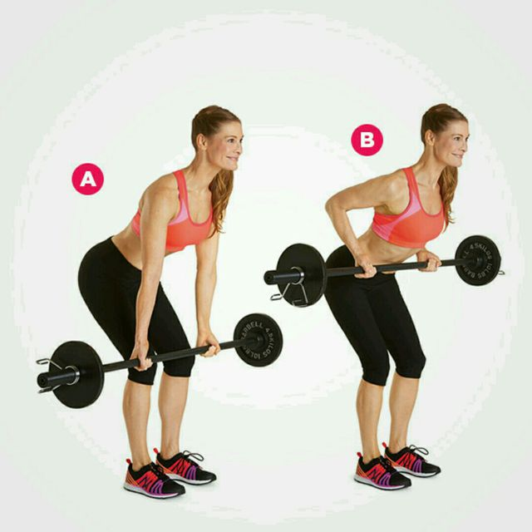
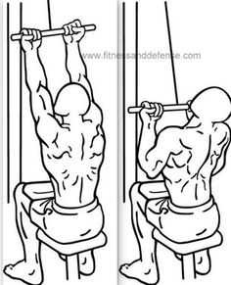
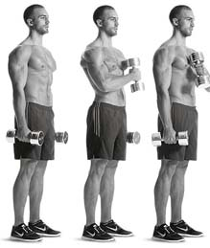
Alternating Cross Body Curls Underhand Grip Lat Pulldown Underhand BB Row

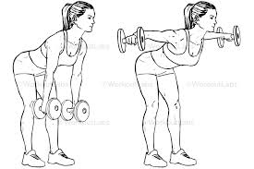
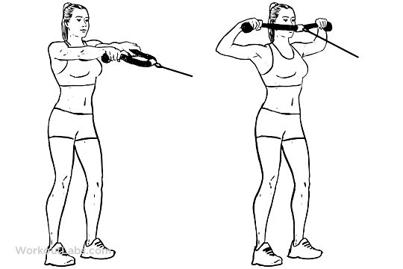
Face Pulls Rear Delt Fly

