School of Education
Teacher Opportunity Corps II
Teacher Recruitment for Urban Schools Today
Application Packet

Please complete the application packet in its entirety and make sure that the following, required documents, are submitted along with this packet.

Student Participant Form
A. CAP Report/Degree Works

B. Copy of Class Schedule

C. Copy of Work Schedule

Application
A. Unofficial Transcript

B. Letter of Support from a Professor

C. Essay explaining interest in Urban Education

D. Resume

E. Cover Letter

- Interview Date

Date Applied
Date Accepted
Date First Enrolled

Submit all materials to the Field Placement Office
175 Wilber Hall

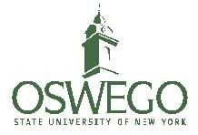
“Become a part of something great!”

School of Education
SUNY Oswego Teacher Opportunity Corps II Teacher Recruitment for Urban Schools Today's (TRUST)

Overview:
The 2015 data on the numbers of certified teachers in New York State show that males and ethnic/racial minorities are noticeably underrepresented in the teaching field. Less than 25% of certified teachers in New York State are male (24.1%), and the representation of ethnic and racial minorities constitutes less than 20% collectively (American Indian .2%, Asian 2.6%, African American 8.4%, Latino 7.4%, and Pacific Islander .008%).

The Teacher Opportunity Corps II is part of the State Education Department's effort to not only recruit and retain more people from underrepresented groups into the teaching field, but by doing so, to help resolve the shortage of teachers who are both qualified and prepared to teach students that have been placed at risk in severely underserved areas.

SUNY Oswego’s ultimate goal is to recruit, retain and graduate students and to increase the number of teachers from underrepresented groups teaching in high need urban schools.

Benefits:
All TOC II participants will receive: (level of support is based on the year of study)
● Financial Support
● Professional Support
● Academic Support
● Social Support

Eligibility:
To be eligible for TOC II, a student must be:
● A resident of New York State;
● African American/Black, American Indian and Alaskan Native, Asian, Hispanic/Latino, Native Hawaiian and Pacific Islander (first priority) and/or be economically disadvantaged (second priority);
● Enrolled full-time in a registered teacher preparation program at the undergraduate level, or be in
the MST program;
● In academic good standing; and a graduate of a recognized high school or have a state approved equivalency diploma. ( if you are a graduate student, you must be a graduate from a regionally accredited college or university.

Requirements:

Bi-weekly Meetings

Bi-weekly “check in” meetings are for candidates to share progress and concerns; receive sustained faculty, staff and peer to peer support and mentoring; to engage in discussions focused on key issues related to urban education and meeting the needs of at risk Pre K-12 students; and network with professionals in the field of education.

TRUST Cohort Meetings

● Freshman & Sophomore: college and career readiness/personal and academic performance skills, i.e study skills, time management, financial literacy/financial aid, digital citizenship, etc.;

● Juniors: career readiness skills. i.e. digital citizenship, practicum experiences, classroom management, teacher certification prep, resume development, interviewing, mentorship, etc.;

● Seniors: data driven instruction, co-teaching and mentoring, culturally and linguistically relevant teaching, issues of diversity, classroom management, etc.). The diagram above gives a scope of the program by classification.

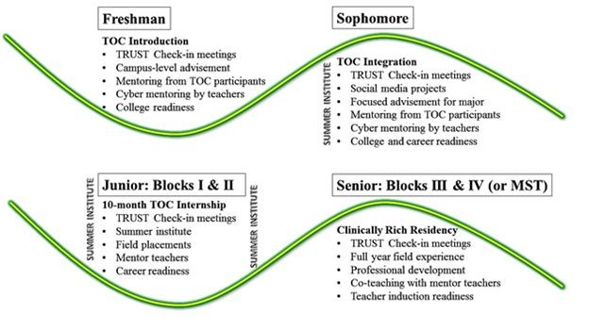
Summer Institute

Participate in week long TRUST Summer Institute professional development activities. Topics to include but are not limited to interviewing skills, resume development, restorative practice, etc.

SUNY Oswego
TRUST Program

TOC II Participant Information Form

Semester
Date of Birth

Name
Student ID number

Current Address

Email address
Phone

Major
Concentration

Hours completed

Current GPA

Academic Advisor’s Name

Anticipated semester of graduation

Attach a copy of your
● CAP report/Degreeworks
● Your transcript
● Class schedule
● Work schedule

Certification Exams/Trainings Completion

● CST: Date Score
● EAS: Date
Score
● EdTPA: Date
Score
● SSHS 1020 (Safe Schools, Healthy Students workshop): Date
● DASA Training: Date

Check the box if you need transportation
Grade

Location of field placement this semester (to be completed by Field Placement Office)
● School Grade
Subject area
● District Host Teacher

Teacher Opportunity Corps II
TRUST Program Application
-Teacher Recruitment for Urban Schools Today-

Name:

Address:

Phone #:

Oswego Email Address:

Major:

Concentration/Minor:

Circle One: Freshman Sophomore Junior Senior Graduate w/ Initial Certification

Elementary attended?
School District

High School attended?
School District

Attach the following with this application:

1. Letter of Recommendation from a professor (can be sent to to Ms. Nichole Brown at toc@oswego.edu) or you can submit with your application packet.
2. An essay explaining your interest in teaching. Why urban education?
3. Cover letter and Resume

