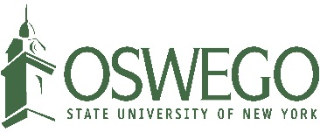

Facilities Services
Major Projects Group
7060 State Route 104
Triple Wide Trailer
Oswego, NY 13126
315.312.6600

Meeting Agenda – ADA Signage - Interior Signage

Meeting Information

Date: June 16, 2016
Time: 9:00 am
Location: 301 Park Hall
Absent
Present
Present
Absent
Attendees: Allen Bradberry – SUNY Oswego
Linda Paris – SUNY Oswego
Joe Walto – PAC Associates
Douglas Baule – ids Custom Graphics

Agenda Items

- Schedule
  - Status update
    - None available as D. Baule was not on call. J. Walto says final product will look great.
  - Schedule for building order
    - J. Walto will press on D. Baule for this. Should have received the schedule around June 13, 2016.
- Submittals
  - Submittals still needed for frames and sign types 3.3, 7.1, 2.1A, 2.1B, and 4.4 and cost estimate for frames.
    - J. Walto will press on D. Baule for this. Should have received the submittals around June 6, 2016.

Other Notes

- None

Next Meeting Information

- Hold June 27 at 9:00 am for conference call if needed
  - SUNY Oswego will call ids Graphics and PAC Associates

