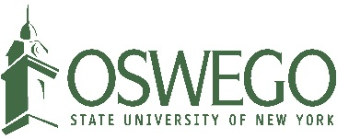

Facilities Services
Major Projects Group
7060 State Route 104
Triple Wide Trailer
Oswego, NY 13126
315.312.6600

Meeting Agenda – ADA Signage - Interior Signage

Meeting Information

Date: May 31, 2016
Time: 9:30 am
Location: 301 Park Hall
Absent
Present
Absent
Absent
Present
Attendees: Allen Bradberry – SUNY Oswego
Linda Paris – SUNY Oswego
Paul Castaldo – PAC Associates
Joe Walto – PAC Associates
Douglas Baule – ids Custom Graphics

Agenda Items

- Schedule
  - Status update
    - Materials are in house and production of signs has begun
  - Schedule for building install order is expected on or around June 13, 2016
  - Production of signs complete by June 27, 2016
- Submittals
  - Submittals still needed for sign types 3.3, 7.1, 2.1A, 2.1B, and 4.4 and frames for LEED certificates
    - Submittals and cost estimate (frames) will be delivered to PAC Associates for review next week
Other Notes

- Lettering on sign 3.1B is the same as 3.1A.

Next Meeting Information

- Call as needed
- Conference call on June 16 at 9:00 am
  - Status update and discuss building install order
  - SUNY Oswego will call ids Graphics and PAC Associates

