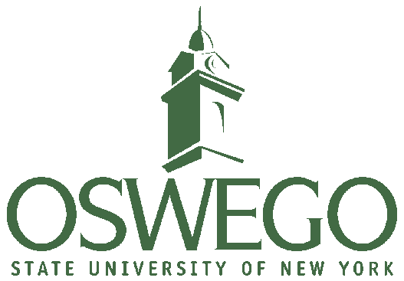

**Department Faculty**

**Angela Perrotto**

Chair, Assistant Professor

angela.perrotto@oswego.edu

**Linda Rae Markert, Ed.D.**

Professor

lindarae.markert@oswego.edu

**Tamara Lipke, Ed.D.**

Assistant Professor

tamara.lipke@oswego.edu

**Educational Administration**

307 Park Hall

SUNY Oswego

Oswego, NY 13126

Phone: 315-312-2264

**Email**: edadmin@oswego.edu

**Educational**

**Administration**

Central New York

Cohort

2019 - 2020

Projected Courses

www.oswego.edu/edadmin

The Educational Administration Depart- ment at Oswego State will offer its Certificate of Advanced Studies (CAS) in Central New York. The CAS program includes 24 hours of coursework selected under advisement from the courses listed at the left and a 9-hour internship. The program leads to full certification in school administration.

**About the Program**

Our program in the Central New York area is a collaborative effort between the educational administration professors and area schools:

* Area administrators serve as guest speakers, co-teachers, or instructors in nearly all courses.
* The department works with school districts to help identify high quality internships.
* The department maintains a strong placement program, serving as a liaison between graduates pursuing employment and districts desiring to hire new administrators.
* Teams of students work on “authentic” learning assignments in and for area schools.
* The department promotes strong communication networking between students and practicing area administrators.

**2019 – 2021 Projected Courses**

**Central New York**

**Summer 2019**

EAD 621 School Personnel Management (3sh)

EAD 622 School Law (3sh) [on-line]

EAD 652 Curriculum Administration (3sh)

EAD 695 Internship (3sh)

**Fall 2019**

EAD 601 Fundamentals of Administration

(6sh)

EAD 641 Supervision: Improvement of

Instruction (3sh)

EAD 695 Internship (3sh)

**Spring 2020**

EAD 610 School Principalship (6sh)

EAD 660 Organizational Change (3sh)

EAD 695 Internship (3sh)

**Summer 2020**

EAD 621 School Personnel Management (3sh)

EAD 622 School Law (3sh) [on-line]

EAD 652 Curriculum Administration (3sh)

EAD 695 Internship (3sh)

**Fall 2020**

EAD 601 Fundamentals of Administration

(6sh)

EAD 641 Supervision: Improvement of

Instruction (3sh)

EAD 695 Internship (3sh)

**Spring 2021**

EAD 610 School Principalship (6sh)

EAD 660 Organizational Change (3sh)

EAD 695 Internship (3sh)

**The CAS Program is offered exclusively at the**

**SUNY Oswego Branch Campus**

**2 Clinton Square, Syracuse, NY**

Please see our web page for specific dates and times

www.oswego.edu/edadmin