Faculty Guide for Assessing the
Capstone Teacher Performance Assessment (TPA) in Tk20

Tk20@oswego.edu
How is the Capstone or Pre-Capstone TPA made available in Tk20?
The assessment is made available to candidates and faculty based on enrollment in specific courses that departments have identified as the course in which the assessment should occur. For example, ADO 420 is the Adolescence Education undergraduate student teaching course in which the Capstone TPA will be completed.

What is the difference between the Pre-Capstone TPA and the Capstone TPA?
The Pre-Capstone TPA is completed during the Methods course. Candidates will have access to the entire assessment; however, they will only complete Parts 1 and 2. Faculty will only assess those rubrics associated with Parts 1 and 2, Rubrics 1 – 4.
The Capstone TPA is completed during Student Teaching. Candidates will compete all four parts of the assessment. Faculty will assess all eight rubrics, and will complete a summative evaluation indicating if the candidate has met all the requirements of the assessment.

Where do I see the Capstone TPA or Pre-Capstone TPA in Tk20?
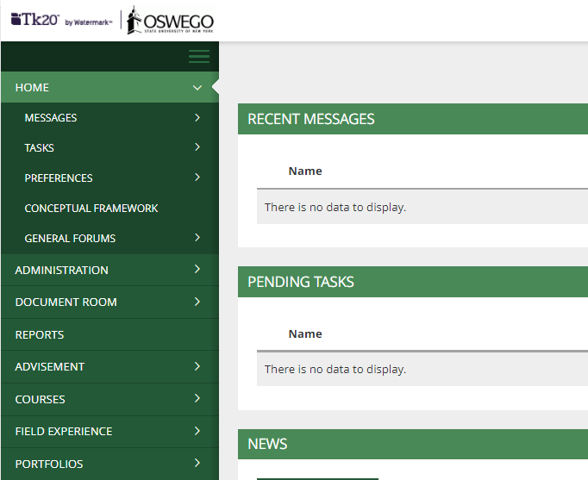
The assessment will appear in the Courses tab (see below) of your Tk20 account.

Click on the Courses tab in the side menu to open the dashboard. The middle section of the screen will then show your dashboard. The picture below shows how the dashboard will appear before candidates have uploaded files. By hovering over the number (circled in blue) you will be able to see names of candidates who have the assessment.
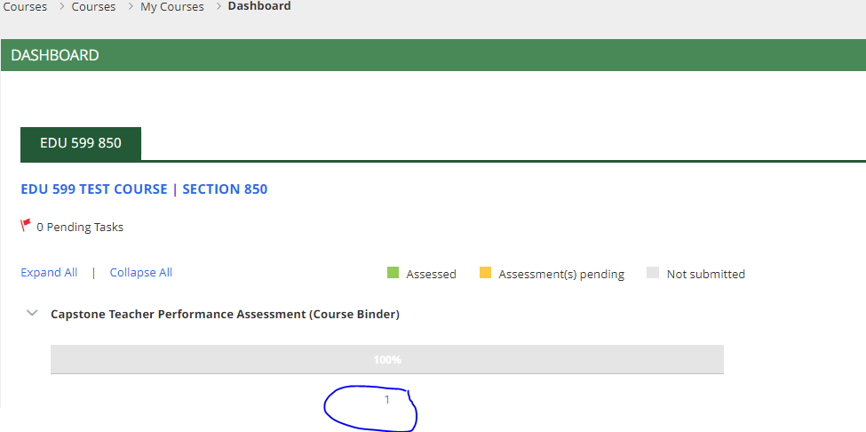

How do I see Capstone TPA documents once candidates have uploaded them?
After candidates have uploaded and submitted the assessment, your dashboard will look like the picture below. Notice the bar has turned yellow which indicates the files have been uploaded, but that you have not yet evaluated the assessment.
Note: If candidates add or drop the course, please notify tk20@oswego.edu and the assessment will be removed.

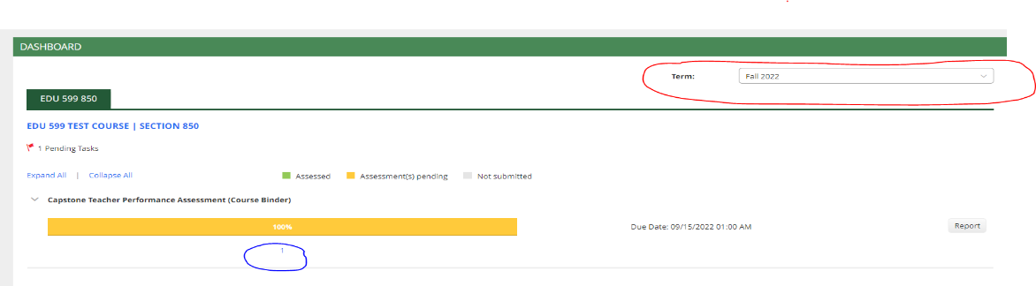

Note: The dashboard will only show the current semester. Therefore, if you are evaluating assessments after the semester has ended, change the term (semester) by choosing the correct semester from the drop-down menu (circled in red).
To open individual candidate submissions, hover over the numerical value (circled in blue). This will give you a list of names. Then click on the name of the candidate whose Capstone TPA you wish to evaluate.

What should the binder look like when I open it?
Individual candidates’ course binders will look like the picture below.
Left-Hand Window: Candidate’s Work  - Click on the tab for the specific Part you want to view (e.g., Part 1, circled in red).  - Scroll down the page to view files associated with the Part you selected.  - One at a time, click on the hyperlinked files (example circled in blue). | Right-Hand Window: Faculty Evaluation  - Click on the title of the assessment (circled in yellow) to open the evaluation document which contains the rubrics.
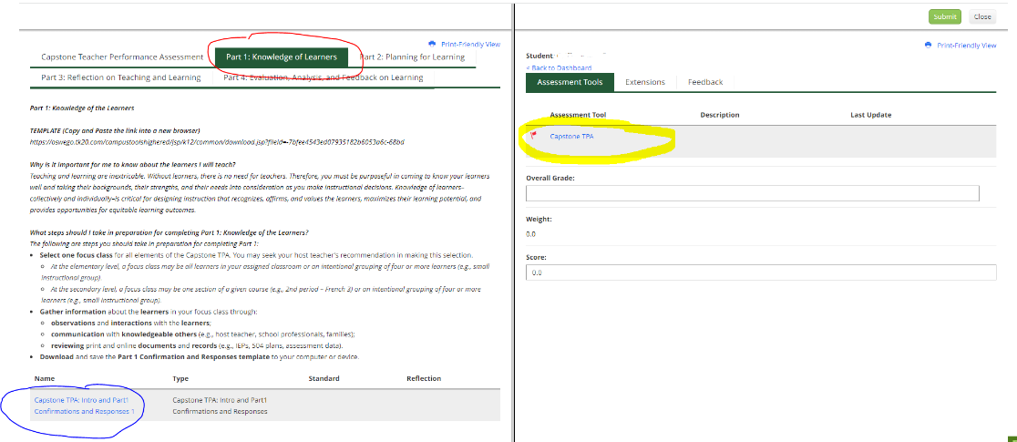

How do I open the files candidates have uploaded?
After clicking on a hyperlinked file (circled in blue above), you will be given two options: View and Annotate or Download (circled in yellow below).
- View and Annotate – The file will open in the left-hand window of the dashboard in Tk20, side-by-side with the rubrics that you opened in the right-hand window. This is the recommended option.
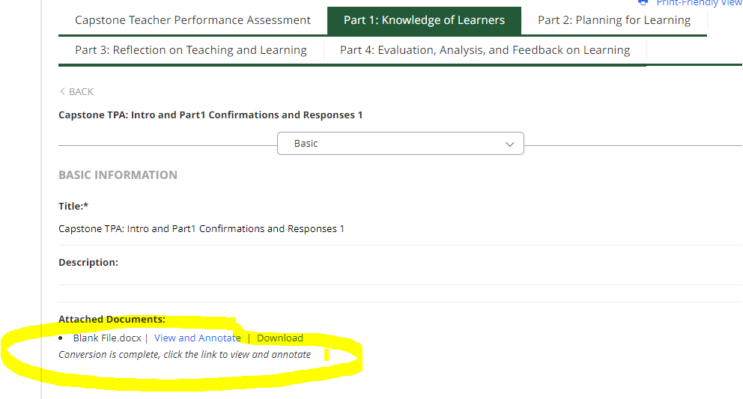
- Download – The selected file will download to your computer, and you will need to open it in Word (for .doc or .docx file types) or Adobe (for .pdf file types).

How do I complete my ratings?
After opening a candidate’s file with the View and Annotate option in the left-hand window and opening the rubrics in the right-hand window, your screen will look like the picture below.
Read all files associated with each rubric. Then select the corresponding rubric rating (0, 1, 2, 3) by clicking on the radio button associated with the rating. Comments are optional.
After evaluating all eight rubrics, complete the summative evaluation. You will click “Yes” if the candidate has met the requirements. If the requirements are unmet, click “No” and complete the next two questions regarding the plan for revision and the due date for revision.
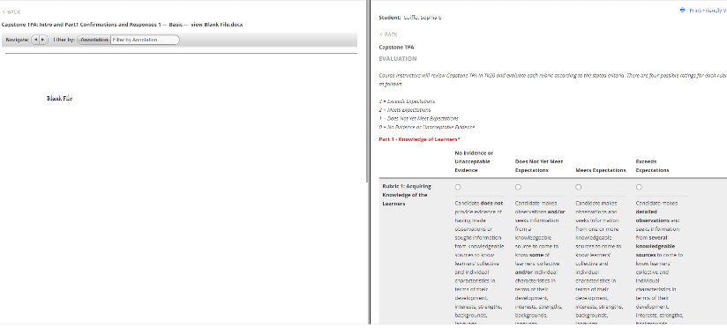

How do I save and submit my ratings?
If, as you complete the evaluation of a candidate’s Capstone TPA, you need to pause your work, scroll to the bottom of the page and click “Save and Close.” You will be able to return to the Dashboard, click on the candidate’s name, and return to complete your work at a later time. Once you have completed evaluating all rubrics and the summative evaluation, scroll to the bottom of the page and click the “Save and Close” button. Then click the “Submit” button found at the top of the page. If you are unable to submit, it is likely that a rating is missing. Return to the evaluation to assure that all ratings and the summative evaluation are complete.
How do I revoke my ratings?
To revoke your ratings, open the candidate’s binder as previously described. Then open the rubrics in the right-hand window. In the upper right-hand corner, you will see a “Revoke” button (circled in red). Click the button.
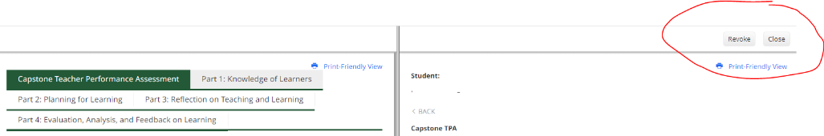

If you have questions or need assistance, email tk20@oswego.edu.

