Candidate Guide for Accessing and Submitting the
Capstone Teacher Performance Assessment (TPA) in Tk20

Tk20@oswego.edu
How is the Capstone or Pre-Capstone TPA made available in Tk20?
The assessment is made available to candidates and faculty based on enrollment in specific courses that departments have identified as the course in which the assessment should occur. For example, ADO 420 is the Adolescence Education undergraduate student teaching course in which the Capstone TPA will be completed.

What is the difference between the Pre-Capstone TPA and the Capstone TPA?
The Pre-Capstone TPA is completed during the Methods course. Candidates will have access to the entire assessment; however, they will only complete Parts 1 and 2. Faculty will only assess those rubrics associated with Parts 1 and 2, Rubrics 1 – 4.
The Capstone TPA is completed during Student Teaching. Candidates will compete all four parts of the assessment. Faculty will assess all eight rubrics, and will complete a summative evaluation indicating if the candidate has met all the requirements of the assessment.

Where do I see the Capstone TPA or Pre-Capstone TPA in Tk20?
The assessment will appear in the Courses tab (see below) of your Tk20 account. Click on Courses, then Coursework, then Course Binders. The name of the course binder is in blue (circled in red below). Click on the name of the course binder, and it will open.
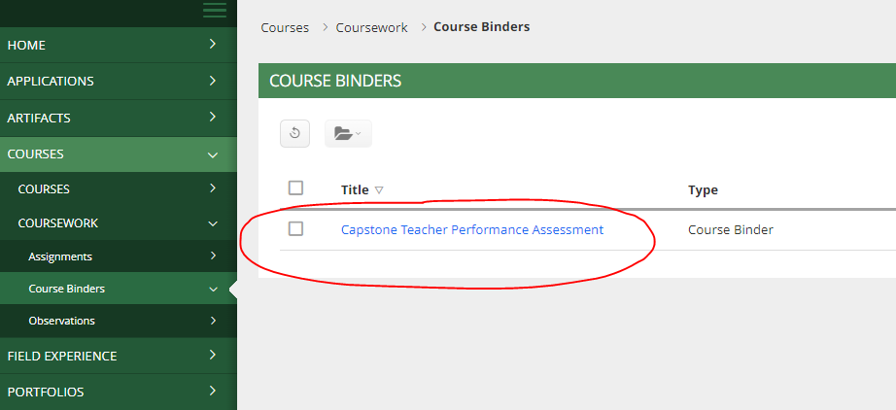

1
2
3

How do I open the Capstone TPA handbook and templates?
The course binder opens to a main tab (circled in blue below) and also includes tabs for each Part of the Capstone TPA. To access the handbook and templates, scroll down the main page, click on the hyperlinked documents (circled in red below), and download them to your computer. The handbook is in .pdf format, and the templates are in Word (.docx) format. If you cannot download the templates, email tk20@oswego.edu, and we will share them with you through Google Drive.
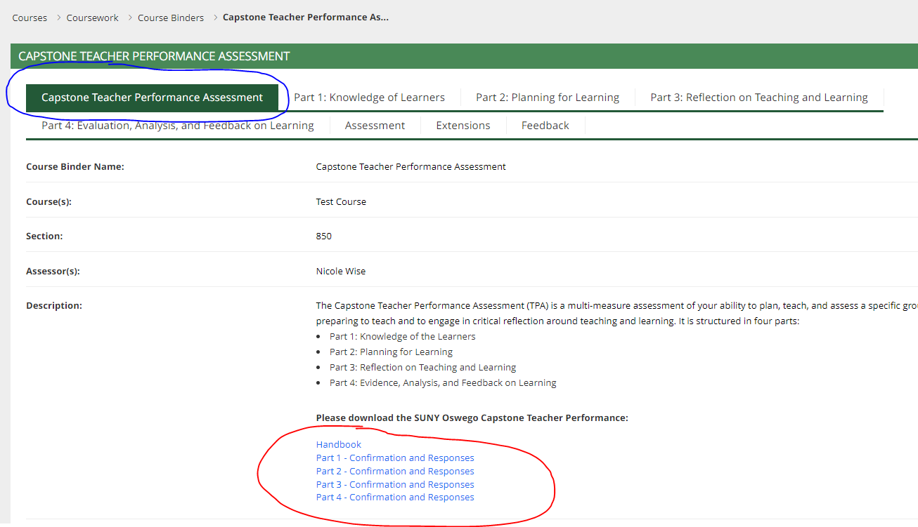

When in my Capstone TPA assessment due?
Consult your course instructor, course calendar, or syllabus for the actual submission due date of your Capstone TPA. Although Tk20 posts a due date, it is NOT your submission due date; instead it is a feature of the Tk20 system that we are unable to modify.

How do I upload my files to Tk20?
Select the tab for the Part (1, 2, 3, or 4) with which your files are associated. On the right-hand side of the screen, locate the file name, and then click “Select,” (circled in red below).
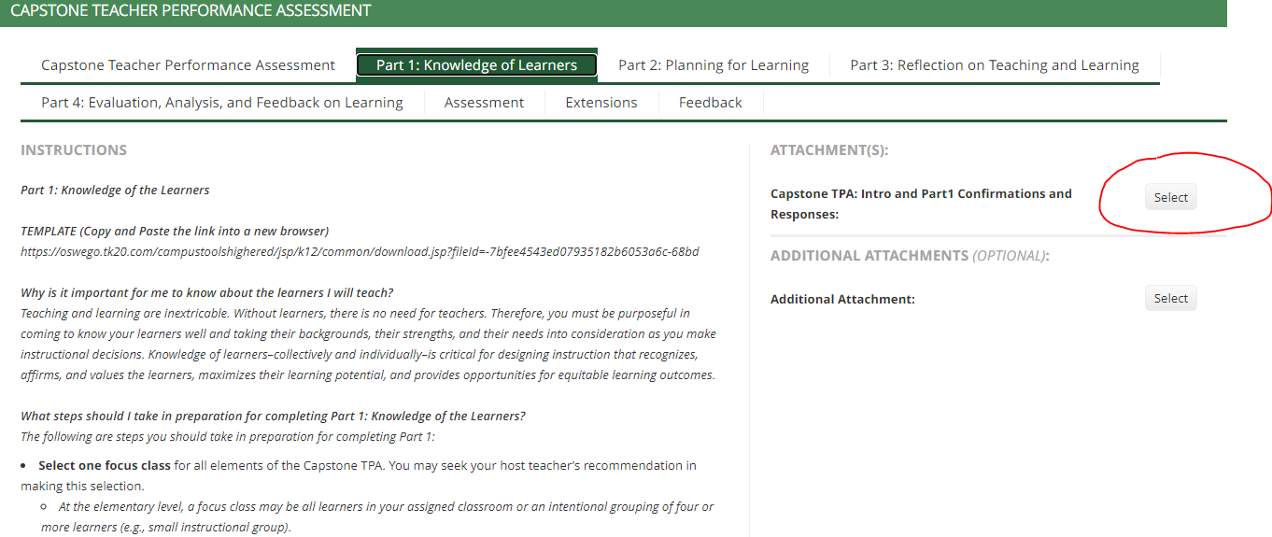

How do I upload my files to Tk20? (continued)
After clicking “Select,” a new window will open. In the new window, click the green “Select File(s)” button (circled in red below at left). Select the file to be uploaded, then click the green “Add” button in the lower right-hand corner (circled in red below at right).
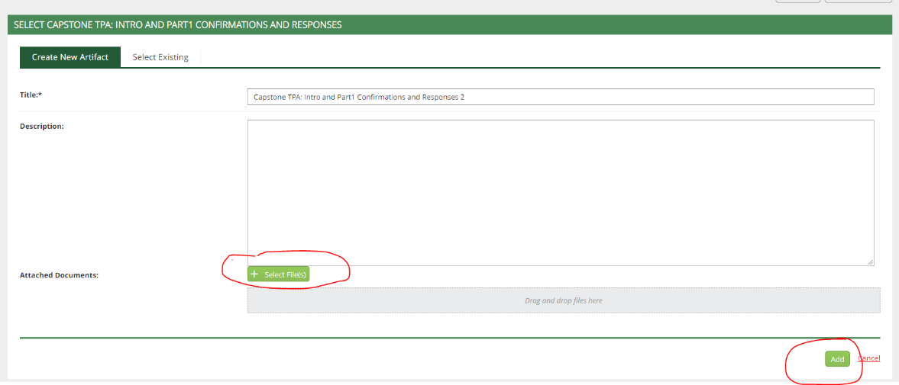
The course binder will be updated to show that the file is attached (circled in red below).
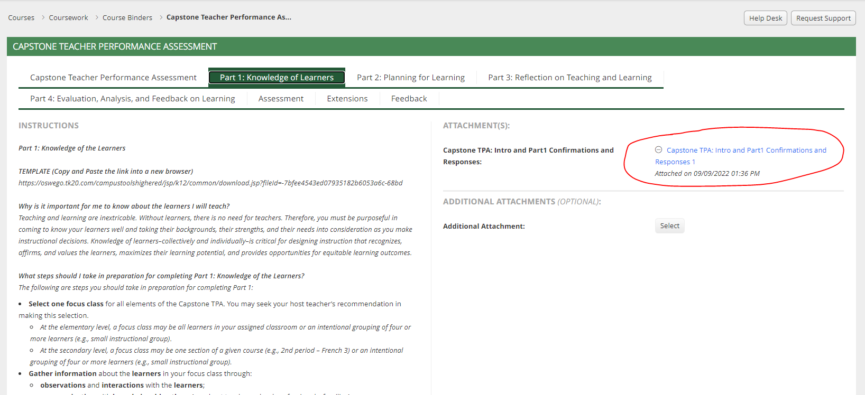

How do I submit my Capstone TPA/Pre-Capstone TPA?
After you have uploaded all the required files, click the green “Submit” button in the lower right-hand corner of the course binder (circled in red below).

How do I recall my Capstone TPA/Pre-Capstone TPA?
If your course binder has been submitted and not assessed yet you can recall it and continue working on it or change uploaded documents. To do this go to the course binder section in your TK20 account.

Click on the check box in front of the name of the binder that you wish to recall. At the top of the page, under the green title bar are two pictures. Click on the recall button.
This is a picture of the recall button:

This will reopen your Capstone TPA/Pre-Capstone TPA and the course binder will now say open for editing and will show a red flag in front of it.
To delete and resubmit a file, go to the section where your file is uploaded. You can delete the upload by clicking on the circle with a horizontal line through it in the File Attachments section. Upload the correct file and Submit.

Note: If your professor has already opened your Field Experience you may not be able to reopen it and you should reach out to your professor.

If you have questions or need assistance, please email tk20@oswego.edu.

