Tk20@oswego.edu

Candidate Guide for the
Capstone Teacher Performance Assessment (TPA) or
Pre-Capstone Teacher Performance Assessment (TPA)

How is the Capstone or Pre-Capstone TPA made available in Tk20?
The assessment is made available to candidates and faculty based on enrollment in specific courses that departments have identified as the course in which the assessment should occur. For example, ADO 420 is the adolescence undergraduate student teaching course where the Capstone TPA will occur.

What is the difference between the Pre-Capstone TPA and the Capstone TPA?
The Pre-Capstone TPA occurs during Methods. Candidates will have access to the entire assessment, however they will only complete Part 1 and 2 and faculty assess only those rubrics associated with Part 1 and 2.
The Capstone TPA occurs during student teaching. Candidates compete all four parts of the assessment, and faculty assess all rubrics. Additionally, for the Capstone TPA faculty will complete a summative evaluation indicating if the candidate has met all the requirements of the assessment.

Where do I see the Capstone TPA or Pre-Capstone TPA in Tk20?
The assessment will appear in the Courses tab of your Tk20 account. Click on Courses > Coursework > Course Binder (see below).
The name of the course binder is in blue (see red circled below). Click on the name of the course binder and it will open.
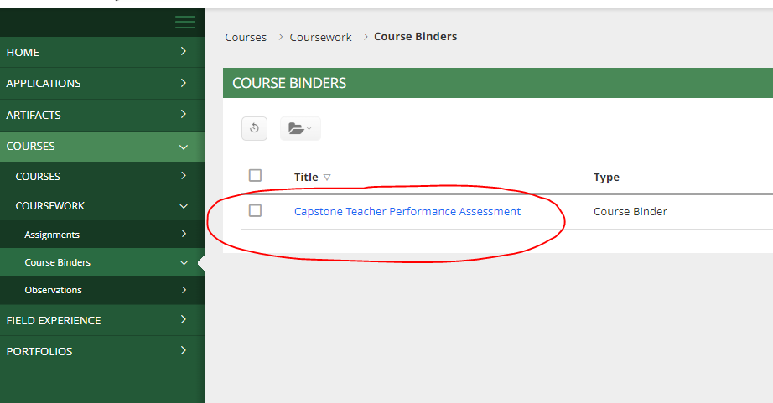

How do I open the Handbook and Templates?
The course binder is designed with a tab for each part, to navigate to each part click on the tab for that part. Note that the course binder will open to the main tab (circled in blue).
To open the handbook and templates click on the link on the main tab (see circled in red). The handbook with open in PDF. The templates will download or open in Word.
NOTE: if you are unable to download the templates for each part contact tk20@oswego.edu and we will share those templates through google drive.
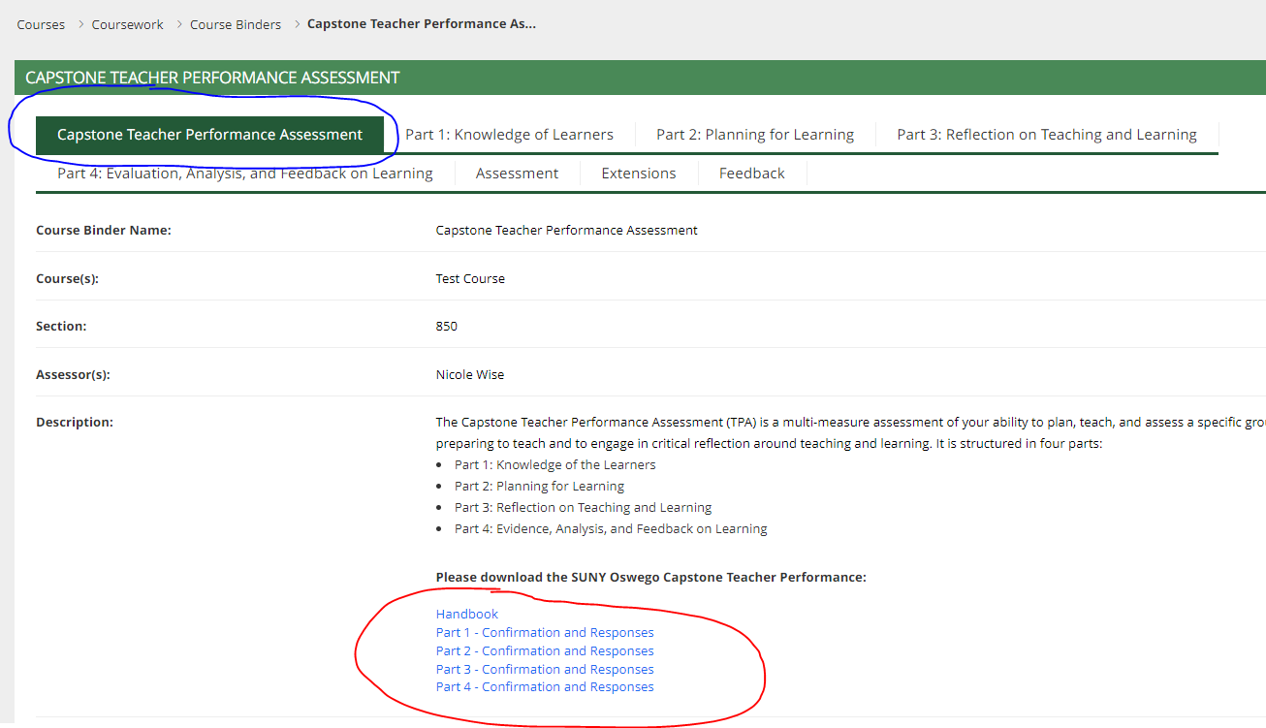

When in my assessment due?
Although there is a due date in your course binder do not abide by this due date! Be sure to ask your supervisor or faculty when the assessment is due.

How do I upload my files?
Click on the tab associated with files you would like to upload. On the right hand side of the screen click on “select”.
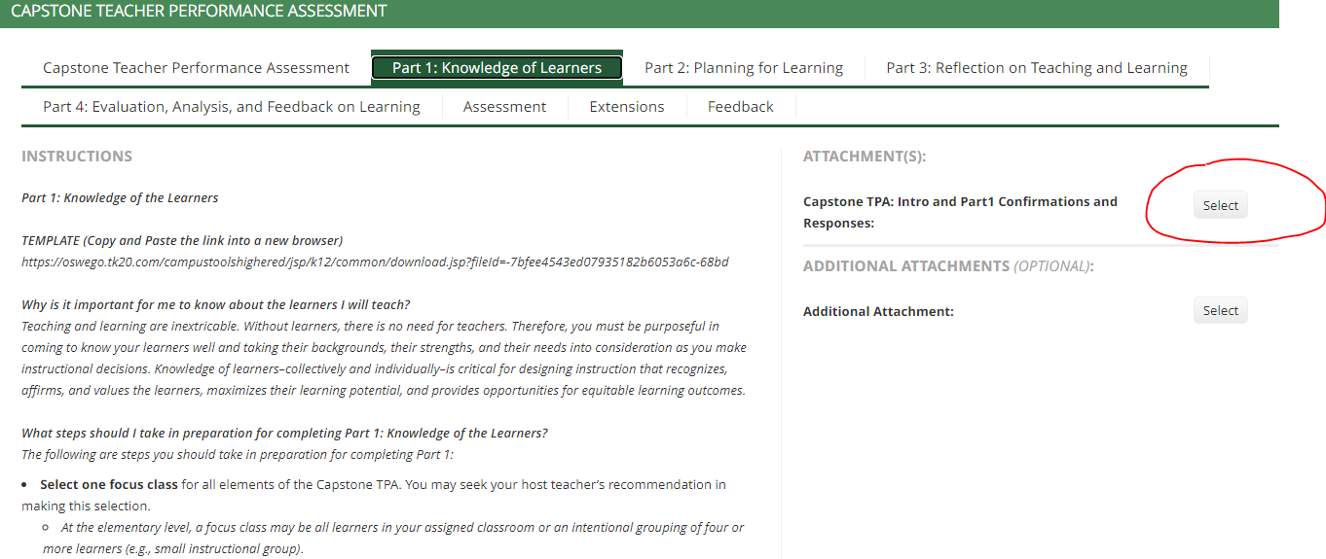

In the new window, click the green “select file” button. Once the file is selected click the green “add” button.

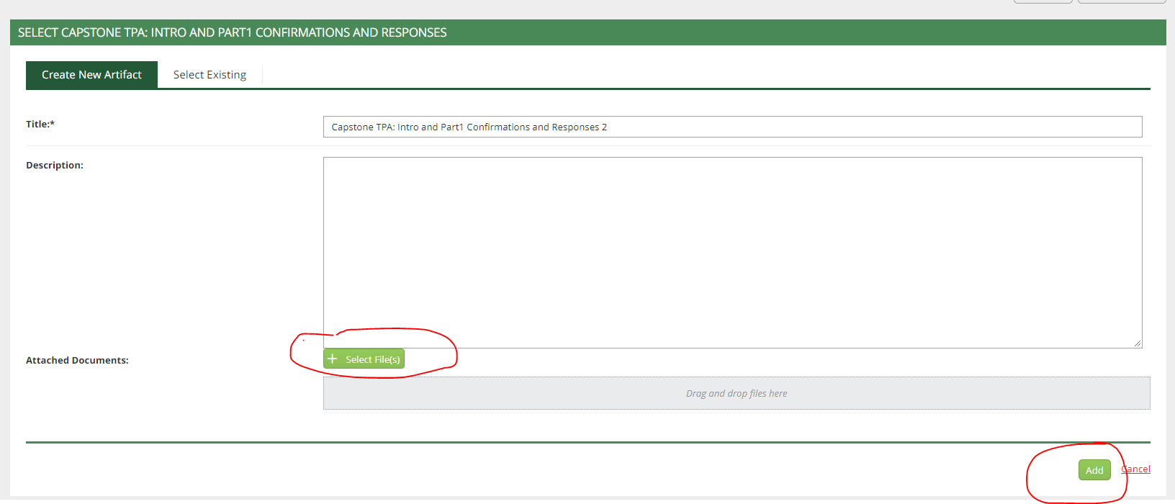
The course binder will be updated to show the file is attached.
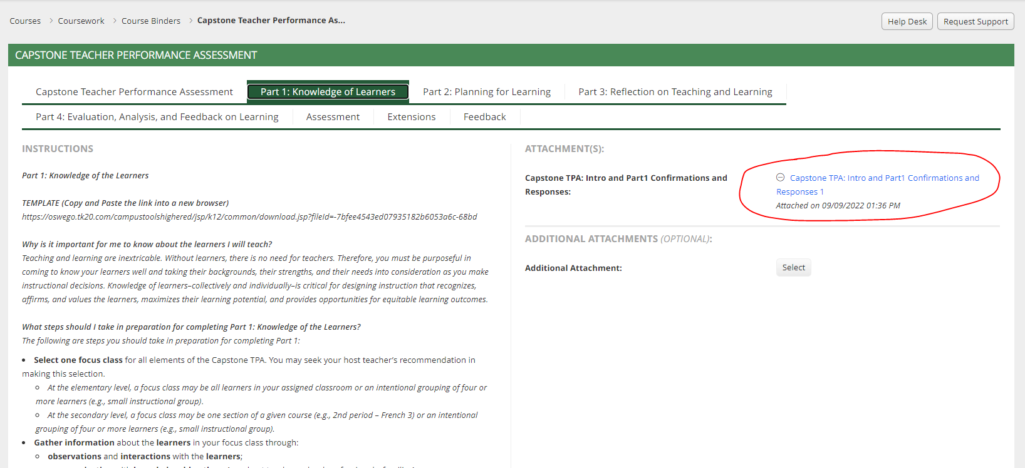

How do I submit my Capstone TPA/Pre-Capstone TPA?

After you have uploaded all the required documents, click the green “submit” button at the course binder.

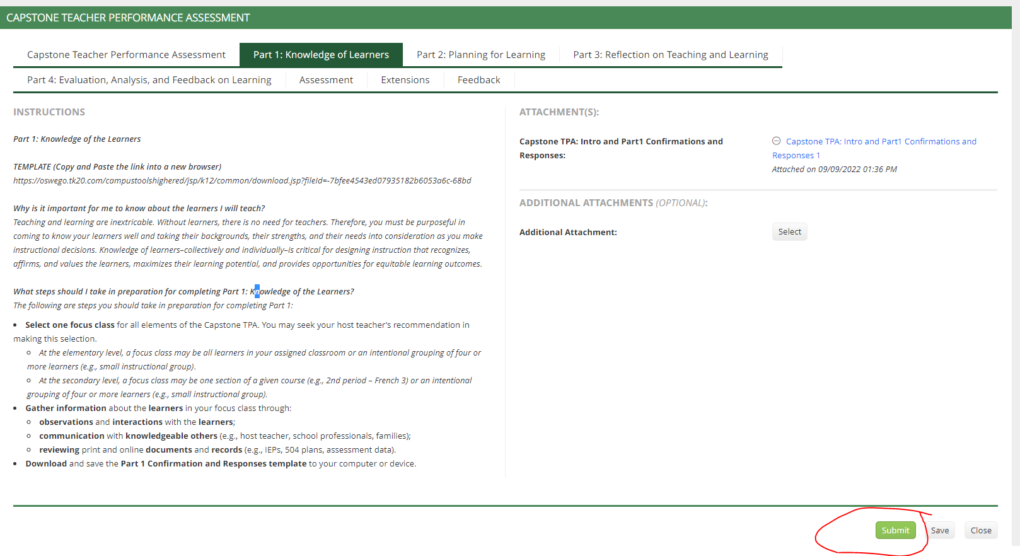

Please reach out to tk20@oswego.edu if you have questions or need assistance.

