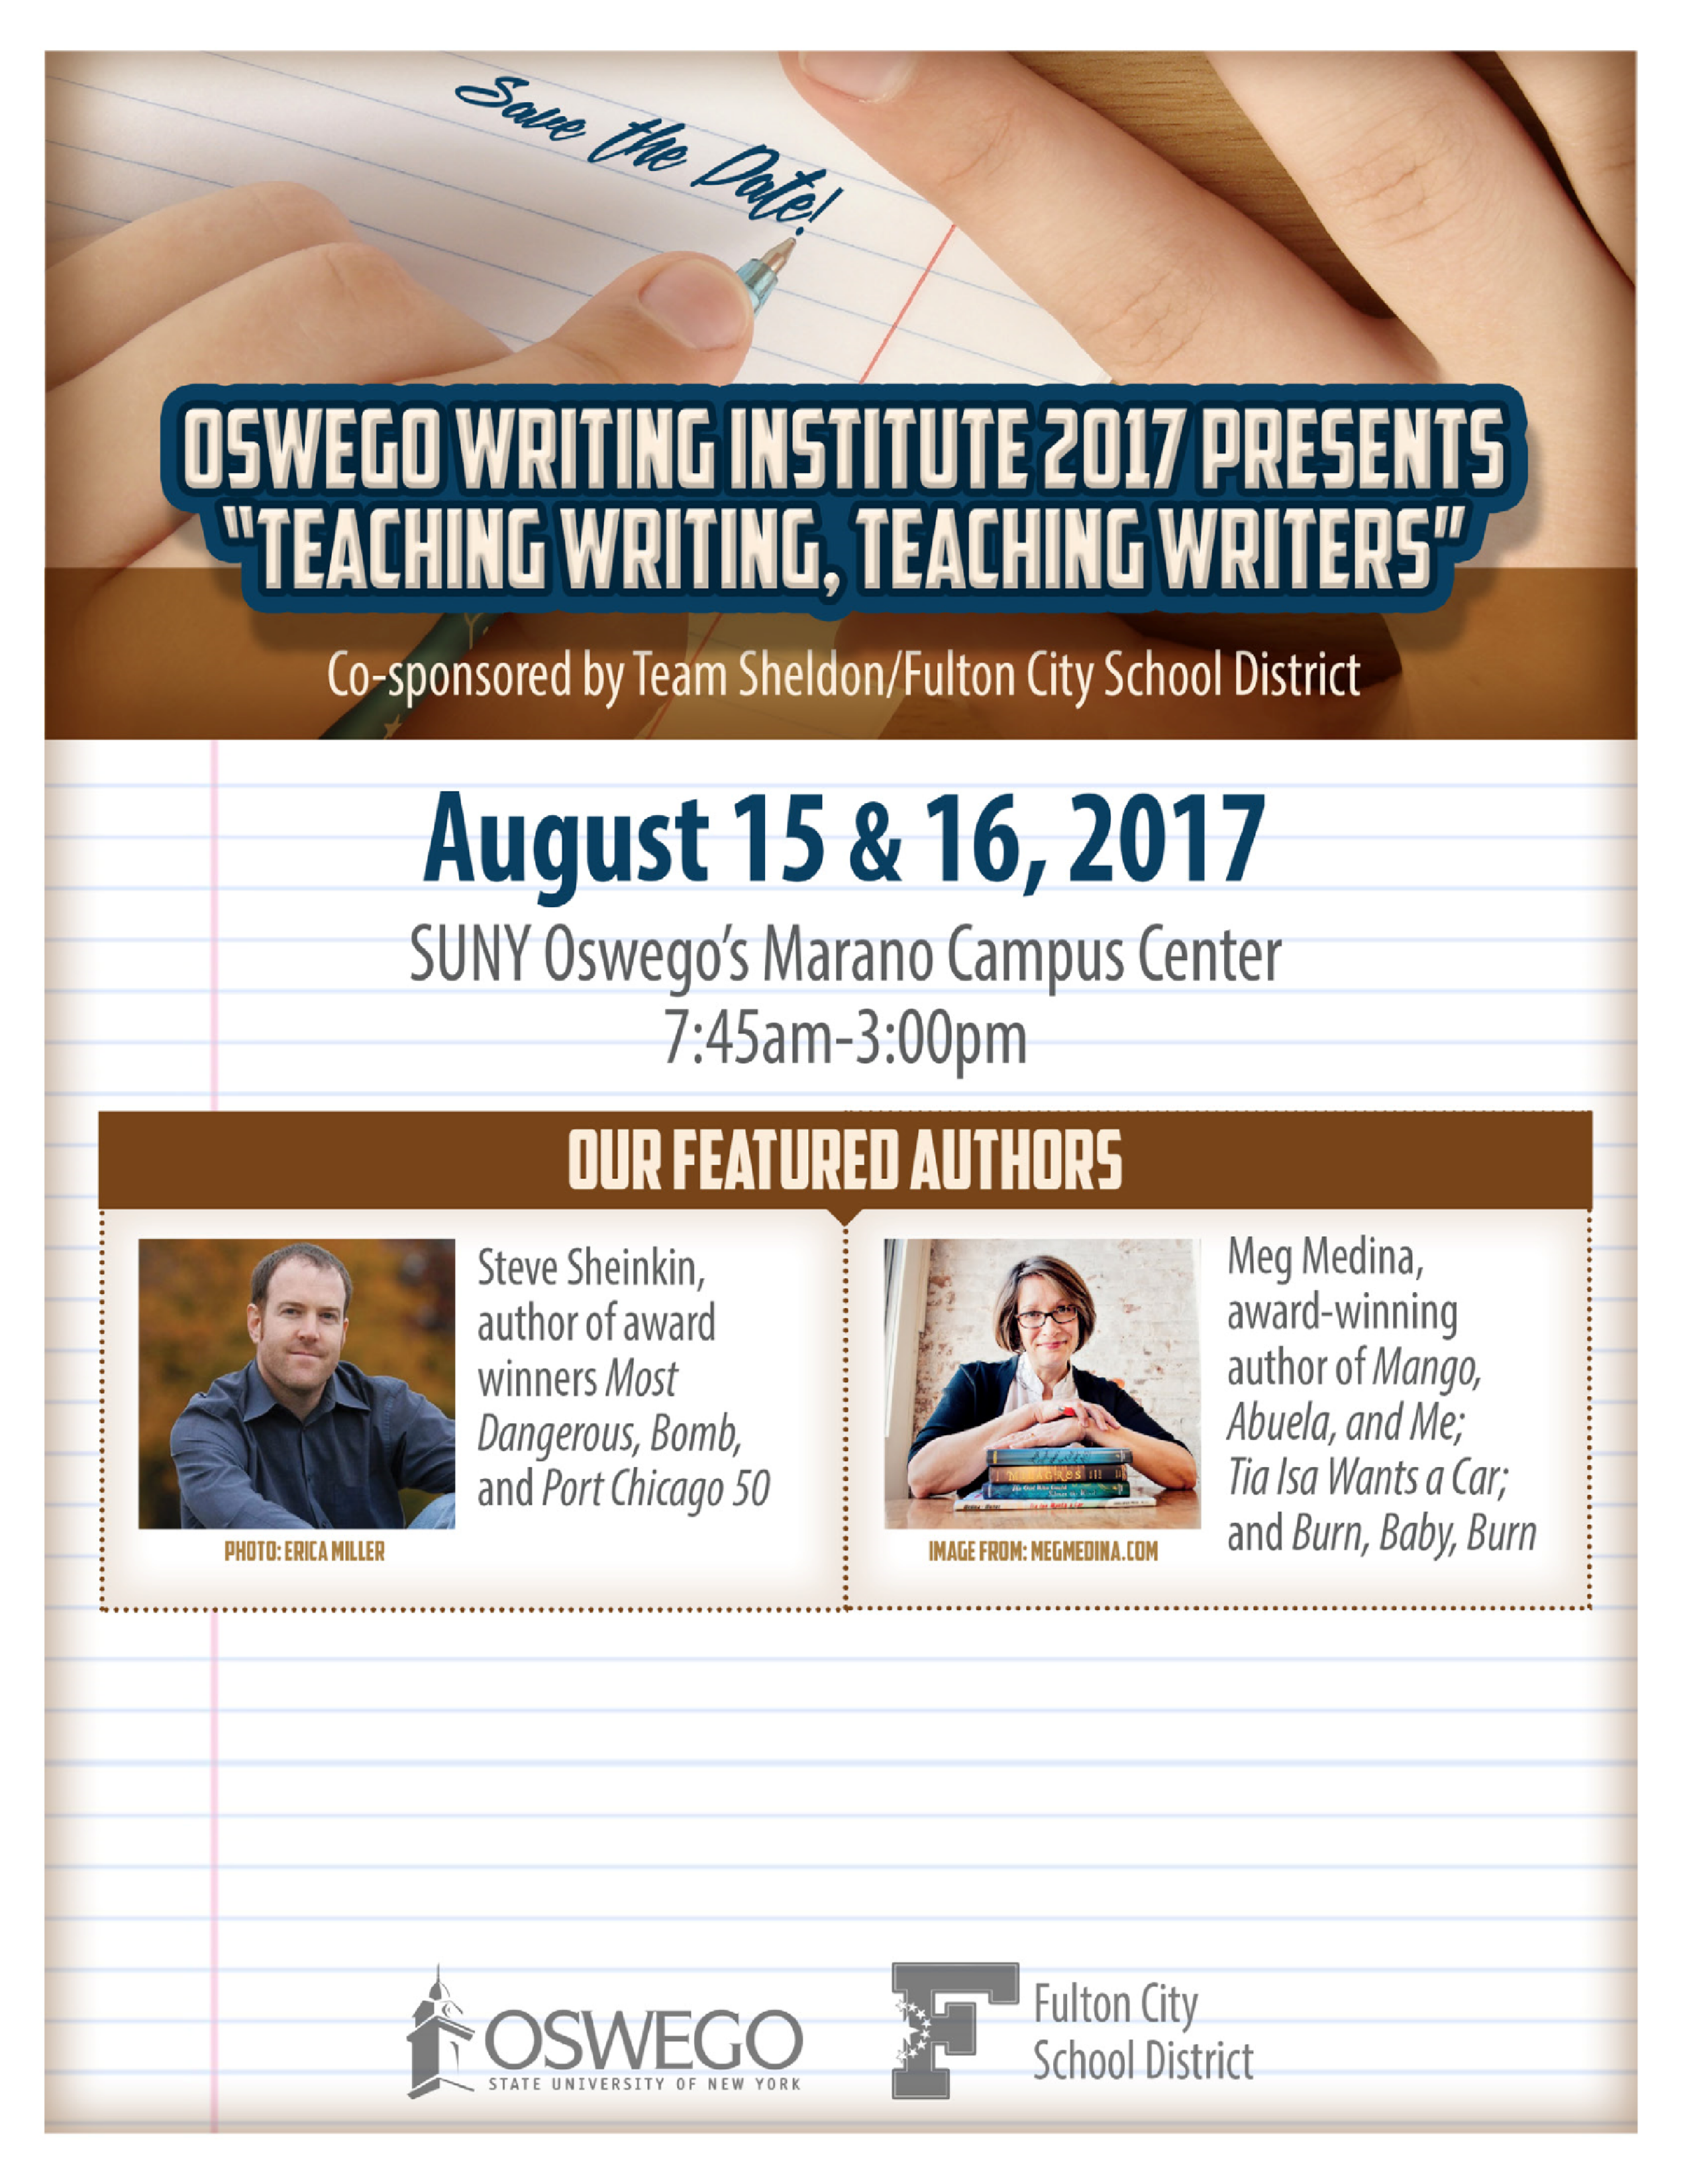

**PLAN AHEAD – DON’T MISS THIS**

**ANNUAL PROFESSIONAL DEVELOPMENT EVENT!**

**Contact:**

Chris Walsh or Carri Waloven,

*Co-Directors*

christine.walsh@oswego.edu

•

cwaloven@fulton.cnyric.org