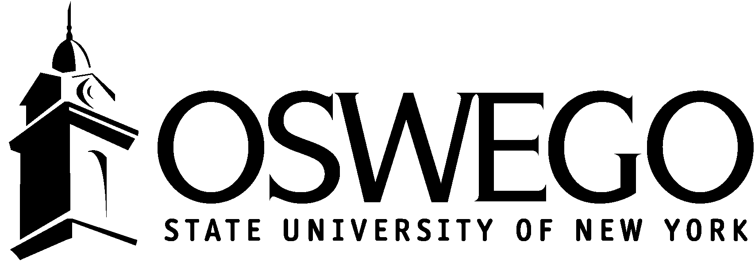
Curriculum and Instruction Department
Student Teaching Observation Form for Modern Language Education

Teacher Candidate__________________________________________ Date_________________________________

Cooperating Teacher________________________________________ Language / Level______________________
School___________________________________________________ Observation 1st € 2nd € 3rd € 4th €

Central Focus of the Lesson:________________________________________________________________________

Cultural Context:_________________________________________________________________________________

Rating Scale: T = Target N = Not There Yet
A = Acceptable NB = No Basis

- Planning
(based on lesson plan, observation, and input from cooperating teacher)
- Plans with students in mind.
- Plans with students’ learning needs in mind.
- Plans with students’ language levels and backgrounds in mind.
- Plans with language acquisition theory in mind.
- Plans with the learning standards in mind.
- Selects instructional materials with the learning standards in mind.
- Selects technology-based tools and resources with the learning standards in mind.
- Plans for integrated communication.
- Plans for integrated culture learning.
- Plans for interdisciplinary learning.
- Plans for language communities connections.
- Plans for on-going assessment.

- Instruction
- Teaches with the target language.
- Manages lessons and the learning environment.
- Communicates with clarity.
- Teaches with accuracy.
- Promotes and manages students’ target language interactions.
- Teaches with students’ learning needs in mind.
- Promotes students’ thinking.

- Assessment
- Assesses students’ learning in multiple ways throughout instruction.
- Assesses students’ standards-based performances.

- Professionalism
- Engages in reflective practice to improve teaching and learning.

Supervisor’s Signature________________________________

Teacher Candidate’s Signature_________________________

Observations and Commentary
___________________________________________
___________________________________________
_________________________________________________________________________________________________________________________________________________________________________________________________________________________________________________________________________________________________________________________________________________________________________________________________________________________________________________________________________________________________________________________________________________________________________________________________________________________________________________________________________________________________________________________________________________________________________________________________________________________________________________________________________________________________________________________________________________________________________________

_____________________________________________________________________________________________________________________________________________________________________________________________________________________________________________________________________
_____________________________________________________________________________________________________________________________________________________________________________________________________________________________________________________________________
_____________________________________________________________________________________________________________________________________________________________________________________________________________________________________________________________________
_____________________________________________________________________________________________________________________________________________________________________________________________________________________________________________________________________
_____________________________________________________________________________________________________________________________________________________________________________________________________________________________________________________________________
_____________________________________________________________________________________________________________________________________________________________________________________________________________________________________________________________________
_____________________________________________________________________________________________________________________________________________________________________________________________________________________________________________________________________
_____________________________________________________________________________________________________________________________________________________________________________________________________________________________________________________________________
_____________________________________________________________________________________________________________________________________________________________________________________________________________________________________________________________________
_____________________________________________________________________________________________________________________________________________________________________________________________________________________________________________________________________
_____________________________________________________________________________________________________________________________________________________________________________________________________________________________________________________________________
_______________________________________________________________________________________

