CPS Department
Mental Health Counseling
Program Evaluation
October 2023

Executive Summary
The Mental Health Counseling (MHC) Program at SUNY Oswego is committed to evaluating the program and using the results of these evaluations to make programmatic changes. The formal evaluations are based on outcome measures from multiple sources at multiple points across the program. Our program evaluations are both summative and formative. The MHC Program objectives form the basis of our evaluation.
Those objects are:
Mental Health Counseling Program graduates will (a) demonstrate mastery of counseling theories and skills and show the ability to utilize them therapeutically in clinical settings in the delivery of mental health service, (b) demonstrate proficiency in the eight common core counseling areas defined by CACREP, and (c) demonstrate appropriate counselor dispositions including the knowledge and skills to work in a multicultural and pluralistic society.
This evaluation found that the MHC Program is meeting the objectives. Areas of relative weakness were identified and plans to address these areas were completed by the MHC Program faculty. The general areas of relative weakness included preparation in crisis counseling, substance abuse counseling, vocational counseling, treatment planning, program evaluation, client advocacy, and responding to feedback.
The MHC Program Faculty met to discuss and enact programmatic changes to strengthen the program. Actions included:
- The program evaluation component of the research methods class (CPS 596) will be enhanced. Students will also be required to do a program evaluation proposal in place of the existing research proposal. This change was made for the Fall 2023 semester.

- An advocacy assignment will be added to all Spring 2024 sections of the Mental Health Practicum (CPS 512/513). A copy of that assignment is attached.

- The program crisis component of the Foundations of Mental Health Counseling class (CPS 508) will be enhanced. Students will complete training in the Columbia Suicide Severity Rating Scale. These changes were made for the Fall 2023 semester.
Mental Health Counseling Program Evaluation
The Mental Health Counseling program at SUNY Oswego was evaluated using multiple measures from multiple sources to evaluate the Program’s ability to meet the Mental Health Counseling Program’s stated objectives. The Mental Health Counseling Program has three program objectives that are reported in several places including the Program website, the student handbook, the site supervisors’ handbook, and other sources. Below is a table that outlines the Mental Health Counseling Program objectives, the data collected to evaluate progress towards the objectives, and a brief explanation of how that data are analyzed and used for program improvement.
Mental Health Counseling Program graduates will:
Objective | Data to be collected | Data types | How/when collected | Method for how data will be reviewed/analyzed | Explanation for how data will be used for curriculum and program improvement.
1. Demonstrate mastery of counseling theories and skills and show the ability to utilize them therapeutically in clinical settings in the delivery of mental health services. | CPS 510 Counseling Theory and Process Performance Assessment | Aggregate student assessment data that address student knowledge, skills, and professional dispositions | Collected on TK20 for every section of 510 near the end of each Fall semester. | Reviewed for each student in CPS510 by the instructor.  Aggregate data is reviewed annually in a MH faculty meeting. Aggregate data is reviewed annually in a MH faculty meeting. Trends, strengths, and concerns are noted and any actions needed will be recommended and recorded. | Actions recommended by the MH faculty will be used for program improvement.
 | Practicum/Internship evaluations | Aggregate student assessment data that address student knowledge, skills, and professional dispositions | Collected on TK20 for every section of CPS 512/513 (MH practicum classes) and 515/516 (MH internships) near the end of each section of practicum or internship.  Completed by site supervisors | Reviewed for each student in a MH practicum or internship by the instructor.  Aggregate data is reviewed annually in a MH faculty meeting. Trends, strengths, and concerns are noted and any actions needed will be recommended and recorded. | Actions recommended by the MH faculty will be used for program improvement.
 | Alumni Survey | Systematic follow-up studies of graduates | Collected bi-annually within the department. | Aggregate data is reviewed bi-annually in a MH faculty meeting as well as in a Program Advisory Group meeting. Trends, strengths, and concerns are noted and any actions needed will be recommended and recorded. | Actions recommended by the MH faculty will be used for program improvement.  Actions recommended by the PAG will be used for program improvement.
 | Site Supervisor Survey | Systematic follow-up studies of employers | Collected annually within the department. | Aggregate data is reviewed annually in a MH faculty meeting as well as in a Program Advisory Group meeting. Trends, strengths, and concerns are noted and any actions needed will be recommended and recorded. | Actions recommended by the MH faculty will be used for program improvement.  Actions recommended by the PAG will be used for program improvement.
 | Employer Survey | Systematic follow-up studies of employers | Collected bi-annually within the department. | Aggregate data is reviewed bi-annually in a MH faculty meeting as well as in a Program Advisory Group meeting. Trends, strengths, and concerns are noted and any actions needed will be recommended and recorded. | Actions recommended by the MH faculty will be used for program improvement.  Actions recommended by the PAG will be used for program improvement.
2. Demonstrate proficiency in the eight common core counseling areas defined by CACREP that include (1) professional counseling orientation and ethical practice, (2) social and cultural diversity, (3) human growth and development, (4) career development, (5) counseling and helping relationships, (6) group counseling and group work, (7) assessment and testing, and (8) research and program evaluation. | CPCE | Aggregate student assessment data that address student knowledge, skills, and professional dispositions | Each student must complete and pass the CPCE as an exit exam | Aggregate data is reviewed annually in a MH faculty meeting. Trends, strengths, and concerns are noted and any actions needed will be recommended and recorded. | Actions recommended by the MH faculty will be used for program improvement.
 | Alumni Survey | Systematic follow-up studies of graduates | Collected bi-annually within the department. | Aggregate data is reviewed bi-annually in a MH faculty meeting as well as in a Program Advisory Group meeting. Trends, strengths, and concerns are noted and any actions needed will be recommended and recorded. | Actions recommended by the MH faculty will be used for program improvement.  Actions recommended by the PAG will be used for program improvement.
3. Demonstrate appropriate counselor dispositions including the knowledge and skills to work in a multicultural and pluralistic society. | Practicum/internship evaluations | Aggregate student assessment data that address student knowledge, skills, and professional dispositions | Collected on TK20 for every section of CPS 512/513 (MH practicum classes) and 515/516 (MH internships) near the end of each section of practicum or internship. | Reviewed for each student in a MH practicum or internship by the instructor.  Aggregate data is reviewed annually in a MH faculty meeting. Trends, strengths, and concerns are noted and any actions needed will be recommended and recorded. | Actions recommended by the MH faculty will be used for program improvement.
 | Employer survey | Systematic follow-up studies of employers | Collected bi-annually within the department | Aggregate data is reviewed bi-annually in a MH faculty meeting as well as in a Program Advisory Group meeting. Trends, strengths, and concerns are noted and any actions needed will be recommended and recorded. | Actions recommended by the MH faculty will be used for program improvement.  Actions recommended by the PAG will be used for program improvement.
 | Alumni Survey | Systematic follow-up studies of graduates | Collected bi-annually within the department | Aggregate data is reviewed bi-annually in a MH faculty meeting as well as in a Program Advisory Group meeting. Trends, strengths, and concerns are noted and any actions needed will be recommended and recorded. | Actions recommended by the MH faculty will be used for program improvement.  Actions recommended by the PAG will be used for program improvement.
 | Demographic Data | demographic and other characteristics of applicants, students, and graduates including: | All data collected and housed in the Graduate Studies Office

For each of the program objectives, the results of the collected data are presented and discussed.

Assessment and Evaluation of Objective 1
Objective 1: Demonstrate mastery of counseling theories and skills and show the ability to utilize them therapeutically in clinical settings in the delivery of mental health services.
Six data sources were collected to evaluate how well the program met the first objective: the CPS 510 Counseling Theory and Process Performance Assessment, the Mental Health Counseling Practicum & Internship Evaluations of Students, the Alumni Survey, the Employer Survey, and the Employer Survey.
The CPS 510 Counseling Theory and Process Performance Assessment is collected at the end of a student’s first semester in the program at the conclusion of the pre-practicum course, CPS 510. This course teaches basic counseling skills and helps to create a foundation for the subsequent field experiences. This Performance Assessment rates the student on 10 counseling skills and 3 professional dispositions using a rubric where 1 = below expectations, 2 = near expectations, and 3 = meeting expectations. Students are expected to minimally score a 2 on all the scales to move through the program without remediation.
The following graph shows the aggregated results of the Fall 2022 class of mental health counseling students. The skills (i.e., attending through reflection of meaning) all averaged between “near expectations” and “meeting expectations.” The relatively lowest ratings of skills were for using confrontation and reflecting meaning. These tend to be more advanced skills compared to the others, so the lower relative ratings are not surprising. The average rating for all skills combined was 2.76.
Students were rated on three professional dispositions: professional behavior, multicultural competence, and accepting feedback. Overall, students were rated highly on these dispositions with an average overall rating of 2.98.

CPS 510 Counseling Theory and Process Performance Assessment
Fall 2022
N=18

Average Skills Rating = 2.76
Average Professional Dispositions Rating = 2.98
The Practicum Site Supervisor Evaluation of Practicum Student is collected at the end of a student’s 2nd semester in the program near the end of their practicum field experience (CPS 512/513). This evaluation had four major scales: basic practicum requirements; counselor practice, knowledge, and skills; becoming a professional counselor, and site and community skills. The first two scales, basic requirements and counselor practice, are applicable to Objective 1. Those scales measure the core skills and knowledge required of mental health counselors. These scales are comprised of 39 questions and the second scale, counselor practice is divided into subscales as shown in the table below. The evaluation is on a 1 – 5 scale where 1 means “highly unsatisfactory” and 5 means “highly satisfactory.”
The table below shows that in all the scales, students performed between “satisfactory” and “highly satisfactory.” The lowest-rated scales include “Applying advanced counseling skills such as advanced accurate empathy and confrontation within the counseling process” and “Formulating and implementing a plan to deal with a client problem.”
Although not shown in the table below, an investigation of individual items that were the lowest rated, the following items were all rated below a score of 4 (satisfactory).
Although not shown in the table below, an investigation of individual items that were the lowest rated, the following items rated below a score of 4 (satisfactory).
- Creating a treatment plan for substance abuse disorders ($\overline{x}$ = 3.80)
- Diagnosing based on DSM5 or other assessment instruments ($\overline{x}$ = 3.83)

Practicum Site Supervisor Evaluation of Practicum Student
Spring 2023
Component | Mean | N
A. Performance of Basic Practicum Requirements | 4.50 | 18
B. Counselor Practice, Knowledge, and Skills | 4.34 | 18
1. Applying core counseling skills of empathy, respect, concreteness, genuineness, and immediacy within the counseling process: | 4.66 | 18
2. Applying advanced counseling skills such as advanced accurate empathy and confrontation within the counseling process: | 4.17 | 18
3. Using modes of direct service intervention appropriate to role level, client needs, and site function | 4.35 | 18
4. Formulating and implementing a plan to deal with a client problem: | 4.10 | 18
5. Terminating and evaluating the counseling relationship: | 4.23 | 18

The Mental Health Counseling Internship Student Evaluation is also used to assess Objective 1. This evaluation is completed by the site supervisor at the completion of every semester that a student is placed at an internship site (CPS 515/516). The evaluation is completed by the site supervisor and is housed in TK20, the online data management system. This evaluation had four major scales: basic practicum requirements; counselor practice, knowledge, and skills; becoming a professional counselor, and site and community skills. The first two scales, basic requirements and counselor practice, are applicable to Objective 1. Those scales measure the core skills and knowledge required of mental health counselors. These scales are comprised of 39 questions and the second scale, counselor practice is divided into subscales as shown in the table below. The evaluation is on a 1 – 5 scale where 1 means “highly unsatisfactory” and 5 means “highly satisfactory.”
The table below shows that in all the scales, students performed between “satisfactory” and “highly satisfactory.” The lowest-rated scales, as was the case with the practicum evaluations, were “Applying advanced counseling skills such as advanced accurate empathy and confrontation within the counseling process” and “Formulating and implementing a plan to deal with a client problem.”
Although not shown in the table below, an investigation of individual items that compose the scales, the following items were all rated below a score of 4 (satisfactory).
Although not shown in the table below, an investigation of individual items that were the lowest rated, the following items rated below a score of 4 (satisfactory).
- Using responsible confrontation to challenge client discrepancies ($\overline{x}$ = 3.96)
- Planning and addressing substance abuse disorders ($\overline{x}$ = 3.91)
- Works effectively with client resistance ($\overline{x}$ = 3.88)

The Mental Health Counseling Internship Student Evaluation
Fall 2022-Summer 2023
Component | Mean | N
A. Performance of Basic Practicum Requirements | 4.46 | 52
B. Counselor Practice, Knowledge, and Skills | 4.30 | 52
1. Applying core counseling skills of empathy, respect, concreteness, genuineness, and immediacy within the counseling process: | 4.50 | 52
2. Applying advanced counseling skills such as advanced accurate empathy and confrontation within the counseling process: | 4.11 | 52
3. Using modes of direct service intervention appropriate to role level, client needs, and site function | 4.32 | 52
4. Formulating and implementing a plan to deal with a client problem: | 4.18 | 52
5. Terminating and evaluating the counseling relationship: | 4.44 | 50

The Alumni Survey is also used to assess Objective 1. The alumni survey is a biannual survey of former students of the Mental Health Counseling Program. This survey was collected in the summer of 2023. The survey is a 26-item questionnaire with two open-ended questions. The following set of graphs show the distribution of responses to individual questions. The questions were designed to capture the eight core areas of Mental Health Counseling as well as other areas the faculty determined were critical parts of our training. It is worth noting that most participants in this round were in the program during the Covid era with lockdowns and other unique challenges.
Responses to these questions were generally positive. Graduates in general report that they believe the program prepared them for work as a Mental Health Counselor. Items where at least 10% of the respondents reported negative responses were determined to be areas of relative weakness. These items assessed preparedness in career development, crisis intervention, and treatment planning. Program evaluation skills, while not meeting the criteria above for a relative weakness, was also an area that could be improved.
Alumni Survey 2023 N=24
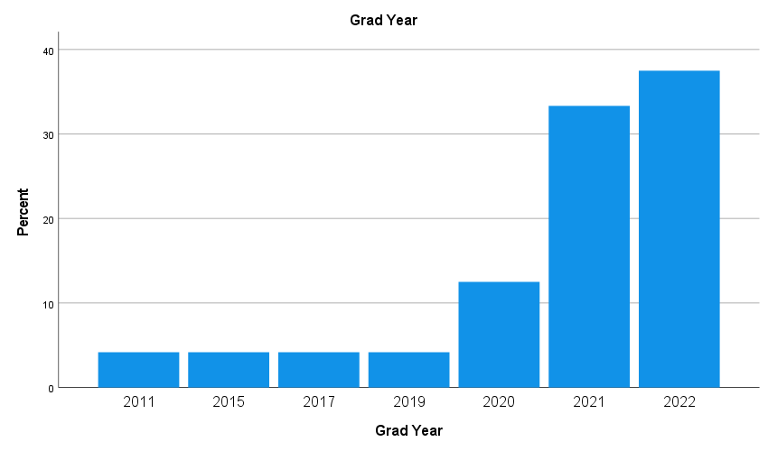

Please rate how well you believe the program prepared you in the following core areas of MH counselor training:

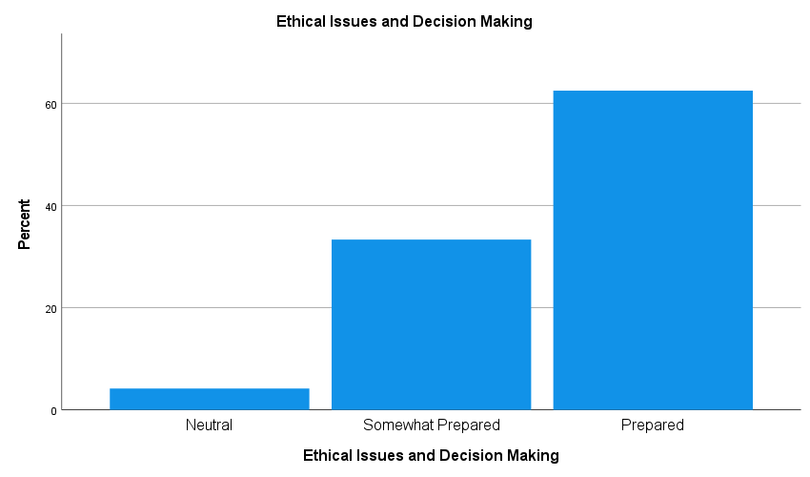

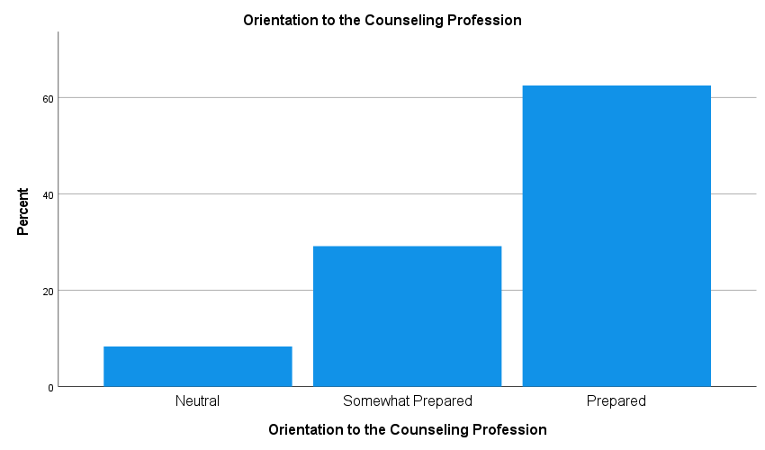

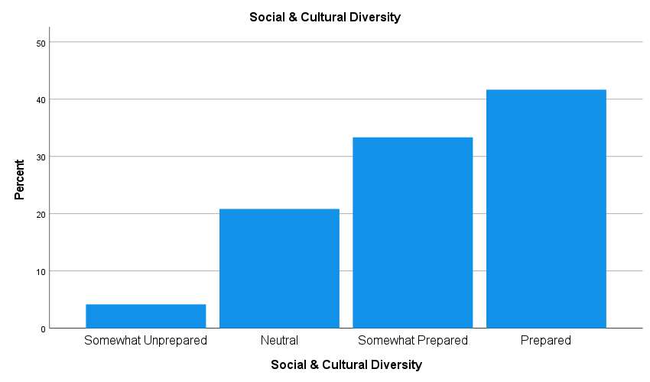

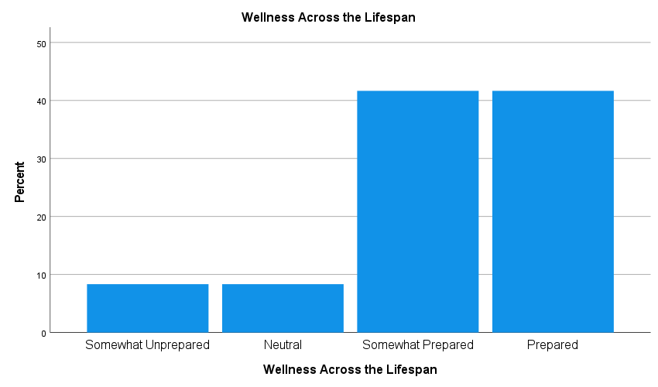

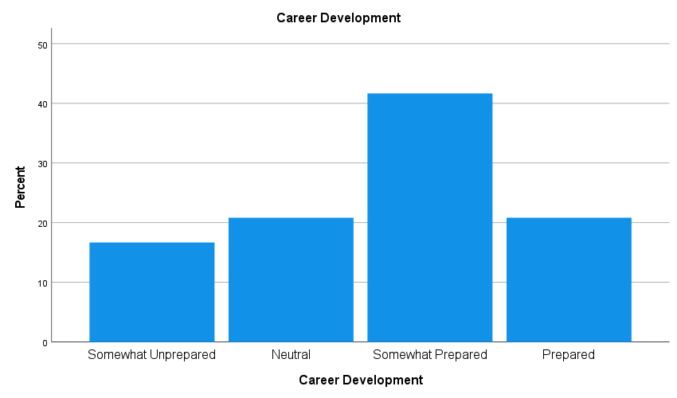

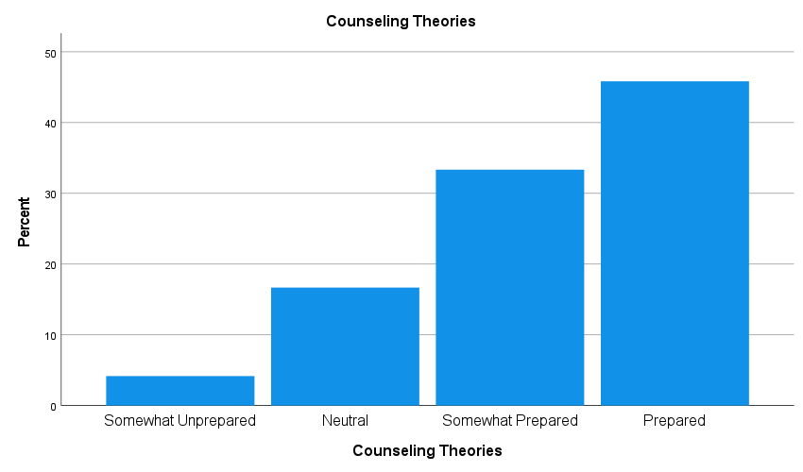

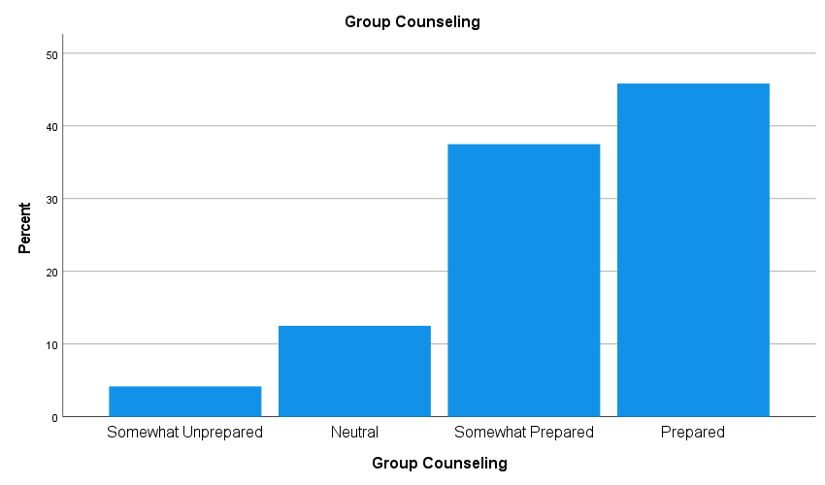

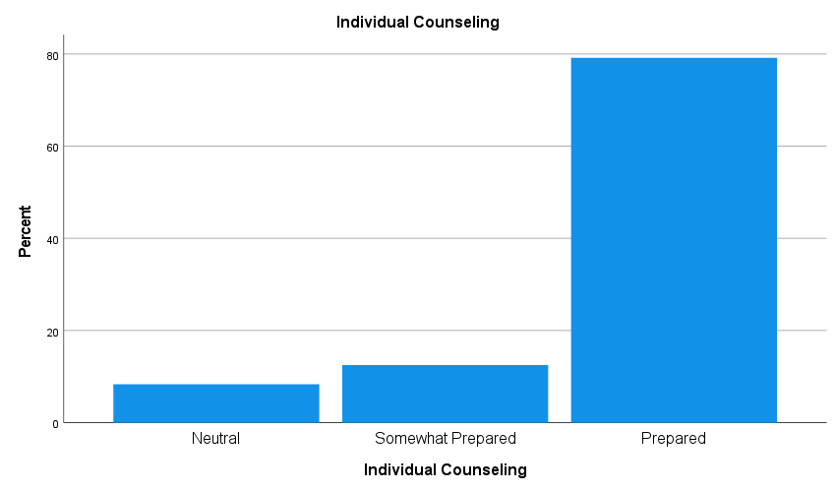

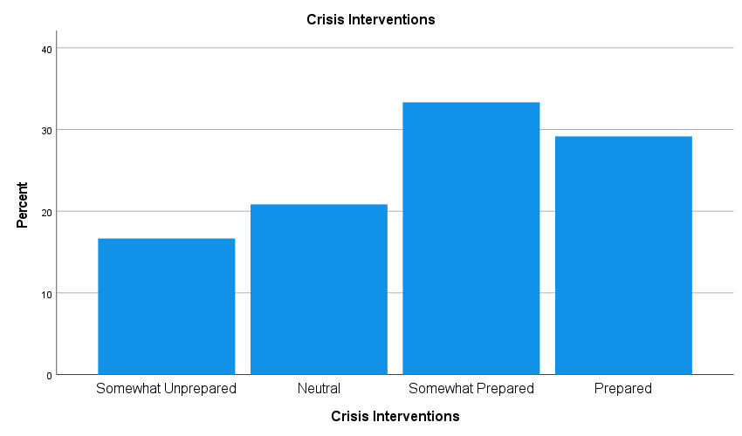

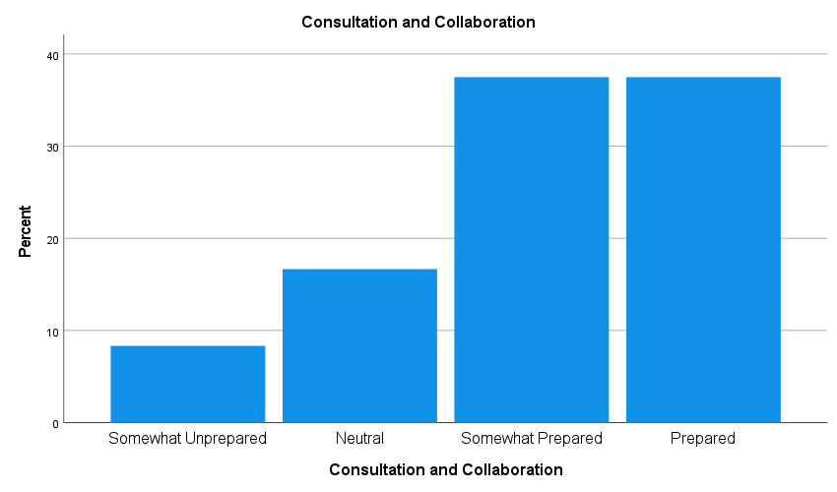

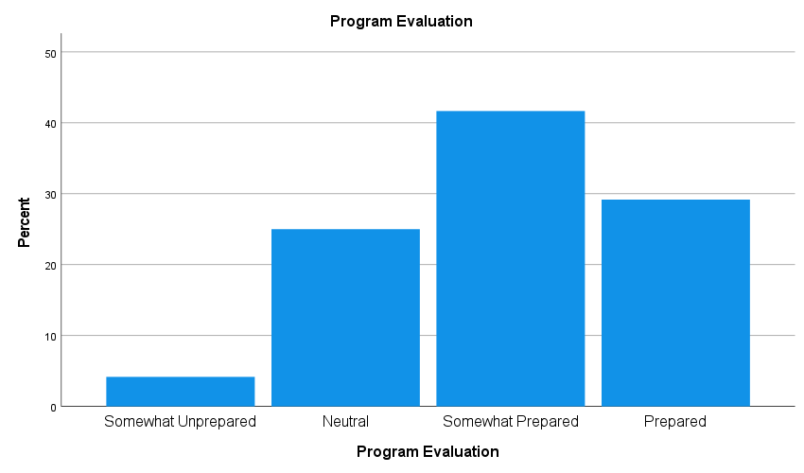

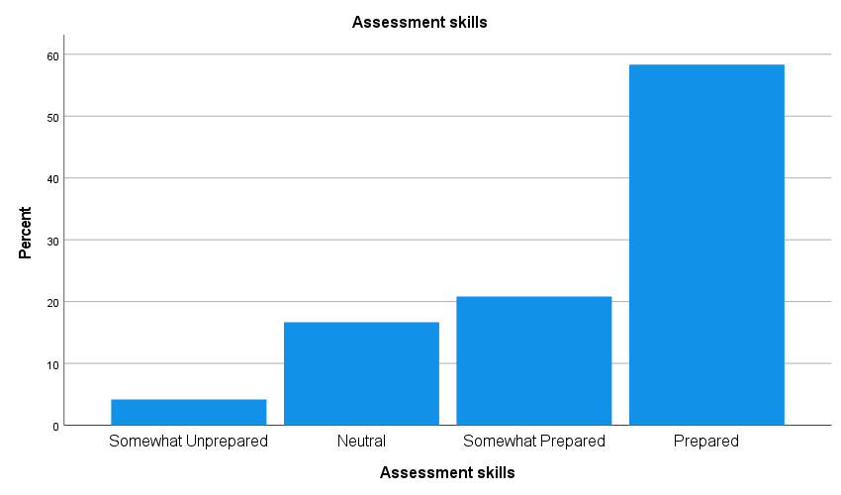

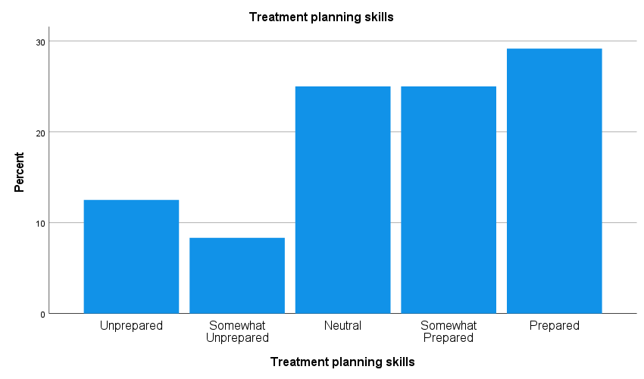
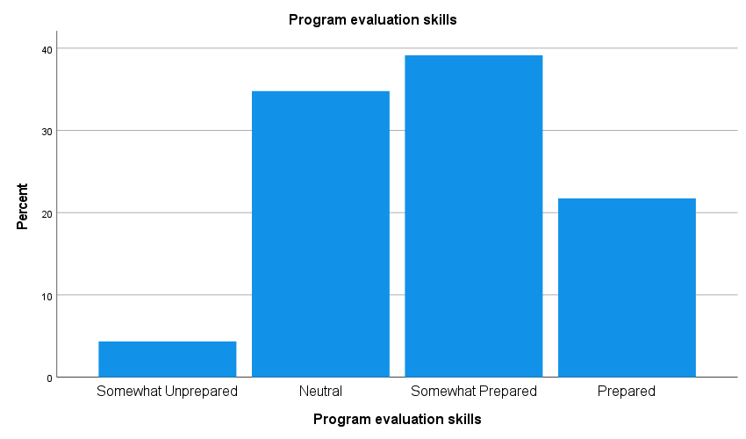

Please rate your experiences in the following areas as students in the SUNY Oswego MHC Program:

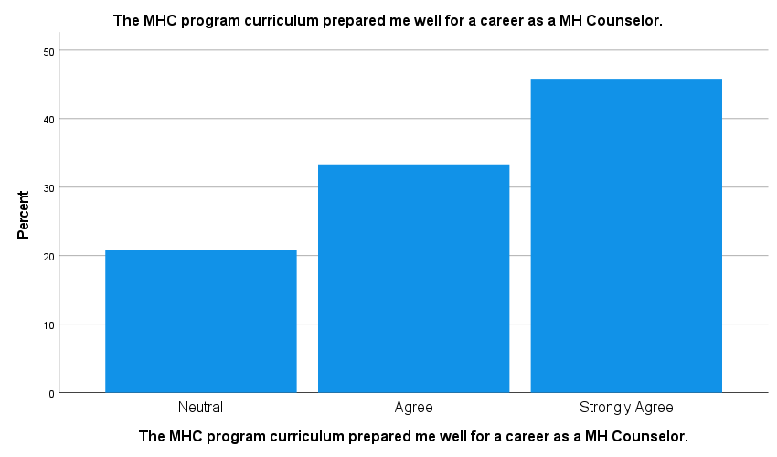

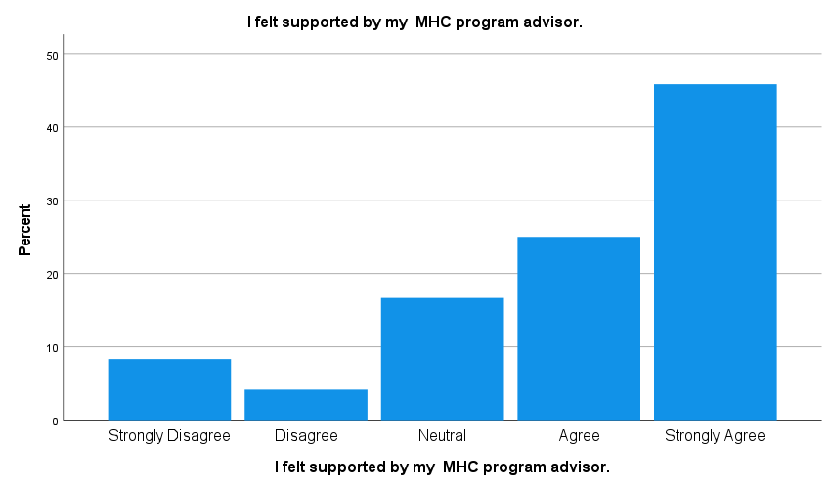

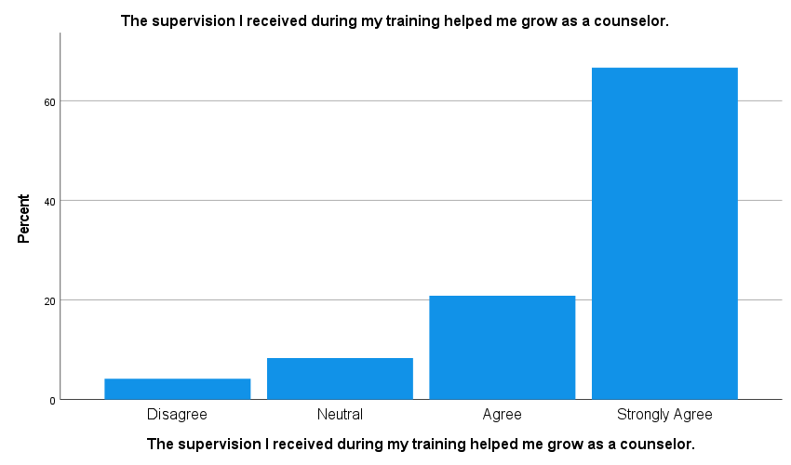

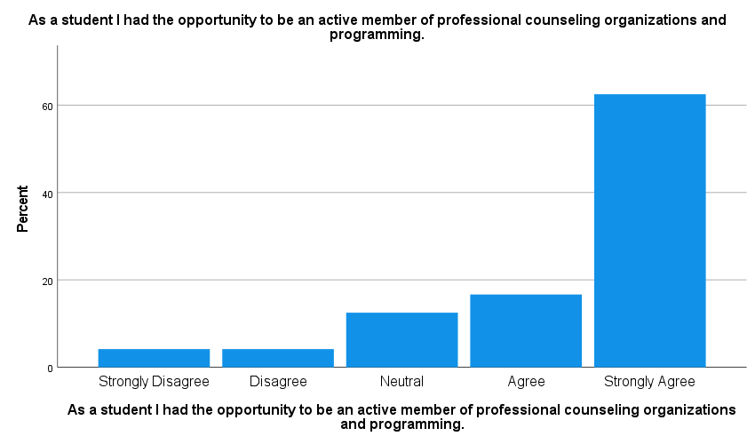

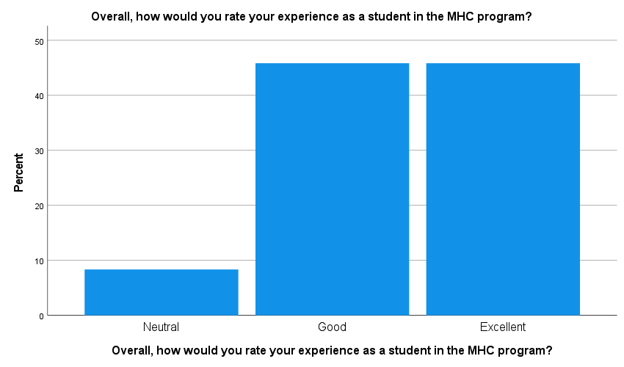

The Site Supervisor Survey was also used to assess Objective 1. This annual survey was administered in the summer of 2023. Fourteen of our site supervisors responded to the survey. The survey was broken into two major themes: specific professional skills and professional dispositions. The specific professional skills were applicable to evaluating Objective 1.
The section regarding specific professional skills shows that site supervisors generally rate CPS students as “good” in the listed skills. There were some notable points that were elucidated in the results. A significant portion of the respondents indicated that they were not able to evaluate students on substance abuse counseling and group counseling. A close inspection of the results did indicate that students at sites that emphasize SA counseling were generally rated as good. While substance abuse counseling might be specific to certain sites, it seems that we need to promote more opportunities for students to participate in groups. Site supervisors may have just supervised practicum students who traditionally are focused on developing individual counseling skills. However, going forward the program will work to create more group counseling opportunities.

Site Supervisor Survey 2023
N=14
Specific Professional Skills
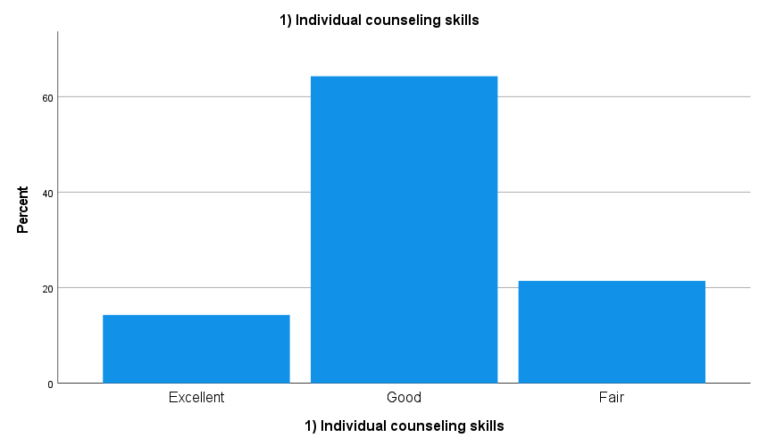

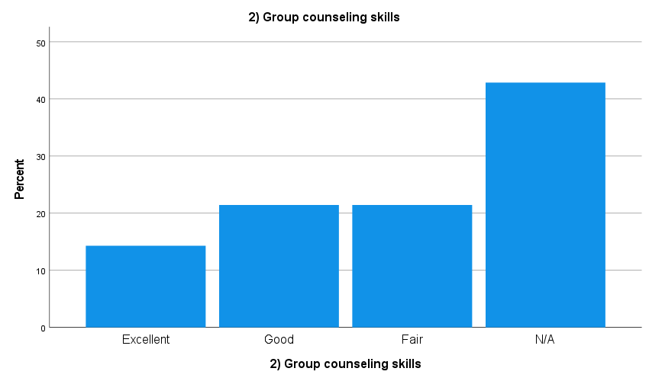

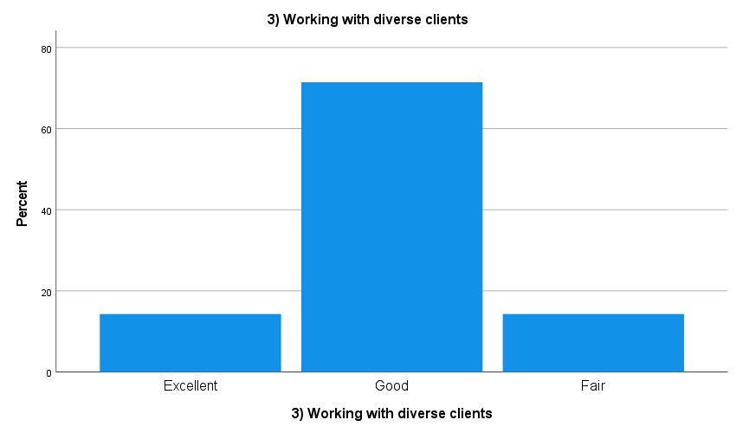
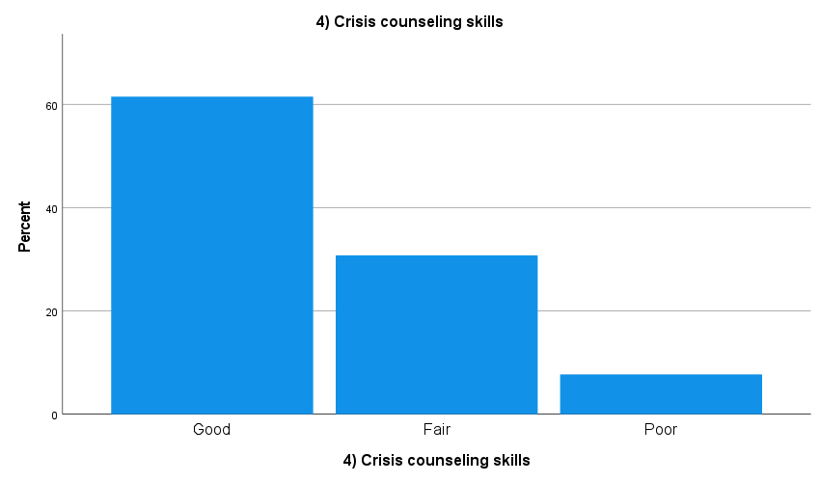

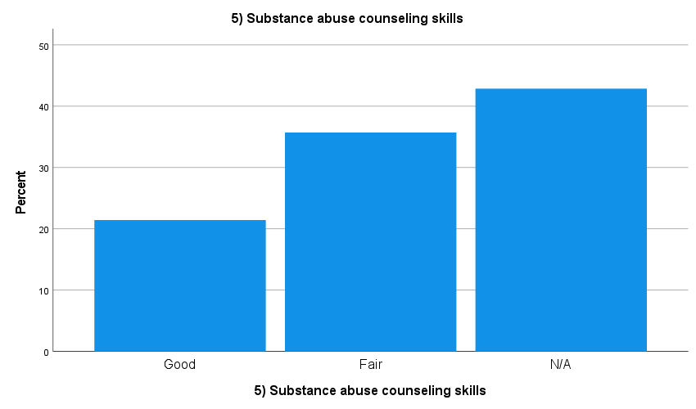

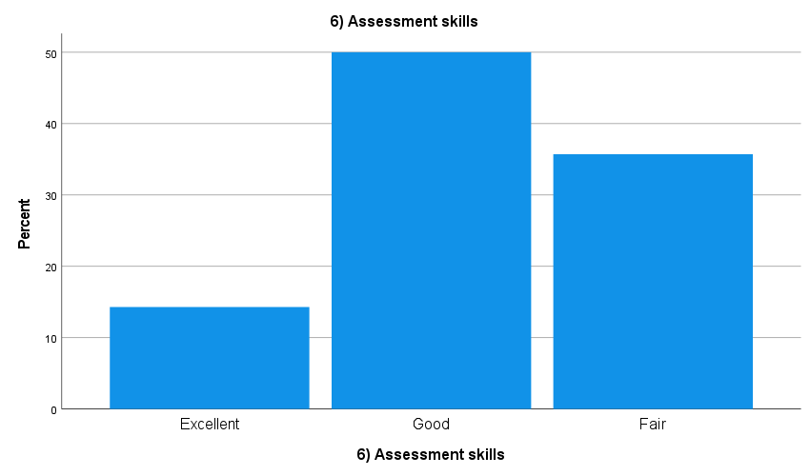

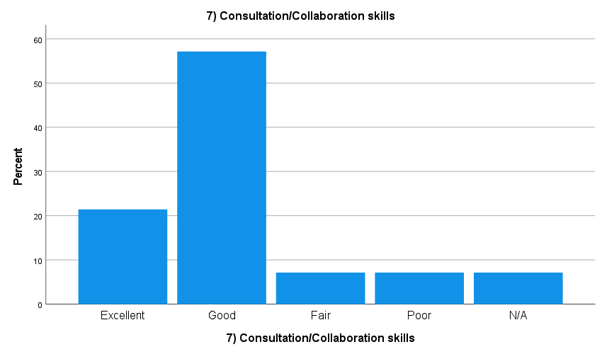

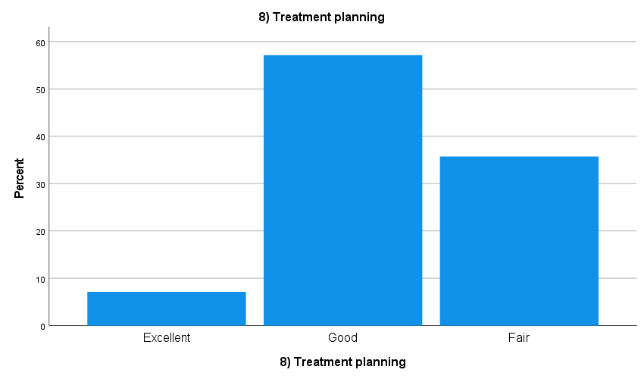

The employer survey is a biannual survey administered to regional employers of our graduates. Employers were contacted and asked to complete the survey. Six counseling businesses responded to the survey. Employers were asked to provide their general perceptions of Oswego MH Counseling graduates as employees at their sites. The survey was composed of two major scales. One scale was an assessment of Oswego graduates' specific professional skills and the second section assessed professional dispositions. For objective one, the scale of professional skill assessment was used.
The modal responses when evaluating Oswego graduates were “good” on a scale from poor to excellent. There were some noteworthy findings. Crisis counseling received a modal response of “fair.” This is an area the faculty will discuss regarding the need to increase training in that area. However, changes of the last year were made to increase class time on crisis interventions. Those changes are not likely reflected in this survey administration. Vocational counseling skills and substance abuse were also rated slightly lower than other items with equal “good” and “fair” responses.
Employer Survey 2023 N=6

Graduates' Specific Professional Skills:
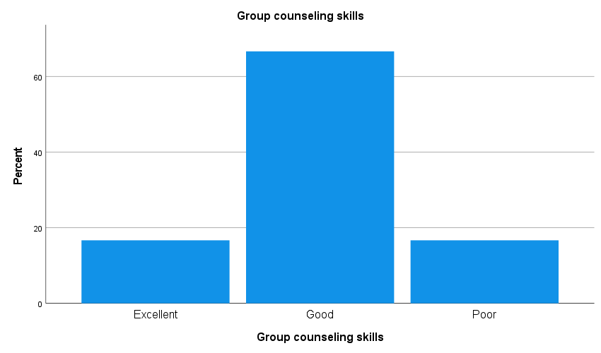

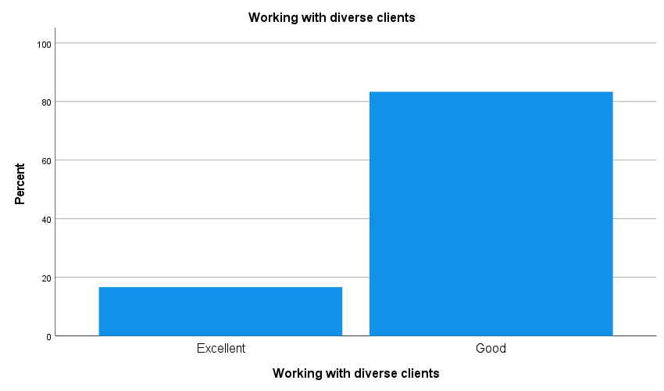

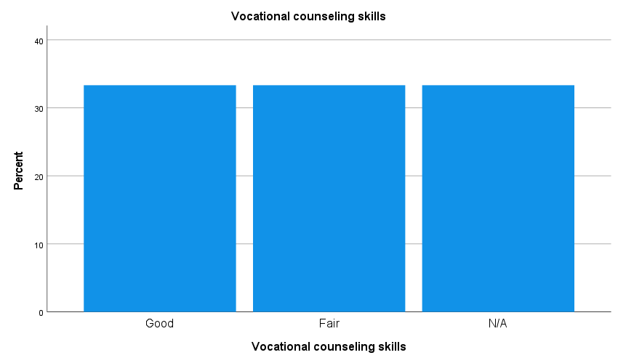
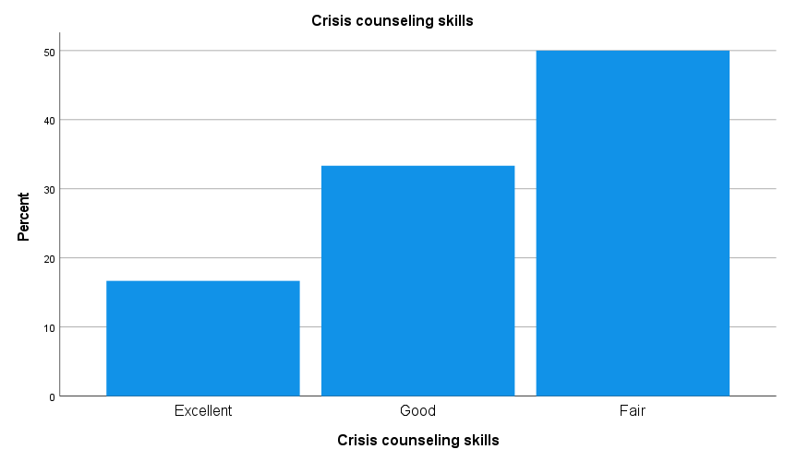

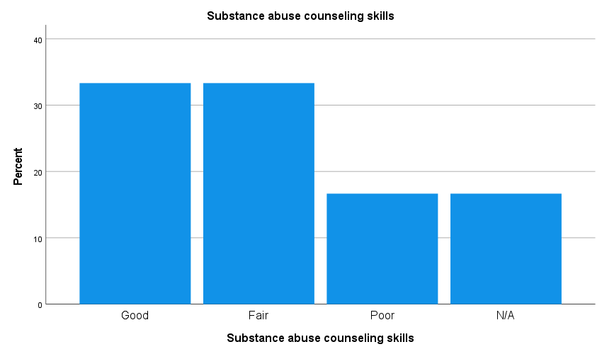

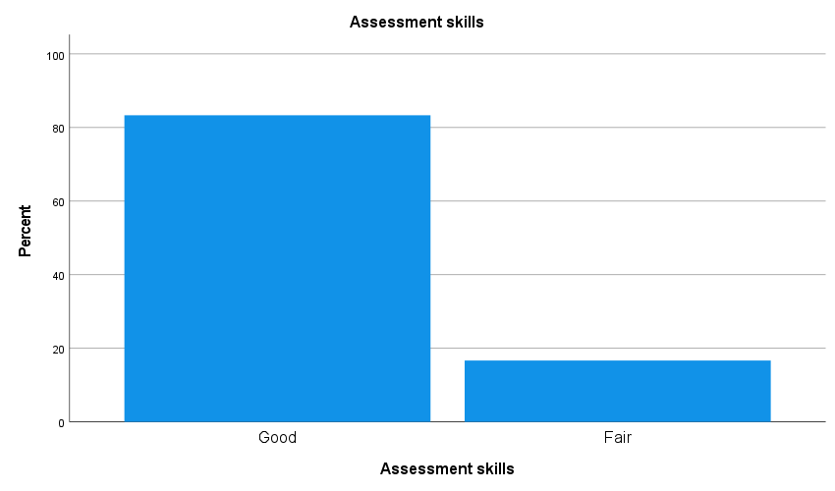

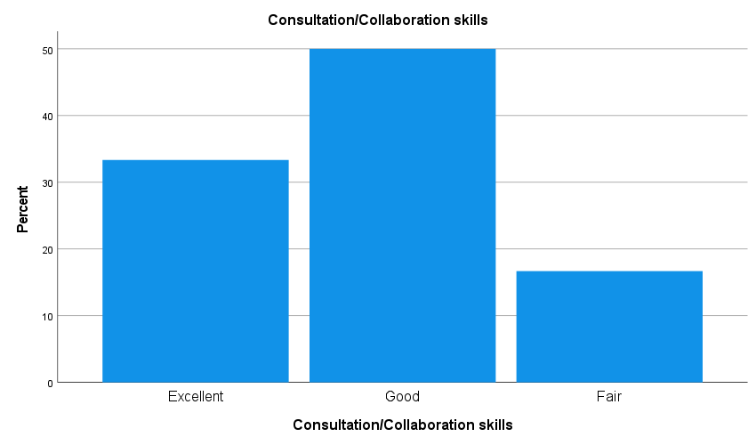

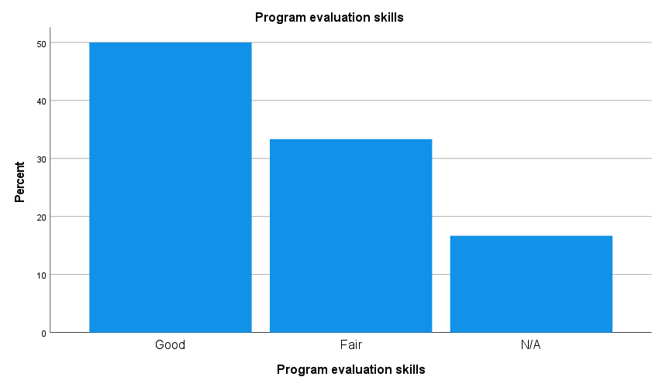

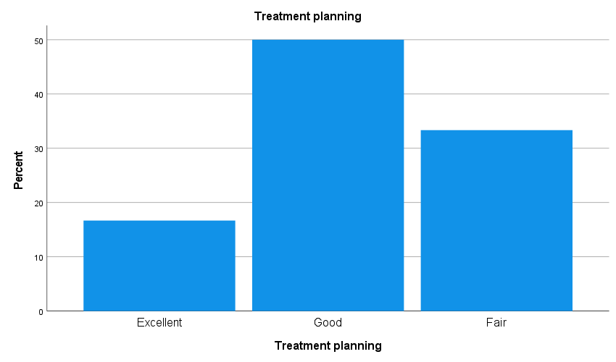

Summary of Objective 1 Findings
Six measures were used to assess Objective 1 to demonstrate mastery of counseling theories and skills and show the ability to utilize them therapeutically in clinical settings in the delivery of mental health services.
The results across measures indicate that the CPS Dept. is meeting this objective. Four areas for improvement were noted including crisis counseling, substance abuse counseling, vocational counseling, and treatment planning. These are areas that the program faculty and the Program Advisory Committee will discuss this upcoming year to determine if and what changes should be made.
Assessment and Evaluation of Objective 2
Objective 2. Demonstrate proficiency in the eight common core counseling areas defined by CACREP that include (1) professional counseling orientation and ethical practice,(2) social and cultural diversity, (3) human growth and development, (4) career development, (5) counseling and helping relationships, (6) group counseling and group work, (7) assessment and testing, and (8) research and program evaluation.
This objective is focused on assessing CPS MH Counseling students’ knowledge in the eight common core areas of counseling. This is achieved through two measures, the Counselor Preparation Comprehensive Examination (CPCE) and the Alumni Survey.
The CPCE is an national exam that assesses students’ knowledge related to the eight (8) common–core areas defined by CACREP and listed in the objective. This is an exam that is used as an exit exam and is required by all students to pass prior to graduation.
The CPCE is a 160-question exam, although only 136 items are included in the grade. Each of the common core areas are assessed by 17 items. The test is graded by Pearson and the results are sent to the department. Scores are reported for each of the 8 core areas as well as a total score. The test-maker also provides national data on the test. Students must score minimally within one standard deviation (the average range) from the national average to pass the test. Students may retake the test if unsuccessful. Scores were compiled for the last year from August 2022 to August 2023. Twenty-eight students took the test and all passed on their initial try.
Compared to the national sample of students who also took the CPCE as an exit exam, CPS students did approximately 1 point above the average national score. On knowledge of the 8 core areas, CPS students are on par with the national average.
The eight core areas were examined to identify the areas of comparative strength and weakness. To do this, the average score in each of the eight core areas was calculated for Oswego students who took the test over this evaluation period. Each of the core areas’ average score was then compared to the average overall core areas’ score. So, if the average overall core area score was 12 and one of the core areas had an average score of 11, the difference would be -1. Negative scores indicate areas of relative weakness, and positive scores are areas of relative strength.
The table below shows the areas of relative strength are Group Counseling and Research Methods. Social and Cultural Diversity is a core area of relative weakness.

Common Core Area | Difference from mean
Professional Counseling Orientation and Ethical Practice | .5
Social and Cultural Diversity | -1.6
Human Growth and Development | .25
Career Development | .25
Counseling and Helping Relationships | -.6
Group Counseling and Group Work | 1.04
Assessment and Testing | -.1
Research and Program Evaluation | 1.6

The Alumni Survey is also used to assess Objective 2. This survey was also used to assess Objective 1, which primarily focused on skills. However, the questions that were designed to capture the eight core areas of Mental Health Counseling also apply to Objective 2 which more broadly focuses on knowledge and skills related to the core components of counseling.
The previously shown results of that survey found that responses were generally positive. Graduates in general report that they believe the program gave them the skills and knowledge in the core areas of Mental Health Counseling to be effective Mental Health Counselors. Items where at least 10% of the respondents reported negative responses were determined to be areas of relative weakness. These items assessed preparedness in career development, crisis intervention, and treatment planning.
Summary of Objective 2 Findings
Two measures were used to assess Objective 2: Demonstrate proficiency in the eight common core counseling areas defined by CACREP. The results of those measures show that the Mental Health Program is meeting Objective 2. Our program is on par with programs nationwide as demonstrated by the nationally normed CPCE. Former students who are in the field also report that overall, they have been prepared for the counseling field in regard to these common core areas. Areas of relative weakness were identified and will be discussed with program faculty and the Program Advisory group which has alumni, supervisors, and others from local counseling agencies.
Assessment and Evaluation of Objective 3

Objective 3. Demonstrate appropriate counselor dispositions including the knowledge and skills to work in a multicultural and pluralistic society.

The Mental Health Counseling Program collects data from multiple sources to assess professional dispositions including the ability to work in a multicultural and pluralistic society. Site Supervisor ratings of practicum and internship students routinely collect this data. The Employer Survey and the Site Supervisor Survey collect employers’ and supervisors’ knowledge of Oswego students’ demonstration of desired dispositions. In addition to these sources, demographic data related to applicants, enrolled students, and graduates is presented.
The Employer Survey was also used to assess Objective 3. The Employer Survey is a biannual survey administered to regional employers of our graduates. Employers were contacted and asked to complete the survey. Six counseling businesses responded to the survey. Employers were asked to provide their general perceptions of Oswego MH Counseling graduates as employees at their sites. The survey was composed of two major scales. One scale was an assessment of Oswego graduates' specific professional skills and the second section assessed professional dispositions. For Objective 3, the scale of professional dispositions was used.
The modal responses when evaluating Oswego graduates were “good” on a scale from poor to excellent. The strongest rating was for “ethical and legal” behaviors from Oswego graduates. Although our students were rated as doing well on these scales, possible areas for improvement could include: working with diverse clients and responsiveness to feedback.

Employer Survey 2023 N=6

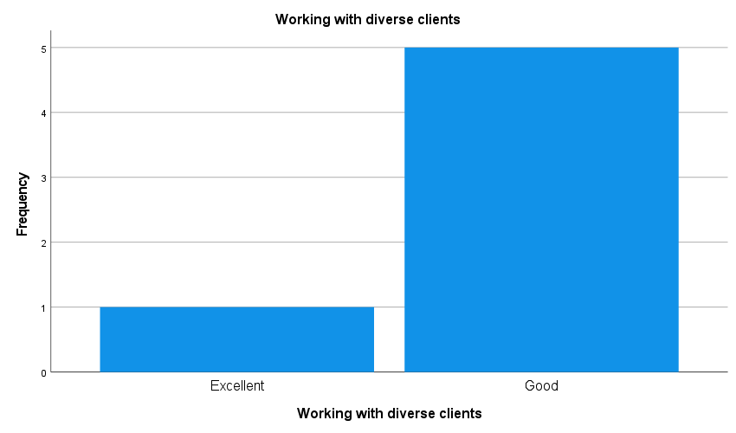

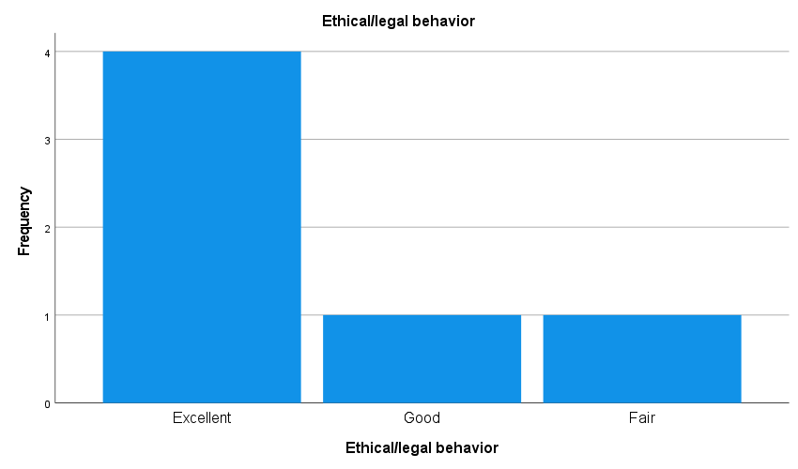

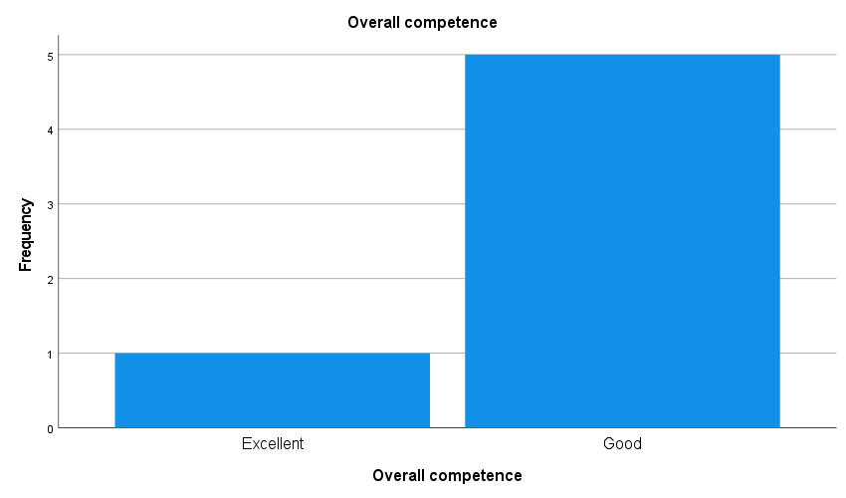

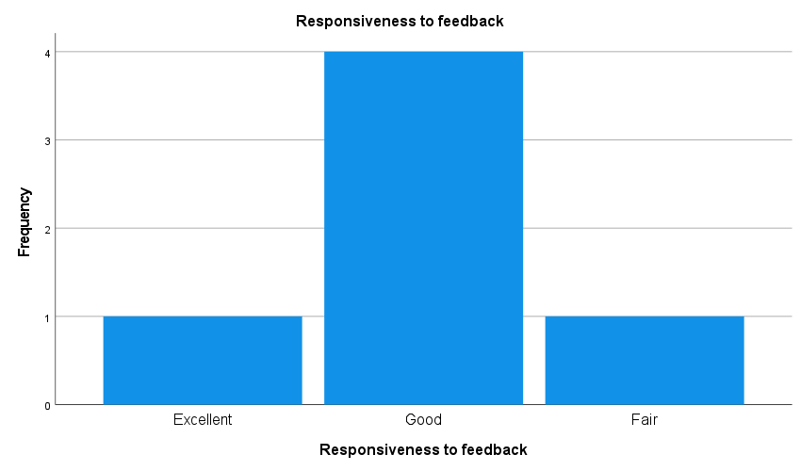

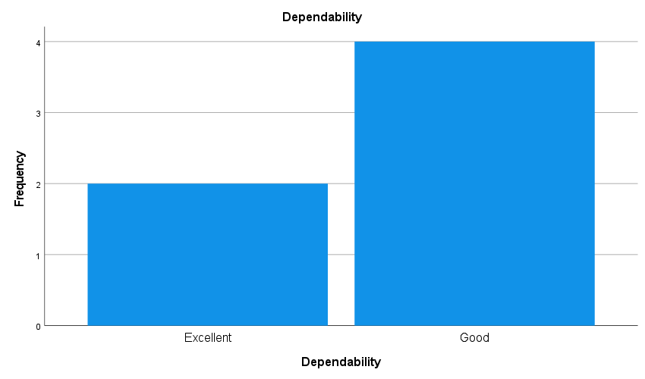

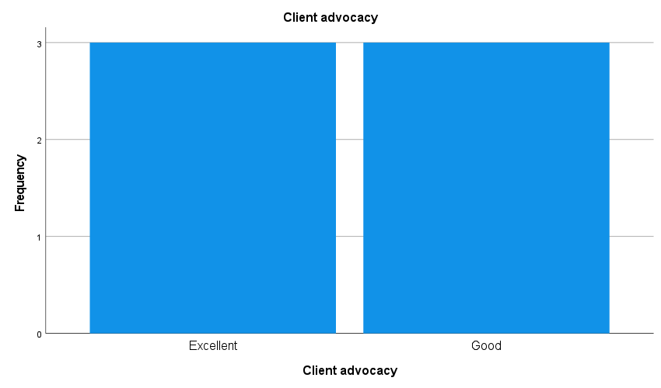

The Site Supervisor Survey was also used to assess Objective 3. This annual survey was administered in the summer of 2023. Fourteen of our site supervisors responded to the survey. The survey was broken into two major themes: specific professional skills and professional dispositions. The professional disposition items were applicable to evaluating Objective 3.
The modal responses to these items were “good” and “excellent.” Site supervisors rated Oswego students the highest in “ethical and legal behaviors,” “dependability,” and “responsiveness to feedback.” “Client Advocacy” was most often rated as “good.” This may be an area to explore for program improvement.

Site Supervisor Survey Professional Dispositions

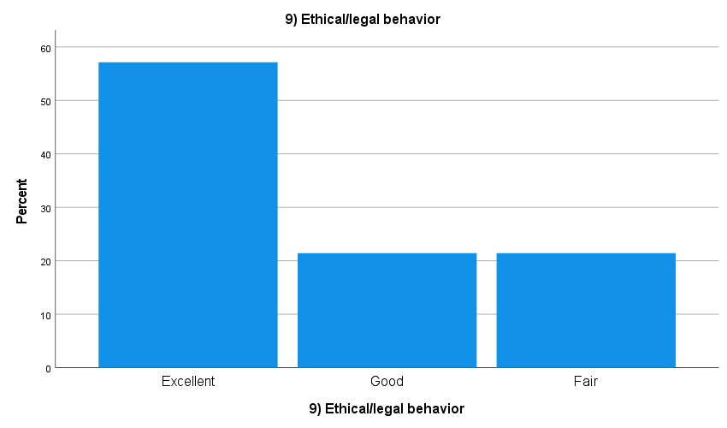
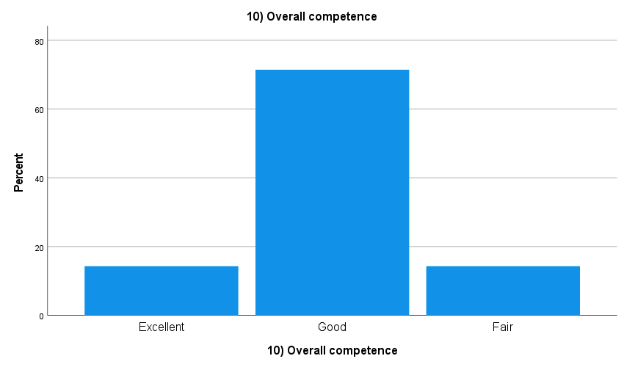
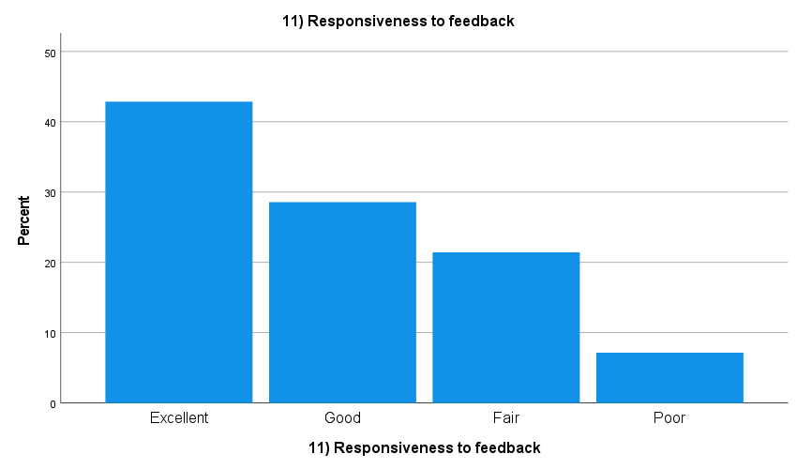

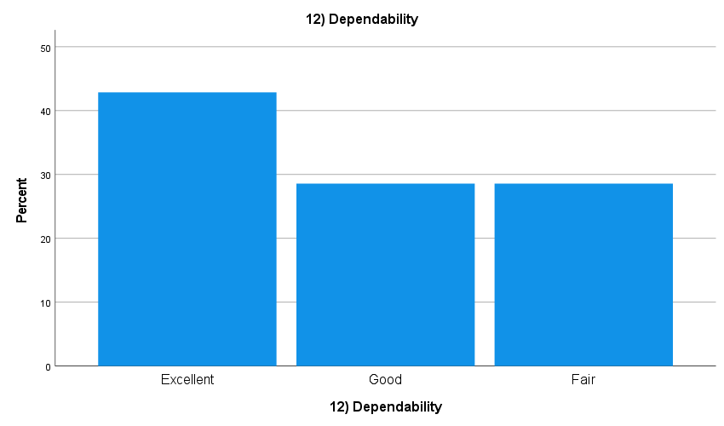
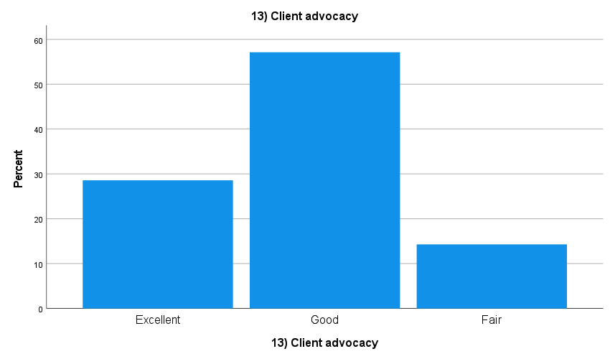

The Practicum Site Supervisor Evaluation of Practicum Students was also used to assess Objective 3. This evaluation had four major scales: basic practicum requirements; counselor practice, knowledge, and skills; becoming a professional counselor, and site and community skills. The scale becoming a professional counselor is applicable to Objective 3. That scale is comprised of 20 items that compose the four subscales shown in the table.
The evaluation is on a 1 – 5 scale where 1 means “highly unsatisfactory” and 5 means “highly satisfactory.” The table below shows that in all the scales, students performed between “satisfactory” and “highly satisfactory.” The lowest-rated scale was “Applying content from counselor program courses in the placement site.”
Although not shown in the table below, an investigation of individual items that compose these scales was performed. The lowest-rated items were all rated below a score of 4 (satisfactory).
- Discussing conflicting obligations/choices/expectations between self, client, and colleagues ($\overline{x}$ = 3.92)
- Applying knowledge of theory/empirical findings ($\overline{x}$ = 3.86)

Practicum Site Supervisor Evaluation of Practicum Student
Spring 2023
Component | Mean | N
C. Becoming a Professional Counselor | 4.35 | 18
1. Demonstrating a capacity for self-observation and self-awareness: | 4.36 | 18
2. Using Counseling Supervisors for learning: | 4.54 | 18
3. Applying content from counselor program courses in the placement site: | 4.02 | 18
4. Managing time and work demands: | 4.46 | 18

The Mental Health Counseling Internship Student Evaluation was also used to assess Objective 3. This evaluation had four major scales: basic practicum requirements; counselor practice, knowledge, and skills; becoming a professional counselor, and site and community skills. The scale becoming a professional counselor is applicable to Objective 3. That scale is comprised of 20 items that compose the four subscales shown in the table.
The evaluation is on a 1 – 5 scale where 1 means “highly unsatisfactory” and 5 means “highly satisfactory.” The table below shows that in all the scales, students performed between “satisfactory” and “highly satisfactory.” The lowest-rated scale was “Applying content from counselor program courses in the placement site” and the highest-rated scale was “Managing time and work demands.” It should be noted that because these are relatively minor differences, they are not likely to be very meaningful.
An investigation of individual items that compose these scales was performed. No individual item was rated lower than a 4 (satisfactory).
The Mental Health Counseling Internship Student Evaluation
Fall 2022 - Summer 2023
Component | Mean | N
C. Becoming a Professional Counselor | 4.41 | 52
1. Demonstrating a capacity for self-observation and self-awareness: | 4.35 | 52
2. Using Counseling Supervisors for learning: | 4.40 | 52
3. Applying content from counselor program courses in the placement site: | 4.33 | 52
4. Managing time and work demands: | 4.55 | 52

Demographic Data
Sixty-five students were actively enrolled in the Mental Health Counseling Program at the beginning of the 2023 Fall semester. The demographics of the students are shown below. Results are shown for the entire program and for individual campus locations.
MH Counseling Program Demographics
Oswego & Syracuse Campuses Combined
Race | N | %
White | 54 | 84.4
Asian | 4 | 6.3
African American/Black | 5 | 7.8
Asian/African American/Black | 1 | 1.6

Gender | N | %
Female | 41 | 62.1
Male | 25 | 37.9

Ethnicity | N | %
Non-Hispanic | 58 | 87.9
Hispanic | 6 | 9.1
Unknown | 2 | 3.0
MH Counseling Program Demographics
Syracuse Campus

Race | N | %
White | 20 | 87.0
Asian | 1 | 4.3
African American/Black | 2 | 8.7

Gender | N | %
Female | 15 | 62.5
Male | 9 | 37.5

Ethnicity | N | %
Non-Hispanic | 21 | 87.5
Hispanic | 2 | 8.3
Unknown | 1 | 4.2

MH Counseling Program Demographics
Oswego Campus

Race | N | %
White | 34 | 82.9
Asian | 3 | 7.3
African American/Black | 3 | 7.3
Asian/African American/Black | 1 | 2.4

Gender | N | %
Female | 26 | 61.9
Male | 16 | 38.1

Ethnicity | N | %
Non-Hispanic | 37 | 88.1
Hispanic | 4 | 9.5
Summary of Objective 3 Findings
Three measures were used to assess Objective 3 regarding professional dispositions and the ability to effectively work with diverse clients.
The results across measures indicate that the CPS Dept. is meeting this objective. Possible areas for improvement could include giving interns more skills in client advocacy, working with diverse clients, responding to feedback, and applying knowledge of theory/empirical findings.

