SUNY Oswego Community Services
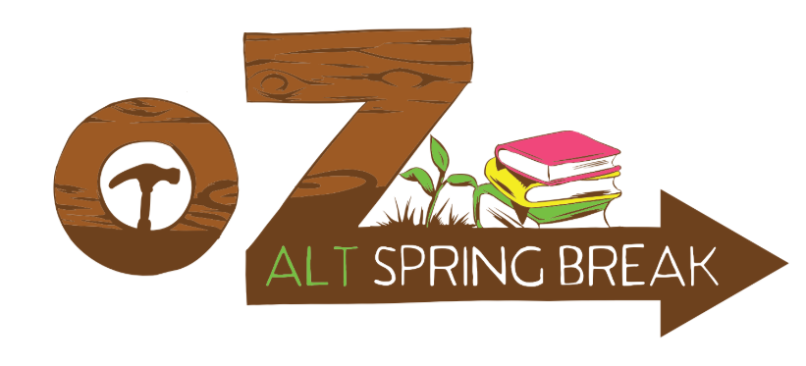

The State University of New York at Oswego’s Alternative Break Program
Spring Break 2019: March 16 – 24
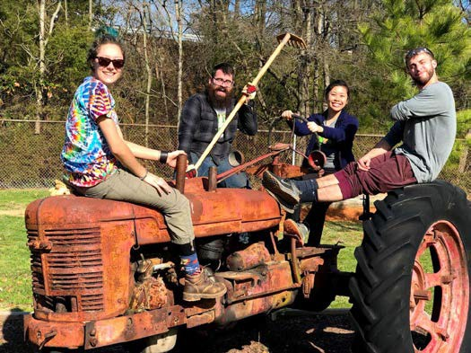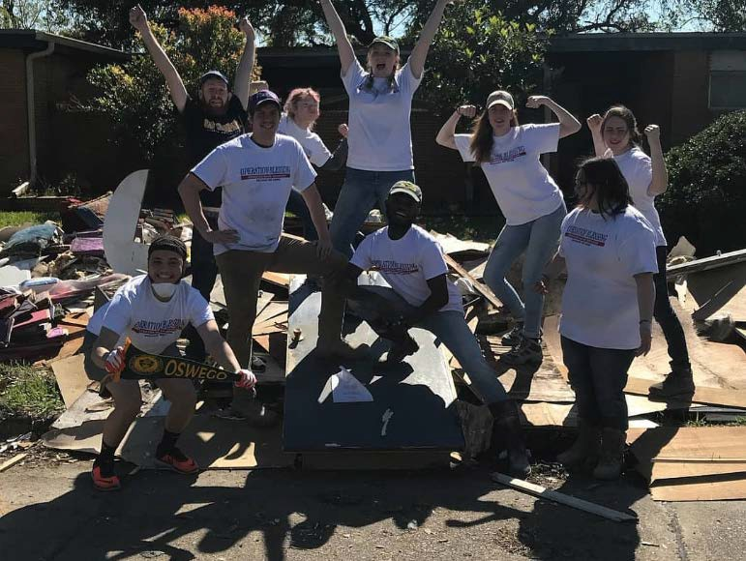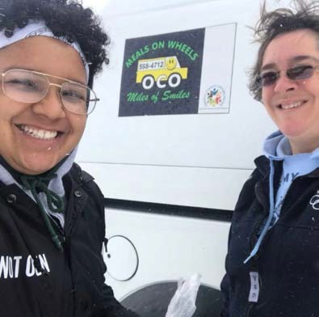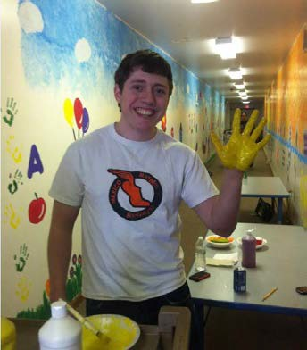

Alternative Spring Break Info Packet
Application Due: November 20, 2018

About Oz Alt Break

Oz Alt Break is SUNY Oswego’s Alternative Break program housed in the office of Community Services. Since 2001, SUNY Oswego students have dedicated their Winter and Spring breaks to engaging in strong direct service to local, domestic, and international communities. These week-long immersive service trips partner with community organizations to support efforts such as animal welfare, disaster relief, youth education, environmental concerns, quality affordable housing, health care, food security, and poverty alleviation.

Alternative Break participants do not “help” or “fix problems.” Instead of viewing our host site communities through a deficit framework, Oz Alt Break works from an asset based model. Our participants (referred to as Alt Breakers) serve alongside community members to strengthen the organization they are serving with. Our service focuses on creating justice, not doing charity. This framework allows Alt Breakers to learn from the knowledge and experience of our host sites while also working towards becoming active citizens who serve for the common good.

Oz Break values:
- Active Citizenship: A continuum where the ultimate goal is for individuals to prioritize the community in their values and life choices.
- Social Justice: A process and a goal where there is full and equal participation for all groups in a society that is mutually shaped to meet everyone’s needs and full potential.
- Simple Living: Limiting our negative impact on the environment and community by keeping within limits that reflect the socio-economic conditions of the communities we work in and lower our ecological footprint.
- Diversity and Inclusion: Commitment to individual and programmatic efforts to build mutual respect,
dignity, access, and equity among all groups of people.
- Self-Awareness and Reflection: Creating time and space to analyze how we impact the community and ways in which we contribute to and can alleviate social problems.
Trip Elements

Direct Service
All Oz Alt Break trips engage in direct or “hands on” projects and activities that address unmet social needs as determined by the community. Depending on the trip’s focus issue, this direct service could look like building or repairing a house, serving meals, working with youth, maintaining hiking trails, creating care packages, and much, much more. Sometimes the work is physically demanding, sometimes it is emotional. No matter what the site, your full participation will lead to you gaining new skills, building meaningful relationships, and working towards a more socially just world.

Reflection and Education
Oz Alt Break recognizes that service is just one component of social justice and active citizenship. The combination of direct service, social issue education, and daily reflections during the trip result in the most successful and transformative Alternative Breaks. Before, during, and after trips, group leaders will facilitate discussions, reflections, and team builders to encourage a deeper understanding of service and community.

Full engagement
Alt Breakers are expected to be fully engaged, body and mind, during the entire trip. One of the most important aspects of full engagement is our commitment to a Drug and Alcohol Free experience. Alternative Breaks are just what the name implies, an alternative to traditional college breaks. In fact, the Alternative Break movement began in the late 1980’s as a counter cultural response to the “MTV culture” of spring breaks. A drug and alcohol free policy (no matter age or the laws) assures Alt Breakers will provide the best possible service to our host sites and get the most out of their trip experience. If a participant is found to be using, possessing, manufacturing, or distributing drugs or alcohol, they will be required to return home at their own expense. Participants found in violation will not be permitted to participate in Alternative Breaks for at least one academic year.

Accommodations

Meals
Included in trip costs are three meals a day and snacks. Alt Breakers plan, prepare, and eat meals together as a team. In an effort to adhere to our simple living and sustainability values, we budget $7 per person per day for meals. This budget is almost three dollars a day more than the amount an individual receives through SNAP (Food Stamps) benefits. We accommodate dietary restrictions and allergies.

Housing
Housing is included in trip costs. In the spirit of simple living, groups do not stay in hotels but instead partner with churches, colleges, hostels, and community centers. Air mattresses or barrack-style bunk beds are common. This means most of our housing sites require Alt Breakers to bring their own bedding, towels, and toiletries. Community Services has several sleeping bags available if participants do not have their own.

Transportation
Transportation to and from sites is provided by the program; including flights for international trips. All domestic trips are traveled to by car. Students who are van trained through the college or who are 21 years of age and older with a valid driver’s license are encouraged to sign up as drivers. For car trips especially, Alt Breakers are urged to save space by bringing only one small-medium duffel bag plus a sleeping bag.

Required Info Sessions & Pre-Trip Meetings

Info Sessions
All applicants MUST attend an information session in order to be accepted. These sessions introduce students to the basics of Oz Alt Break, introduce each trip, and offer time for applicants to ask any questions.

Oct 31st | 6:00pm | Marano 143 | Nov 13th | 9:00am | Marano 143
Nov 1st | 11:00am | Marano 143 | Nov 14th | 4:00pm | Marano 143
Nov 7th | 1:00pm | Marano 143 | Nov 15th | 6:00pm | Marano 141
Nov 9th | 3:00pm | Marano 141 | Nov 16th | 3:00pm | Marano 141

Pre-Trip Meetings
Once you have been selected and placed into a trip, your Group Leader will contact you about Pre-Trip Meetings. These three meetings are an essential and required part of Alternative Break. You will get to know your fellow Alt Breakers, receive important details about your specific trip, and learn more about your host site organization, host site community, and the issues related to your trip topic.

Cost & Payments

The cost of all trips includes transportation (including flights if international), housing, and meals. Payments can be made in cash or check made out to Auxiliary Services. These payments should be dropped off to a Community Services staff member only. Do not submit a payment to anyone other than the Coordinator of Community Services or the Community Services GA unless explicitly told otherwise. Be sure to obtain a receipt. This assures the safe acceptance of your payment.

A nonrefundable $25 deposit of is due with the application. Applications will not be considered until the deposit is submitted. This $25 will be put towards the trip fee once you have been assigned to a trip. If you are not assigned to a trip you will receive your deposit back.

Need Based Scholarships

Scholarships
A small number of scholarships are available to provide financial assistance to students who qualify for Oz Alt Break, but do not have the financial means to participate. Due to limited funds, we ask that students only apply for a scholarship if the cost of an Alternative Break trip would prevent them from participating. Oz Alt Break reserves the right to confirm the applicant’s need with the Financial Aid office.

Scholarship Requirements:
  - Application: All scholarship applicants must complete the attached Oz Alt Break participant application and attend an information session by the listed due dates.
  - Scholarship Section: On the attached Oz Alt Break application there is a “Scholarship” section. Fill out this section in its entirety including the additional short answer question.

Deposit Waiver
Students who are members of the SUNY Oswego Educational Opportunity Program are able to waive the initial
$25 application deposit. EOP members who wish to have the deposit fee waived should check the EOP waiver box in the scholarship section of the attached application.

Affordable Housing for All: Homeownership
and Repairs in a Rural Area
TRIP DESCRIPTIONS

 | Organization | Shoals Habitat for Humanity is dedicated to eliminating substandard housing through constructing, rehabilitating, and preserving homes for members of their community. For 37 years, their volunteers have advocated for fair and just housing policies, and provided training and resources to help families improve their housing conditions.
 | Service | Building or repairing homes in various stages of construction. No Previous construction experience is required as you will go through orientation of all projects and tools on site.
 | Location | Florence, AL
 | Cost | $150
Trailblazers for Change: Environmentalism and State Park Maintenance

Organization | The American Hiking Society’s Alternative Break program partners with America’s parks and forests to increase environmental stewardship and use of public outdoor areas. Currently partnering with 9 state parks, wildlife refuges, and environmental centers, American Hiking Society allows volunteers to experience nature first hand while improving access to the public.
Service | Various trail improvement projects throughout the park including, but not limited to, brush trimming and removal, gravel laying, trail repair and marking, and shoreline cleanup. Volunteers should expect to hike up to 3 miles every day and be prepared to get dirty.
Location | Belle Isle State Park, VA
Cost | $150

Staycation: Exploring Oswego County’s Challenges and Strengths

Organization | Oswego Health, Oswego County Opportunities, ARISE, Richardson Bates House, Fort Ontario, and other local organizations.
Service | Participants will serve with a different organization each day. Service may include preparing and distributing meals, building wheel chair ramps, working with senior citizens, preserving local historical sites, and more. This trip allows participants to learn more about their Oswego home away from home.
Location | Oswego County, NY
Cost | $25

Poco a Poco: English Language Learning with Spanish
TRIP DESCRIPTIONS
Speaking Youth

Organization | Outreach 360's vision is a world in which every child lives a life of choice. They focus on education, particularly English literacy, and community health as ways to increase opportunity for youth with limited opportunities.
Service | This trip is open to all majors, not just education. Assist English teachers in classroom engagement and lesson planning in rural schools. Work with youth in after-school programs that incorporate learning into play.
Location | Monte Cristi, Dominican Republic
Cost | $1,100

Agua Limpia: Clean Water Efforts After Hurricane Maria

Organization | Since Hurricane Maria, Proyecto Agua Limpia has distributed water filtration systems to families across Puerto Rico. Partnering with the Puerto Rico Science, Technology & Research Trust and using a public health approach, they look at health issues related to water quality and contamination.
Service | Distributing water filters to municipalities in Puerto Rico that do not have consistent access to clean water. Testing water quality and educating families on how to use water testing kits.
Location | Multiple municipalities in Puerto Rico
Cost | $500

