SUNY Oswego Career Services Online Reference Account Instructions

- Visit the Career Services website at https://www.oswego.edu/career-services/. Click on the “Laker Leads - Reference Service” link located on the right side of the screen. Under Register for an Account, click the green words Access the registration page.

- On the right hand side of the page, click on Register.
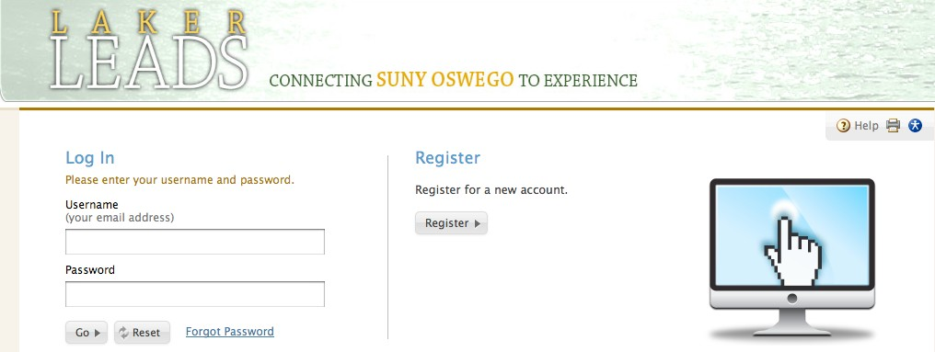

- Enter information in the Registration page, making sure you fill in all required fields marked with an asterisk *
  - Make sure you use a current email address, as all notifications from the system will go to it.

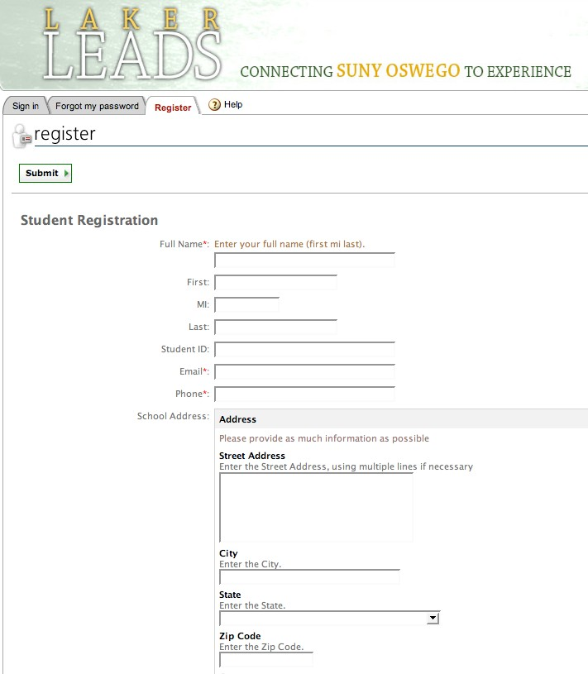

- At the bottom of the page, click Submit.

- Open your email. You will receive a message from careerservices@oswego.edu asking you to verify your email address. Click on the second link to verify.
  - The email verification is time sensitive. If you are unable to check your email at the time of registration, your account may be disabled. Please call our office at 315.312.2255 if this occurs.

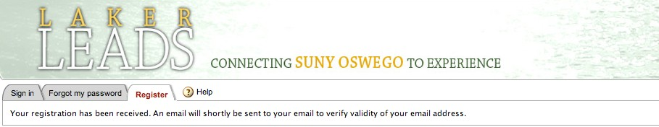

- Click on “click here to continue.”

- Click on “Reference Account.”
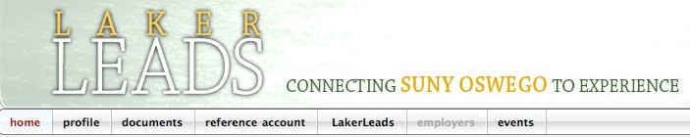

- Click on “I Am Interested” to request your online reference account.

- By this point, the $15 dollar registration fee must be paid before we can activate your account. If you have not already paid, return to the Career Services website at https://www.oswego.edu/career-services/. Click on the “Laker Leads - Reference Service” link located on the right side of the screen. Under the Fee Structure section, click the green Payment Link. Please note that it may take up to 2 business days after payment is made for your reference account to be activated.

- Once your account has been activated, you will be notified via email. Please save or print the handout attached to the email, which will provide directions regarding how to request references and place orders within the system.

- Log into the system using your full email address as your username, and the temporary password you received in the email sent after you verified the authenticity of your email address.
  - Username and password are case sensitive
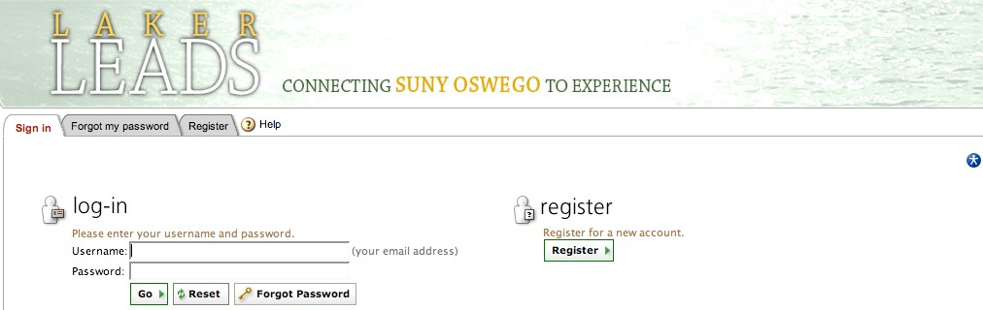

- Click on Reference Account.

- Fill out your Personal Data form and click “Submit.” Three additional tabs will open (Reference Requests, Completed Reference and Orders). You now have full access to your SUNY Oswego Career Services Online Reference Account.
