**PASSPORT TO OSWEGO**

School of Business:

◊ Accounting

◊ Business Administration

◊ Finance

◊ Human Resource Management

◊ Management Info. Systems

◊ Management Science/Operations

◊ Marketing

◊ Risk Management & Insurance

**Transfer Services Coordinator**

Corie Kohlbach

183 Marano Campus Center

315-312-3638

[corie.kohlbach@oswego.edu](mailto:corie.kohlbach@oswego.edu)

**School of Business- B.A.S.A.C**

230 Rich Hall

315-312- 2148

[glynn.english@oswego.edu](mailto:glynn.english@oswego.edu)

**Transfer Success Advisors**

Transfer Center

170 Marano Campus Center

<https://www.oswego.edu/>transfer-services/transfer-center

Rosemarie Pupparo

315-312-4951

[rpupparo@oswego.edu](mailto:rpupparo@oswego.edu)

Alicia King

315-312-2058

alicia.king@oswego.edu

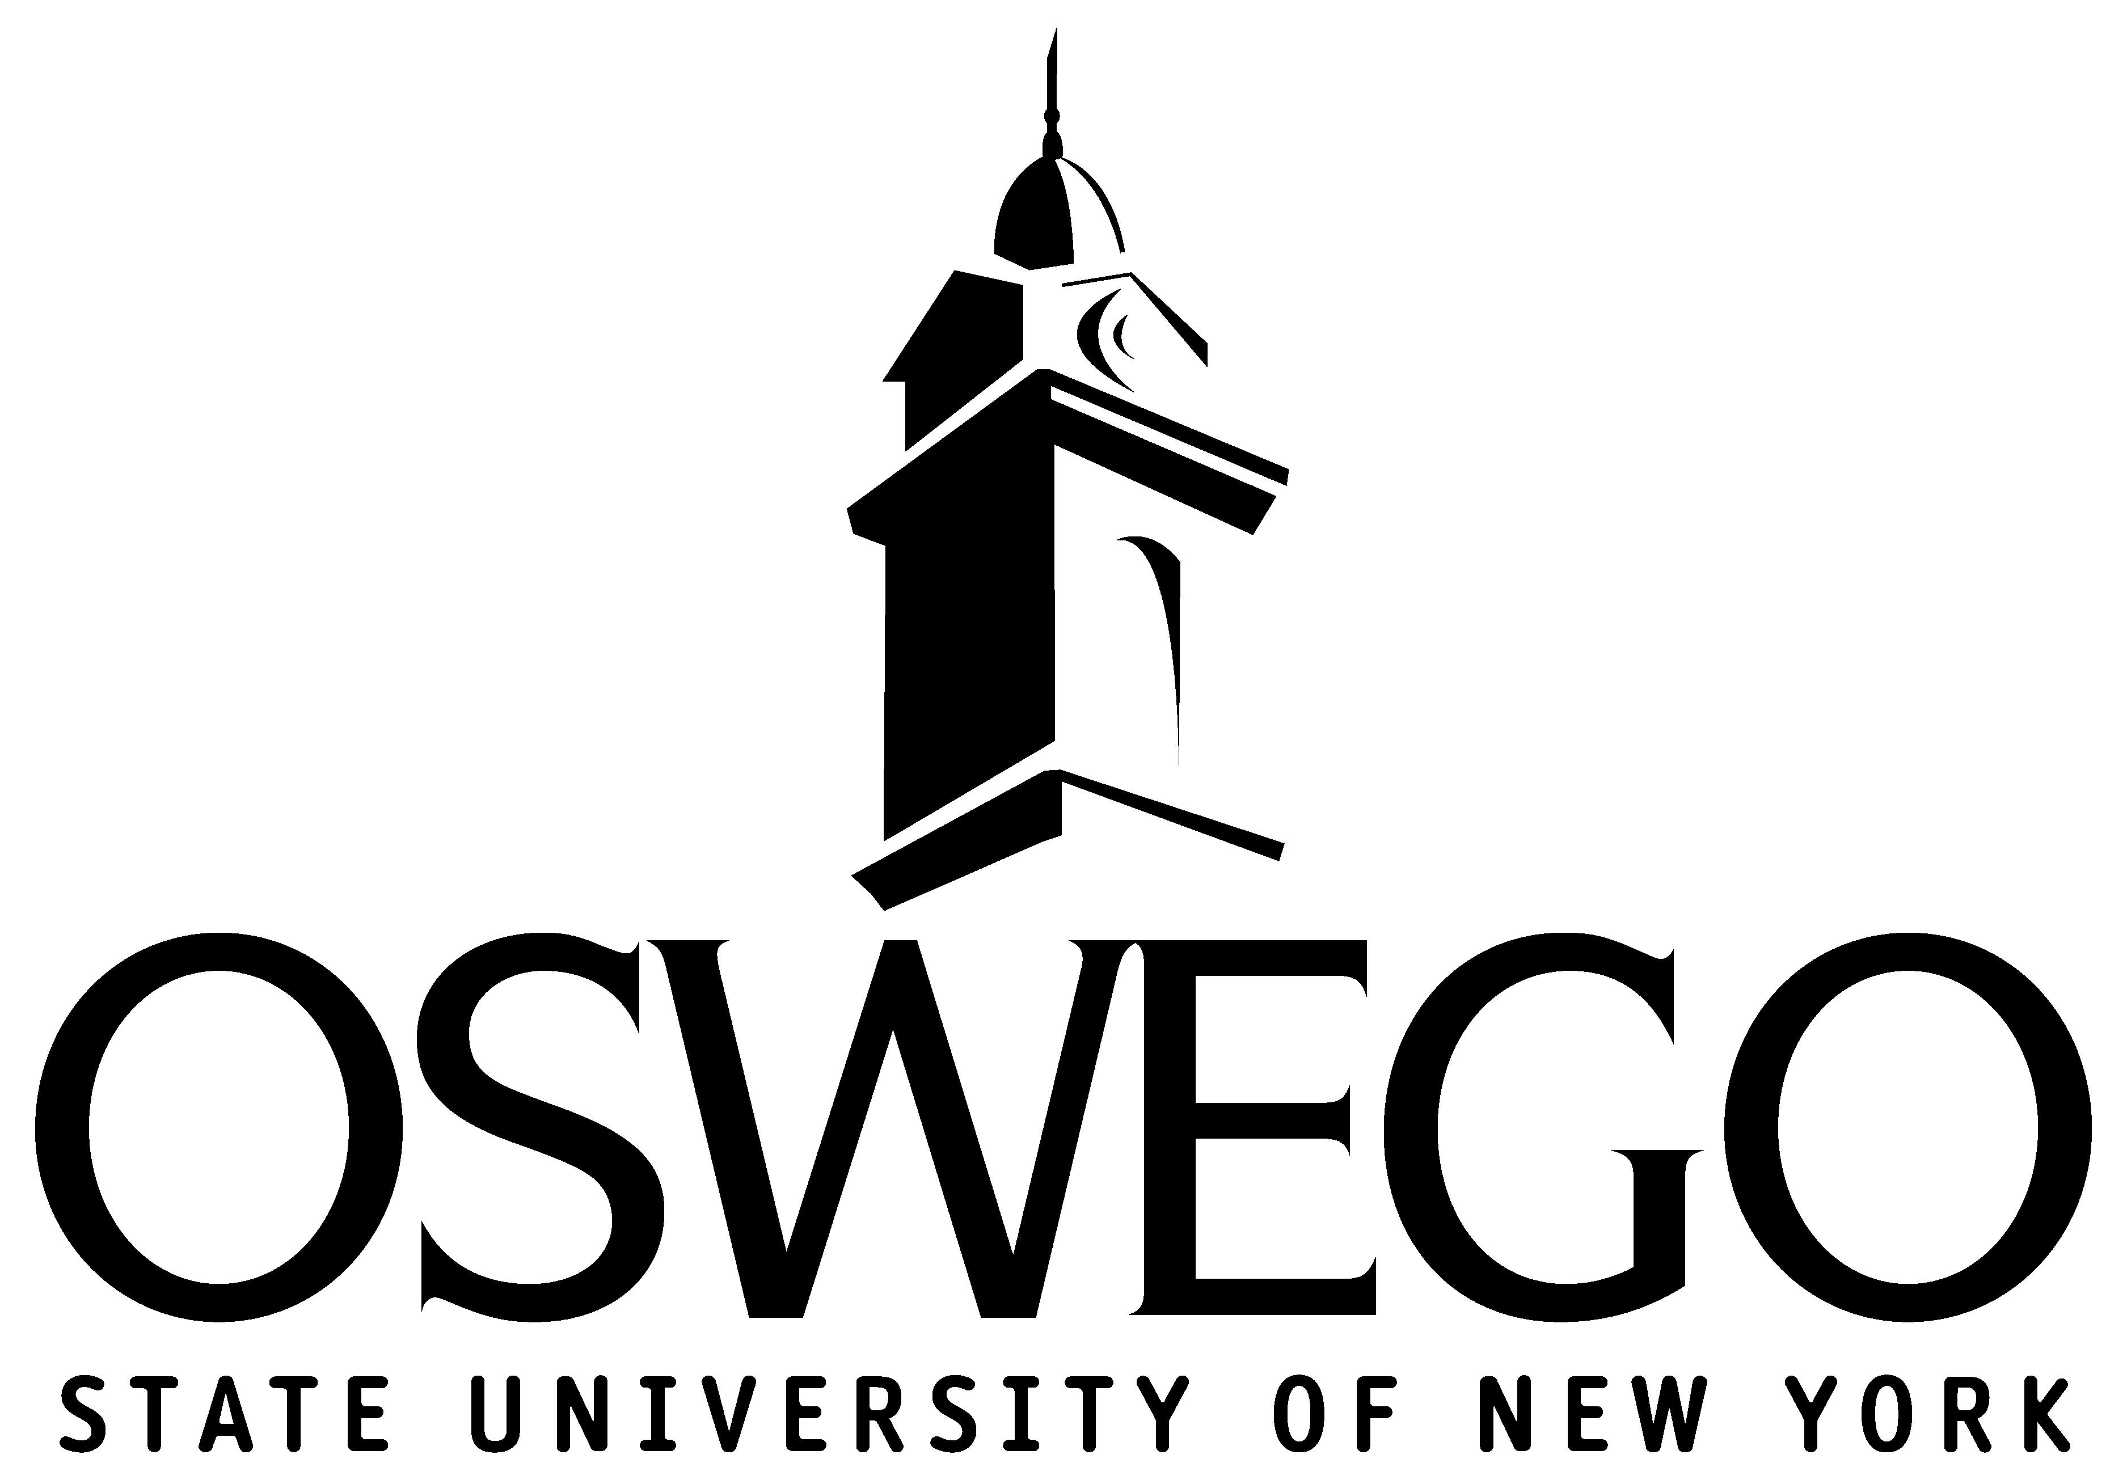

**OPTION B: MANAGEMENT SCIENCE/OPERATIONS**

This major is for students interested in managing the information resources of an organization and is math intensive.

**Junior Year** **Senior Year**

COM 211: Com in Bus MGT 486: Mat Mgt

FIN 325: Corp Fin MGT 415: Dec Anlys

MKT 250: Marketing Prin MGT 495: Mgt Policy & Sim

MGT 310 & MGT 410 MS/O Elective

MS/O Elective Upp. Div. ECO Elective

◊ Business Administration A.S



## **MARKETING**

## This major introduces students to the concepts and tools employed by marketing management professionals. The area encompasses activities towards planning, implementation and control of marketing programs.

## **Junior Year Senior Year**

## COM 211: Com in Bus MKT 467: Adver & Promo

## FIN 325: Corp Fin MGT 495: Mgt Policy & Sim

## MKT 250: Marketing Prin 2 Upp. Div MKT Electives

## MAT 258: Intro to Stats B

## MKT 370 & MKT 375

## Upp. Div. ECO Elective

**OPERATIONS MANAGEMENT & INFORMATION SYSTEMS**

**OPTION A: MANAGEMENT INFORMATION SYSTEMS**

This major is for students interested in managing the information resources of an organization and is computer intensive.

**Junior Year Senior Year**

CSC 120/CSC 212 MGT 495: Mgt Policy & Sim

COM 211: Com in Business MGT 415: Dec Anlys

FIN 325: Corp Fin MGT 486: Mat Mgt

MKT 250: Marketing Prin 2 MIS Electives

OPM 310 & OPM 410 (fa)

Upp. Div. ECO Elective

"The contents of this passport were developed under grant P116F140327 from the U.S. Department of Education.  However, those contents do not necessarily represent the policy of the U.S. Department of Education, and you should not assume endorsement by the Federal Government."

**RISK MANAGEMENT AND INSURANCE**

Students in this major will take specialized courses in risk management, lines of insurance, and employee benefits while gaining core strengths in such business areas as accounting, finance, marketing, and management.

**Junior Year Senior Year**

COM 211: Com in Bus RMI 400 (fa) & RMI 450 (spr)

ECO 340: Money & Bank MGT 495: Mgt Policy & Sim

FIN 325: Corp Fin RMI 320: (spr) Employee Ben

MKT 250: Marketing Prin FIN 354 (fa) & FIN 454 OR 2 MKT

RMI 300: (fa) Intro Risk Mgt Track Electives

RMI 310: (spr) Prop & Liability

**GRADUATION REQUIREMENTS**

All students graduating from SUNY Oswego must have:

✓ A minimum GPA of 2.0 for graduation (in major & cumulative)

✓ A minimum of 122 hours for degree purposes

✓ 42 credits of upper division work (300-400 level) from Oswego

✓ Maximum transfer credits of **62** from community college

✓ At least ½ of major credits taken at Oswego

✓ Major and cognate courses completed with a C- or better



*Numerous international opportunities and discipline-related internships are available and encouraged.*

**Contact the following offices at SUNY Oswego for specific transfer information:**

**SPRING 2016**

The SUNY Oswego courses listed include major and cognate coursework only. Other electives are required; business or other electives should be selected with advisor approval.

Fall only course: (fa) Spring only course: (spr)

**Take BUS 102 (Principles of Management) at ACC!**

Many upper level Oswego Business courses ***require***it (Equivalent course at SUNY Oswego is MGT 261).

If you don’t take BUS 102, you may not finish in 4 semesters after you transfer!

**STEPS FOR EFFICIENT TRANSFER**

1. Print out current degree plan.
2. Check off the courses you have completed.
3. Schedule a meeting with an advisor at ACC.
4. Make sure your remaining ACC courses meet Oswego Course Equivalents. (Consult the course equivalency table in this passport)
5. ***Complete SUNY Gen Ed Requirements at ACC to be exempt from Gen Ed at Oswego!***
6. ***Complete your ACC degree***
7. Apply to SUNY Oswego and meet with a Transfer Success Advisor at Oswego (see back for contact information)

**ACCOUNTING**

This major provides students with the financial information needed for recording business transactions and analyzing the financial effects. The program is registered with the New York State Education Department and qualifies students to sit for the CPA examination.

**Junior Year Senior Year**

COM 211: Com in Bus ACC 305: Acc Info Sys

PHL 205: Intro Classic Ethics BLW 381: Bus Law II

FIN 325: Corp Fin MGT 495: Mgt Policy & Sim

MKT 250: Marketing Prin ACC 330: (fa) Fed Tax

ECO 340: Money & Bank ACC 430/ACC 440

ACC 301/ ACC 302/ACC 310 2 ACC Electives

***Take these courses at ACC:***

**Adirondack Equivalent Course**

**Community College Course at SUNY Oswego**

**FIRST YEAR: 31 hours**

HRD Course: Freshman Experience (1hr) No Credit

ENG 101: Writing I (3hrs) ENG 102

SUNY Gen Ed Basic Comm (3hrs) Transfer Credit MAT 130: Applied Calculus (3hrs) MAT 208/210

CIS 125: Office Productivity Software (3hr) CSC 102

BUS 146: Financial Accounting (4hrs) ACC 201

BUS 147: Management Accounting (4hrs) ACC 202

ANT 101: Cultural Anthropology (3hrs) ANT 112

BUS 102: Principles of Management (3hrs) MGT 261

History Elective (3hrs) Transfer Credit

Health and Wellness (2hrs) Transfer Credit

**Contact the following offices at ACC for specific transfer information:**

**BUSINESS ADMINISTRATION**

This major is a degree in general management. The student is provided with a broad understanding of the many facets of the modern business organization.

**Junior Year**

COM 211: Com in Busi

FIN 325: Corp Fin

MGT 310: Opr Mgt

MKT 250: Marketing Prin

Upp. Div. ECO Elective

**Transfer & Career Services**

106 Warren Hall

518-743-2278

**Assistant Professor of Counseling**

Douglas Gaulin

110 Warren Hall

518-743-2253

[gaulind@sunyacc.edu](mailto:gaulind@sunyacc.edu)

(Preferred email)

**Director of Business/Financial Affairs**

Lisa Dester

127 Warren Hall

(518) 743-2200 Ext. 2232

desterl@sunyacc.edu (Preferred email)

**Business Faculty**

John Arpey

002 Eisenhart Hall

(518) 832-7730

arpeyj@sunyacc.edu (Preferred email)

**Senior Year**

MGT 495: Mgt Policy & Sim

MGT 469: Cult Envirn Intl Bus

HRM 385: Org Behav

2 Upp. Div. BUS Elect.

.

**SECOND YEAR: 34 hours**

BUS 201: Business Law I (3hrs) BLW 355**◊** (280**∞**) ECO 201: Principles of Economics I (3hrs) ECO 200

ECO 202: Principles of Economics II (3hrs) ECO 101

Lab Science Elective (4hrs) Transfer Credit

PHI 207: Business Ethics (3hrs) PHL 306

BUS 202: Business Law II (3hrs) Transfer Credit

BUS Elective (3hrs) Transfer Credit

MAT 127: Intro Stats w/h Probability* (3hrs) MAT 158

Liberal Arts Elective (3hrs) Transfer Credit

Elective (6hrs) Transfer Credit

**◊**Does not meet SUNY Oswego upper division requirement

*Recommended mathematics elective

**∞**For students majoring in ACC, BUS 201 will transfer as BLW 280

⌂See advisor for specific course transfer information

**FINANCE**

This major prepares students for positions in financial institutions such as banking and mutual funds. Other areas include manufacturing, retail and nonprofit organizations.

**Junior Year**

COM 211: Com in Bus

MAT 258: Intro to Stats B

ECO 340: Money & Bank

FIN 325: Corp Fin

MKT 250: Marketing Prin

BLW 355: Legal & Reg Evrn Bus

**Senior Year**

FIN 340: (fa) Fin Statmt Anlys

FIN 354: (fa) Investments

FIN 426 (spr) & FIN 428 (spr)

MGT 495: Mgt Policy & Sim

3 FIN Electives

**GENERAL EDUCATION INFORMATION**

✓ SUNY General Education Requirements (SUNY GER) should be satisfied by completing your ACC degree.

✓ Students who have **not** completed their SUNY Gen Ed Requirements at ACC must complete Oswego’s Gen Ed program.

✓ Some courses taken at 2-year school will **not transfer as upper division credit at Oswego**.

✓ Several courses may be given equivalencies only as lower division credit.

**HUMAN RESOURCE MANAGEMENT**

This major provides students with expertise in employment, recruiting, training and development of employees.

**Junior Year**

COM 211: Com in Bus

FIN 325: Corp Fin

MKT 250: Marketing Prin

ECO 350: Intro Labor Eco

HRM 385 & HRM 386

***Next…***

Choose one of 8 majors in the School of Business at SUNY Oswego.

**Check them out!**

**Senior Year**

HRM 458 (spr) & HRM 459(spr)

HRM 462: Employment Law

HRM 463(fa) & HRM 464 (spr)

MGT 495: Mgt Policy & Sim