Tk20@oswego.edu

Faculty Guide for assessing
Capstone Teacher Performance Assessment (TPA)

How is the Capstone or Pre-Capstone TPA made available in Tk20?
The assessment is made available to candidates and faculty based on enrollment in specific courses that departments have identified as the course in which the assessment should occur. For example, ADO 420 is the adolescence undergraduate student teaching course where the Capstone TPA will occur.

What is the difference between the Pre-Capstone TPA and the Capstone TPA?
The Pre-Capstone TPA occurs during Methods. Candidates will have access to the entire assessment, however they will only complete Part 1 and 2 and faculty assess only those rubrics associated with Part 1 and 2.
The Capstone TPA occurs during student teaching. Candidates compete all four parts of the assessment, and faculty assess all rubrics. Additionally, for the Capstone TPA faculty will complete a summative evaluation indicating if the candidate has met all the requirements of the assessment.

Where do I see the Capstone TPA or Pre-Capstone TPA in Tk20?

The assessment will appear in the Courses tab (see below) of your Tk20 account.

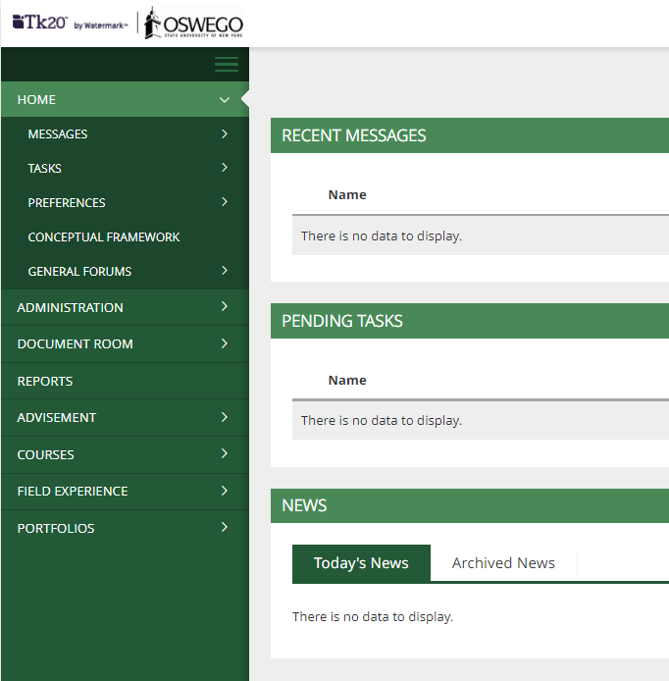
Once clicked on Courses in the side menu your dashboard will open. The middle section of the screen will change and it will show your dashboard. The picture below is how the dashboard will look before candidates have uploaded files. If you hover over the number you will see the candidates who have the assessment.
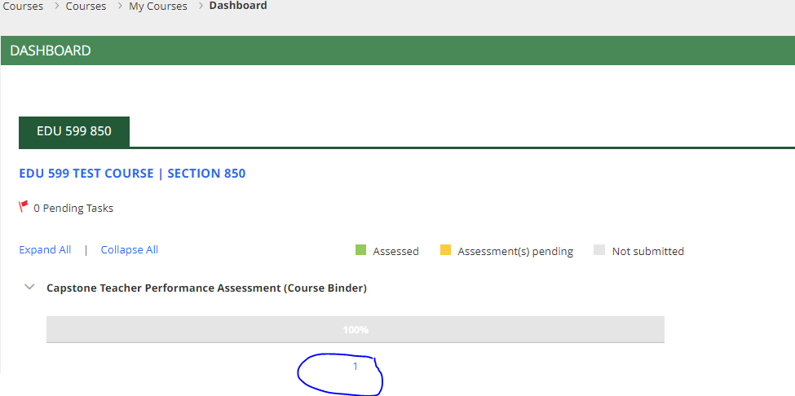

NOTE: If candidates add or drop the course the associated action will occur. For example, if a candidate drops the course the assessment will be removed.

Once candidates have uploaded their documents, how do I see them?
After candidates have uploaded and submitted the assessment your dashboard will look like the picture below. Notice the bar has turned yellow which indicates the assessment is pending.
Note: The dashboard will only show the current semester. Therefore, if you are assessing candidates after the semester has ended change the term by choosing the correct semester from the drop-down menu (shown in the red circle).
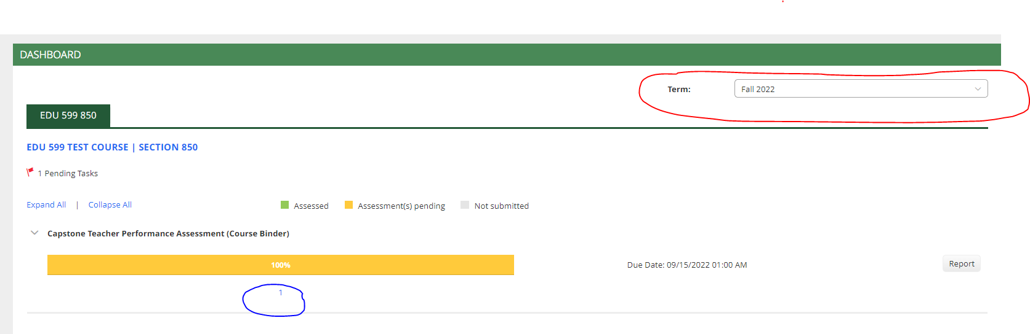

To open individual candidate submissions hover over the numerical value (blue circle in the picture above). This will give you a list of names, click on the name of the candidate you wish to assess.

What should the binder look like when I open it?

Individual candidate’s course binders will look like the picture below.
Left hand side – Candidates work
- Each part has a Tab (red circle indicates Part 1)
- The blue link under name (blue circle) to open the attached files
Right side – Faculty assessment
- The link for the rubric (yellow circle) is on the right side
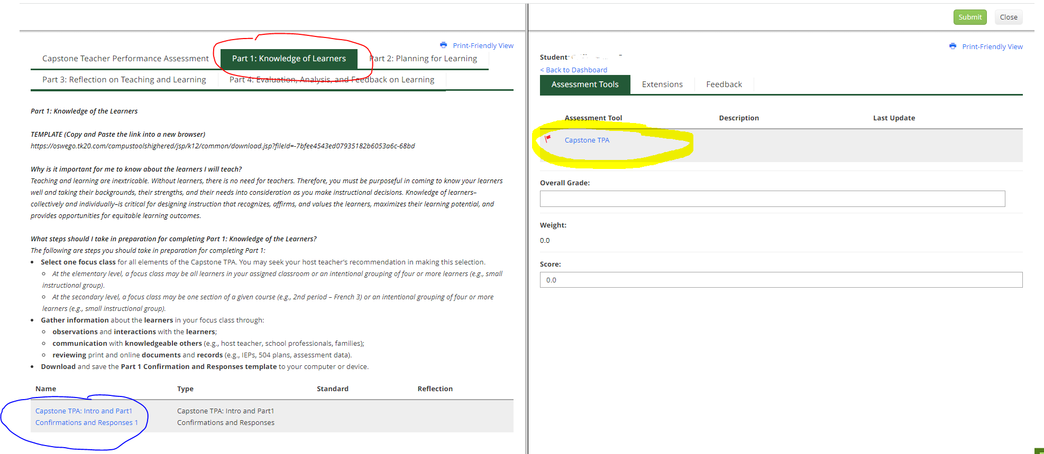

How do I open files candidates have uploaded?

As described above to open the files click the blue link in the binder associated with the section you are assessing. You will be given two options:
- View and Annotate – meaning the file will open in Tk20 and you can view side-by-side with the rubric (it is recommended you choose this option)
- Download – meaning the file will downloaded to your computer and you will need to open it in Word or Adobe.

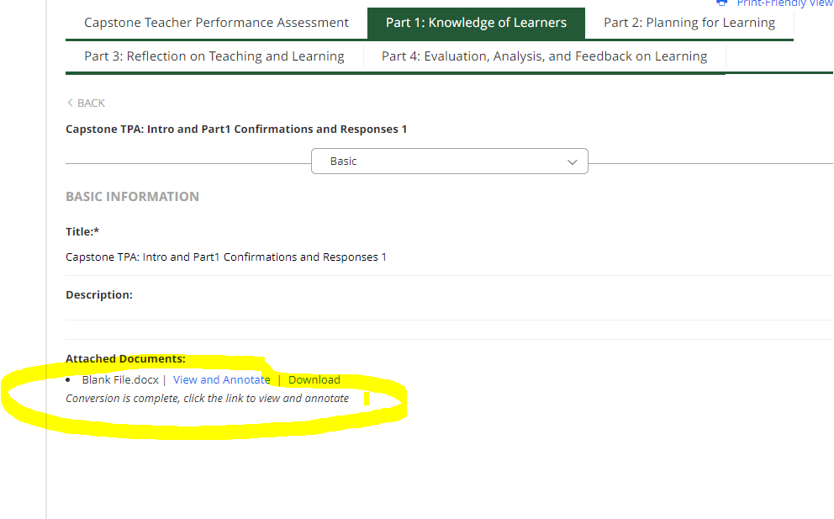

How do I complete my ratings?
As described above open the candidate’s file with the view and annotate option and open the rubric. Your screen will look like the picture below.
In the right-hand side of the screen click the radio buttons for ratings of each of the eight rubrics. Comments are optional.
The summative evaluation is required, click yes if the candidate has met the requirements. If the requirements are unmet, click no and complete the next two questions (plan and due date for revision).

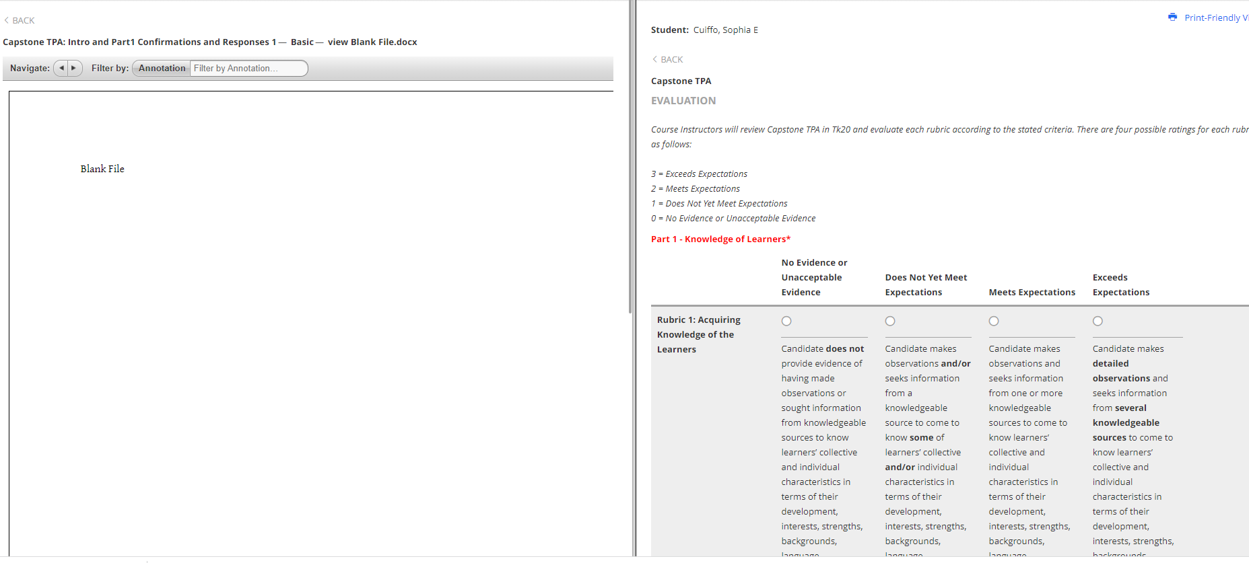

How do I save and submit my ratings?
Once you have completed the rubric, go to the bottom and click the “Save and Close” button. This will bring you back the binder, see picture below of what your dashboard will look like.

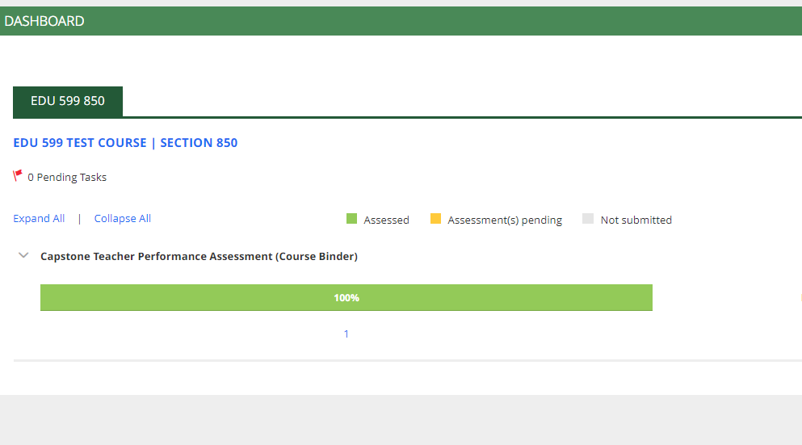

If you are unable to submit?

The eight rubrics along with the summative evaluation are required. If a rating is missing the system will not allow your evaluation to be submitted.

How do I revoke my rating?

To revoke your ratings, open the candidate’s binder as described above. Open the rubric by clicking the rubric link in the right side of the binder. At the top there will be a button to revoke (see picture below). Once you have made changes to your ratings save and submit as describe above.

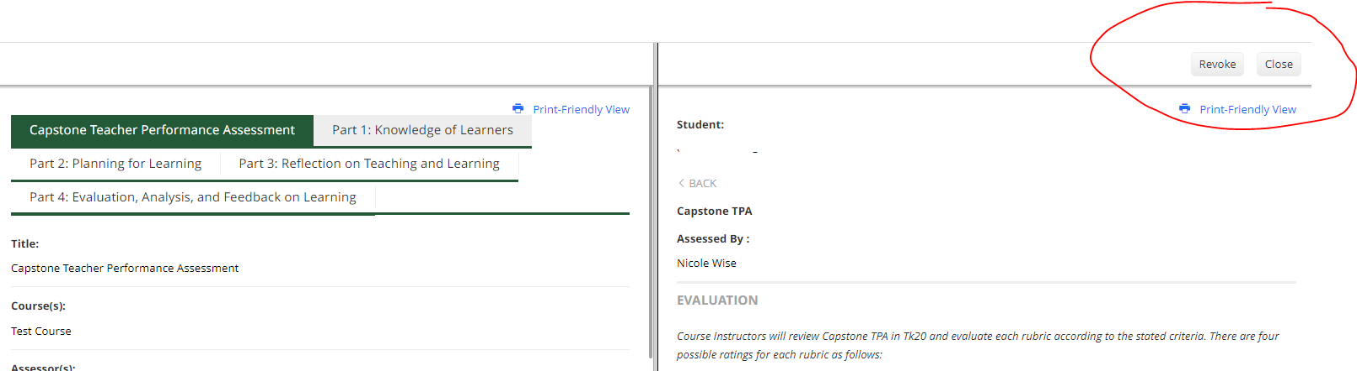

Please reach out to tk20@oswego.edu if you have questions or need assistance.

